Design and Technology Project

Designing your dream outside space!

**1.** Draw and label what you currently have in your outside space.

**2.** Look at these ideas of things that could improve your outside space and create a word bank.

**3.** Draw and label your ideal outside space.

**4.** Describe the changes that you would like to make.

**5.** Create a 3D prototype of your improvements.

**6.** Present your finished prototype.

**7.** Gather materials for your real life outside space.

Well done! If time you could now:

Think about what **plants** we could add to our outside space. (if you haven’t already)

* You might collect (eg. from leaflets) or draw and label pictures.
* Say what types categories of **plant** you think would be best and why. Small plants in pots? Trees? Grasses? Bushes/shrubs? Water plants?

Take photos of changes that you’ve made to your own garden to show your classmates.

Think about the living things that might make a home in your space. Research their life-cycles.

Evaluate your outside space in writing.

**1.** Draw and label what you currently have in your outside space.

This could be your own garden or the school’s outside area. At school we have learnt what “Bird’s eye view” means and are encouraged to draw to scale. Use your phonic knowledge to write labels and colour in realistic colours. This should include plants that are already there.

**2.** Look at these ideas of things that could improve your outside space and create a word bank.

This time ask adults to model how to correctly spell each object and then you write the word underneath the picture. If you can think of other great ideas, draw or look up a picture and then write a label for that.

Useful words: stage, ribbons, tubes, funnels, buckets, stones, soil, fairy area, tree stumps, tyres, mud kitchen, mobiles, chalk board, crates, fabric, sticks, wood, cable drums, table.

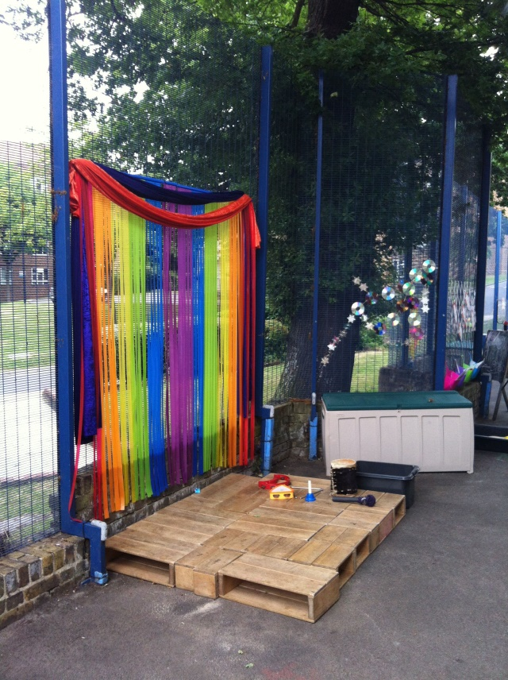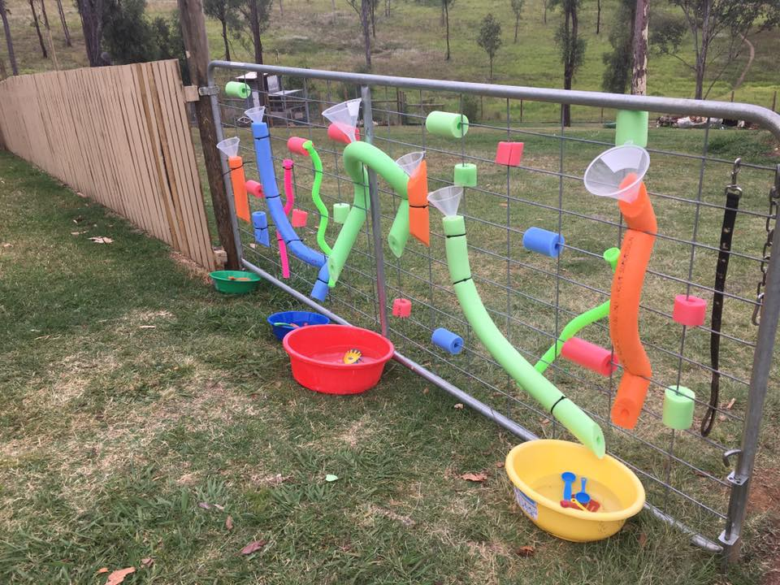

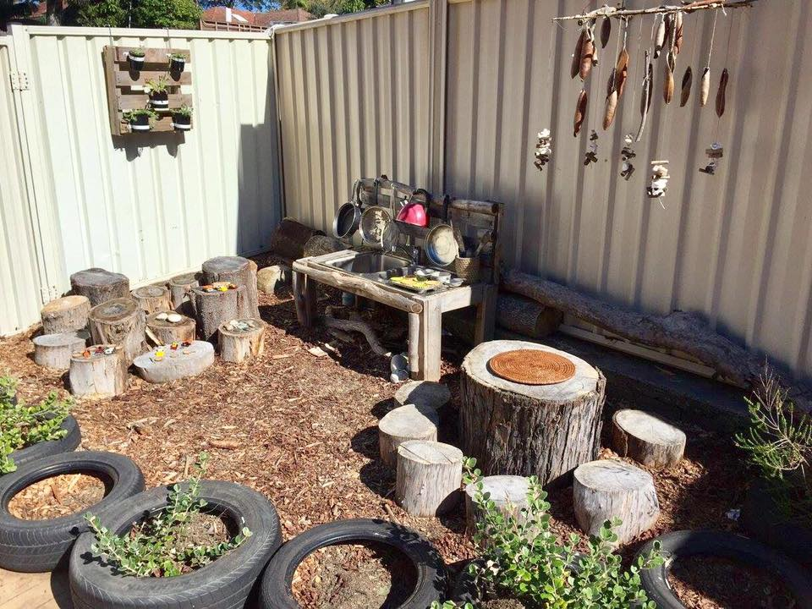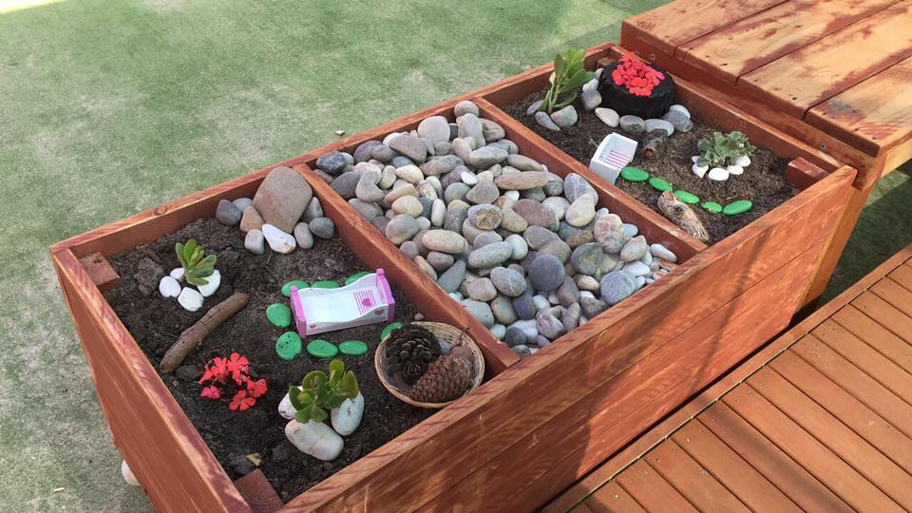

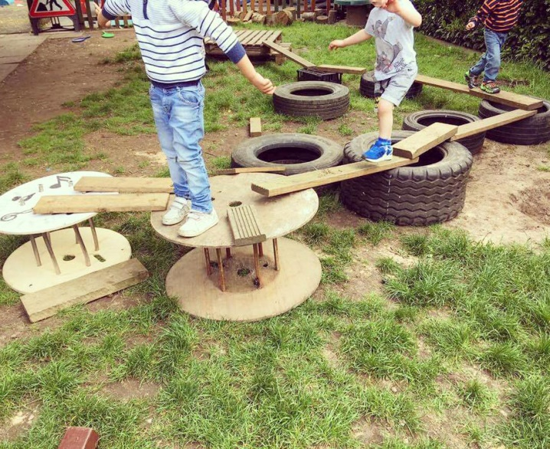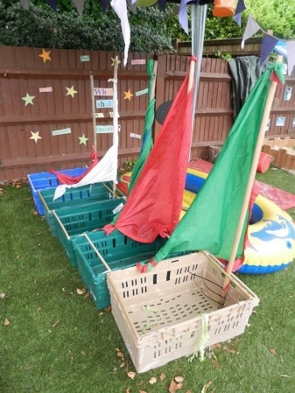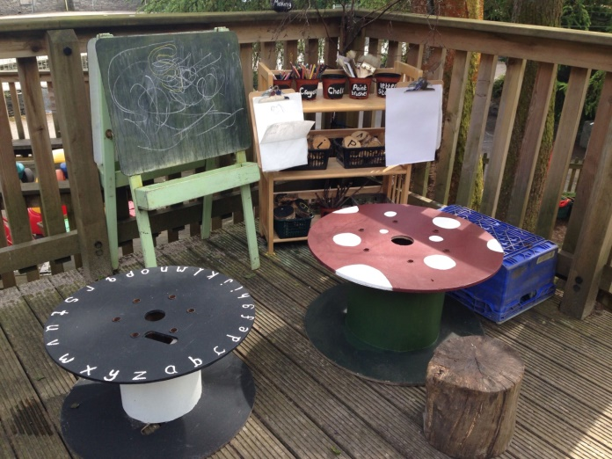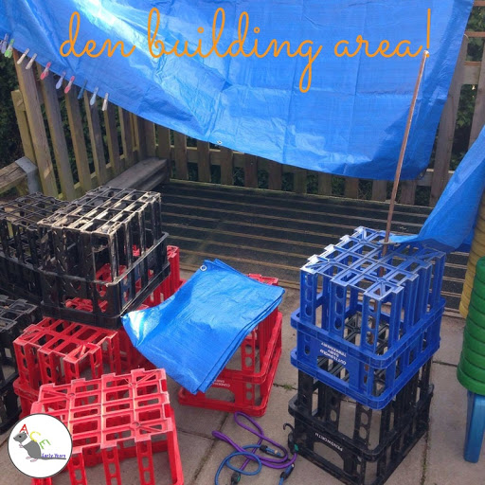

**3.** Draw and label your ideal outside space.

This could be your own garden or the school’s outside area. Use the word bank that you created in the last task to correctly write your labels. Colour in realistic colours.

**4.** Describe the changes that you would like to make.

Have a go at writing your ideas in full sentences. Adults can scribe some for you but you should at least sound words out for them using your voice. Eg. s-w-i-ng. Adults could write out sentence starters for you to copy such as ‘I will’, ‘I would like’ ‘My idea is’.

________________________________________________________________________________________________________________________________________________________________________________________________________________________________________________________________________________________________________________________________________________________________________________________________________________________________________________________________________________

**5.** Create a 3D prototype of your improvements.

Make a mini-outside space using a cardboard box/lid. Use materials from your recycling (“junk modelling”) to create the things that you would like to add to your outside space. Useful materials: cardboard, plastic lids/bottletops, straws, paper, tubes. Remember to add detail and realistic colours with paint or paper.

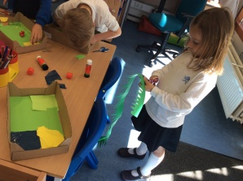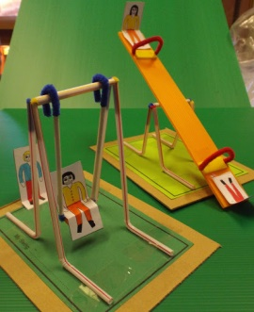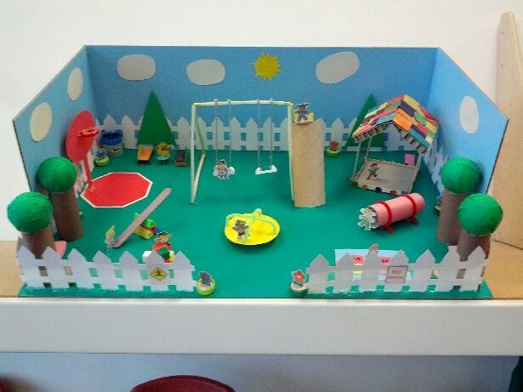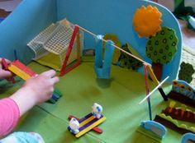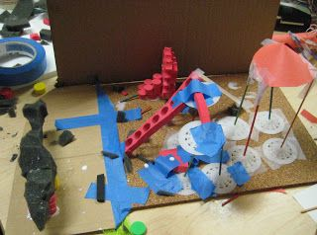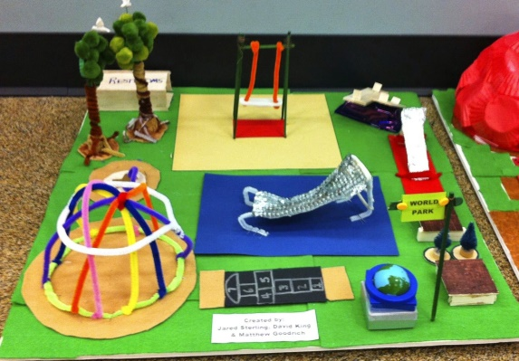

**6.** Present your finished prototype.

Talking in full sentences, explain what you have made and why. How will this element help you to learn or perhaps provide exercise? Say what real-life materials you will use. Decide what we might not actually be able to add in real-life. For example

**7.** Gather materials for your real life outside space.

Now it is time to really make or collect materials and objects/toys that you can learn and play on. It may be that you could paint a pallet that could act as a stage, or even be able to find a spare see-saw that could be brought in to school or kept for your own garden.