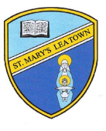
St Mary’s Catholic Primary school remote learning planner for week beginning 18th May
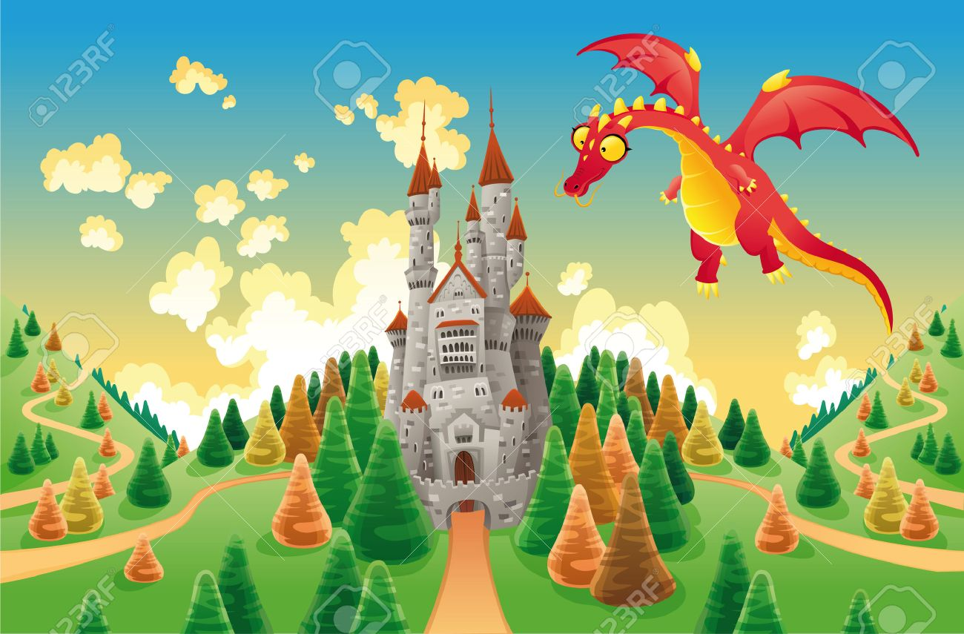
I hope that you are all still managing to keep safe and well and hope you all enjoyed the ‘Marvellous Minibeasts’ theme from last week. I’m sure that you had lots of fun completing the different tasks! This week we are having a ‘Castles and Dragons’ theme. Here are some ideas as a guide for this week.
If you have any queries regarding your child’s learning please email me at williams@lea-st-marys.lancs.sch.uk.
Thank you for your support. Mrs Williams and Mrs Coulter 😊
Twinkl offer code: CVDTWINKLHELPS
Espresso Login: Username: student18704 Password: 123456
English  This week there are some links on the class page to the ‘Castle’ themed 60 second reads. Read the texts and discuss the answers to the questions.  Task 1 – Imagine what it would be like to be a king or a queen for a day, living in your own castle. Would you change the world? Or would you have a fun day doing as you please? Write a diary entry… ‘A day in the life of…...’ Try to include lots of adjectives and adverbs.  Task 2 - Draw a picture of a castle and label it. https://www.twinkl.co.uk/download/26240 Produce an information sheet about castles by researching in books and on the internet to find out more information about them.  Task 3 - Read a story that has a dragon or a castle in it. Draw a story map to show the different events in the story.  Phonics  Look at words that have a ‘soft c‘ in them. Examples are dance, twice, face, ice, space, mice, once, slice, peace, juice.  Can you practise these words in your neatest handwriting? Can you put the words into a sentence?  Year 1 (As well as the above activity)  Play the games on Phase 5 of phonics play website. There are a range of games that your child will enjoy. | Maths  Repeating patterns  Can you create your own repeating patterns using shapes, or objects in your home? Try to make them more interesting by using more colours/ objects.  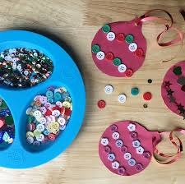  Year 1 and Year 2 – Numbers  Compare the numbers and write <, > or = in the box. The numbers are differentiated for different abilities, the further you scroll down the larger the numbers. https://www.twinkl.co.uk/download/87903  Year 1 and Year 2 – Word problems  Word problems on a castle theme: Write some maths word problems based on our Castles and Dragons theme, e.g. The queen had 16 cakes and the king ate 5. How many were left? The dragon laid 6 eggs one day and 8 the next. How many eggs did she lay in total?  ……Can you solve them?
Topic Activities
Art ideas:
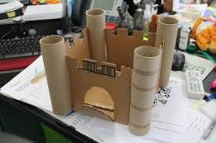
Create your own castle using junk modelling!


Paint a picture of a dragon. Make it as colourful as you can!

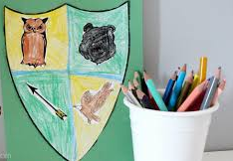
Design and make a shield. Create your own coats of arms to go on your shield. Think about your
name, hobbies, where you live etc. https://www.twinkl.co.uk/download/13457

Geography – Find out about a castle in England (e.g. Lancaster Castle, Skipton Castle, Clitheroe Castle.) Research information about it and make a poster or a fact file about the castle of your choice.

Science – What materials could a castle be made from?
- Can you make a bridge to go over a moat? Use material strong enough to support a bag of sugar.

R.E.
During May we think especially of Mary. We pray the rosary and say Mary’s special prayer, the Hail Mary. Say the Hail Mary slowly, thinking carefully about the words. https://www.twinkl.co.uk/download/1483190 Make a poster dedicated to Mary, using words, pictures and symbols to represent this special month.
PE/Art
As part of our stay at home sports day complete the following.
  - Have an opening ceremony. Using junk modelling from around your house create a sports day torch and send me a picture.
  - Create an obstacle course in your house/ garden. Make sure that it is safe!
  - Choose a song and create a dance to start our sports day. What would be an appropriately inspiring song?
  - Design and make a healthy snack which would help you hit peak performance on sports day.
  - Design and draw a mascot for your sports day.

Any of the above activities could make our sports day page!! https://www.justgiving.com/fundraising/stmaryssportsday



