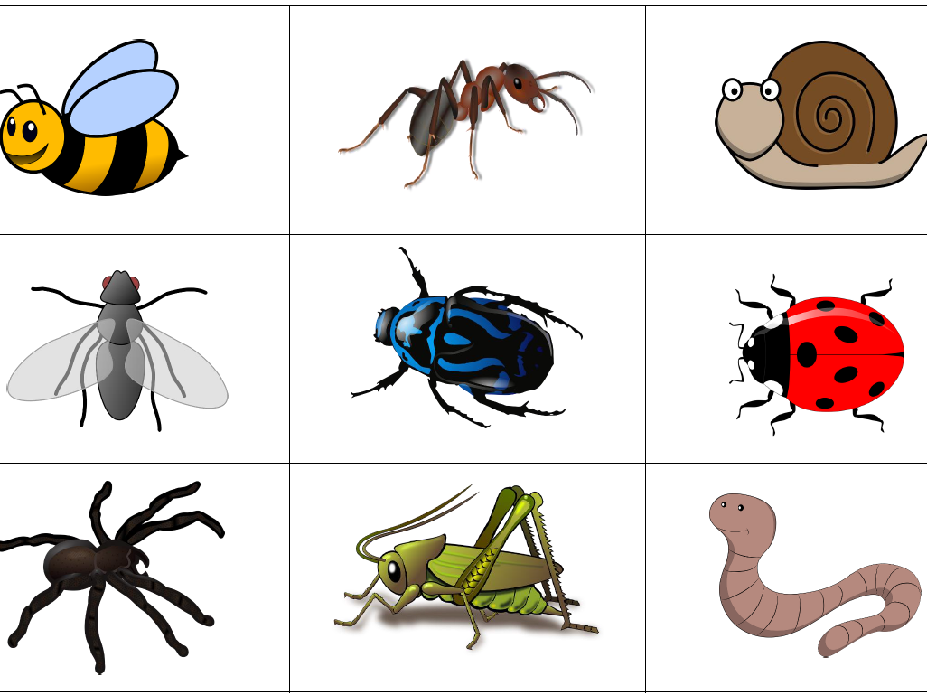
We hope that you are all keeping safe and well.
If you have any queries regarding your child’s learning please email me at williams@lea-st- marys.lancs.sch.uk.
Over the next two weeks we have a new theme which is ‘Mad about Minibeasts!’

English  ➢Watch the video. Open the link for this week’s story which is ‘Superworm.’ Read and listen to the story with your child: https://www.youtube.com/watch?v=0keNDquvZEE  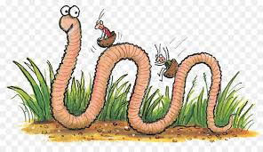  ➢Discuss Look at all the different pictures of Superworm in the book. How are they different from each other? Which is your favourite? Can you describe it to an adult? Which words have you used to describe Superworm?  ➢Draw and label a picture of Superworm.  ➢Write a list of words and phrases to describe Superworm.  You could also:  - Use the book to create a collection of rhyming words and phrases.  - Think of some questions that you might like to ask Superworm. How might he respond?  - See what you can find out about worms:  Yucky Worms https://www.youtube.com/watch?v=MV3A864z9W0  ➢Read the minibeast words:  Can you read the words on the wordmat?  https://www.twinkl.co.uk/resource/t-t-2894-minibeasts-word-mat-detailed-version | Spelling/Phonics  Review phase 3 sounds  - Practise saying, reading and writing words with phase 3 sounds and tricky  words (Examples on class page/printed in pack)  Practise phase 4 consonant clusters at the beginning of words.  Look at the consonant cluster ‘st’ Examples of words are stop, stem, stick.  Watch the video link: https://www.youtube.com/watch?v=mPtYpqEwEHo  - Say the sounds  - Blend the sounds  - Read the words with the sounds in  Use link: Phase 4 consonant clusters  Practise your blending on ‘Phonics Play’ games. Select Phase 4 or child appropriate  activity (phase 2/3)  Read by sounding out, then blend https://new.phonicsplay.co.uk/resources/phase/4  Practise reading your tricky words, from phase 2 to phase 5  https://www.phonicsplay.co.uk/
  RE
  Use a large piece of paper to draw the outline of a house.
  Think about what makes your home feel special, what you enjoy
  doing together as a family, or what some of the special memories
  you have together are.
  Write or draw these things in or around your house drawing. Once you have done this, you can decorate and colour in your house.
  Think of your own prayer that you would like to say for your family.
Maths  Repeating patterns-  - How good are you at spotting minibeast peg patterns? Follow the link then choose the correct pictures to complete the sequences:  https://central.espresso.co.uk/espresso/modules/ey_problem_solving/activities/index.html  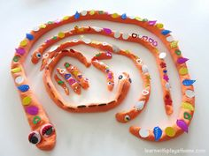  - Draw worms of different lengths or create models of Superworm out of play doh. Design your own repeating patterns on the worms, using coloured spots or buttons.  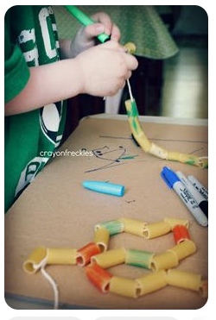  - You will need pasta and string. Have a go at threading the pasta on to the string to make a worm. Create repeating patterns on the worm by colouring the pasta in and transforming it into Superworm!  Number challenge: Ask an adult to hide some numbers written on pieces of paper or card. See how many numbers you can find and if you can read them. You can draw the right number of dots or circles to show the meaning of the number. Can you put the numbers in order?  Solid Shapes (cube focus)  - Watch the video about 3D shapes.  https://central.espresso.co.uk/espresso/modules/ey_shape/video_solid1.html  - This week look for cubes inside and outside your home. Practise using mathematical language to describe the shape.  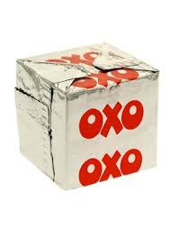 | Topic  Art ideas  Choose one of these activities:  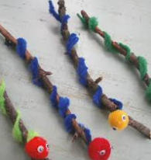  - You could make your own ‘Superworm’ by finding a twig and decorating it in any way you like, e.g with paper strips, string, pipe cleaners or pom poms.  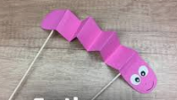  - You could make a wiggly worm using coloured paper and little sticks.  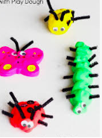  - Or use play doh to make some minibeast models.  https://theimaginationtree.com/best-ever-no-cook-play-dough-recipe/  PE/Music  Make up your own dance to the Creepy Crawlies Calypso song  https://www.youtube.com/watch?v=N10nLIqCqFY  Science  Choose one of the creatures from the story ‘Superworm.’ Find out some facts about it and write them down to create a fact sheet.
SHAPE \* MERGEFORMAT

