English  Watch the video. ‘A look at what life is like in the International Space Station’ with Tim Peake  https://central.espresso.co.uk/espresso/primary_uk/subject/news/video/item903694/gradef/index.html?source=search-all-all-all-all&source-keywords=space  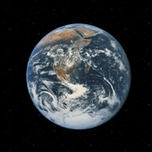  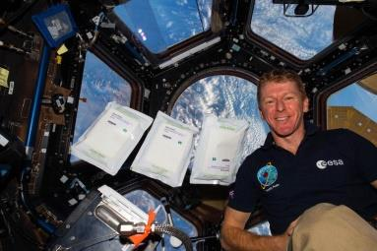  Discuss what astronauts might do in space. How is it different from living on Earth?  Draw and label a picture of an activity that an astronaut might do in space.  Write some interesting facts about the International Space Station.  Read the high frequency words:  https://central.espresso.co.uk/espresso/primary_uk/subject/module/activity_index/item62767/gradef/index.html | Spelling/Phonics  Review phase 3 sounds  - Practise saying, reading and writing words with phase 3 sounds and tricky words  (Examples on class page/printed in pack)  Practise phase 4 consonant clusters  - Say the sounds  - Read words with the sounds in  On ‘Phonics Play’ games, select Phase 4 Or child appropriate activity (phase 2/3)  Read by sounding out, then blend https://new.phonicsplay.co.uk/resources/phase/4  Practise reading your Wizard Words, from phase 2 to phase 5 https://new.phonicsplay.co.uk/resources/phase/4/train-your-brain-ph4  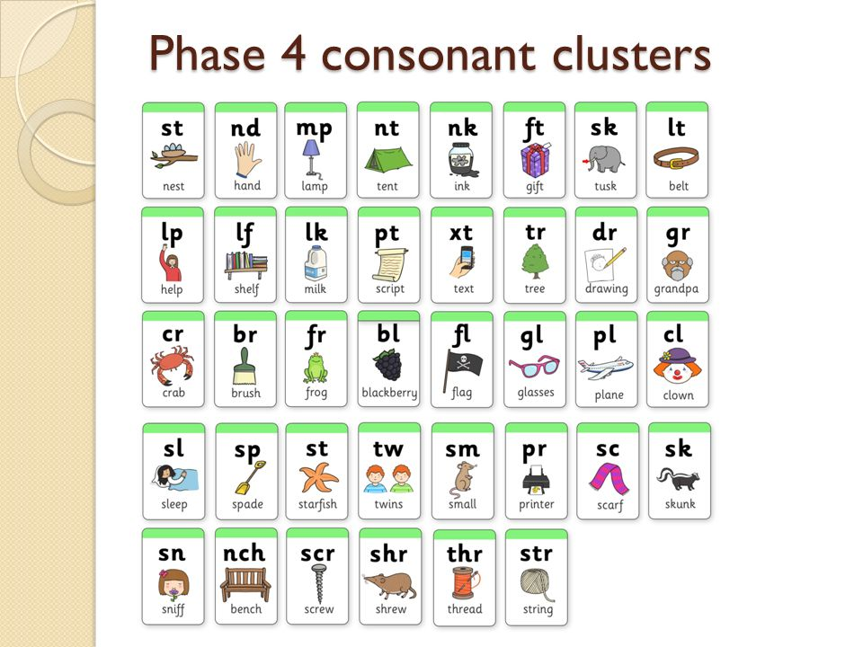
Maths  Ordering objects by size  - Put the stars in order from the biggest to the smallest:  https://central.espresso.co.uk/espresso/primary_uk/subject/module/activity/item865479/gradef/module861998/index.html  - Put the planets in order smallest to the biggest:  https://central.espresso.co.uk/espresso/primary_uk/subject/module/activity/item865505/gradef/module861998/index.html  Solid Shapes (sphere focus)  - Watch the video about 3D shapes, discuss the shape of our planet.  https://central.espresso.co.uk/espresso/modules/ey_shape/video_solid1.html  - This week look for spheres inside and outside your home. Practise using mathematical language to describe the shape (refer to the 3D shape properties mat) | Topic  PE/Art  As part of our stay at home sports day complete the following.  - Have an opening ceremony. Using junk modelling from around your house create a sports day torch and send me a picture.  - Create an obstacle course in your house/ garden. Make sure that it is safe!  - Choose a song and create a dance to start our sports day. What would be an appropriately inspiring song?  - Design and make a healthy snack which would help you hit peak performance on sports day.  - Design and draw a mascot for your sports day. Here are some Olympic mascots to help you.  Any of the above activities could make our sports day page!  https://www.justgiving.com/fundraising/stmaryssportsday    Science  - Answer the question “What would it be like on the moon?” by watching https://central.espresso.co.uk/espresso/primary_uk/subject/module/video/item862004/gradef/module861998/index.html  - Ask Tim Peake questions: https://www.bbc.co.uk/bitesize/topics/zw44jxs/articles/z822hv4

