INSIDE A TRADITIONAL ENGLISH CHURCH OF ENGLAND PARISH CHURCH

Use the following key words to label the parts of the church:

Nave Organ pipes Transept Statues Hymn Board

Kneelers Hymn Books Organ Altar Chalice

Pulpit Font Chancel Pews Lectern

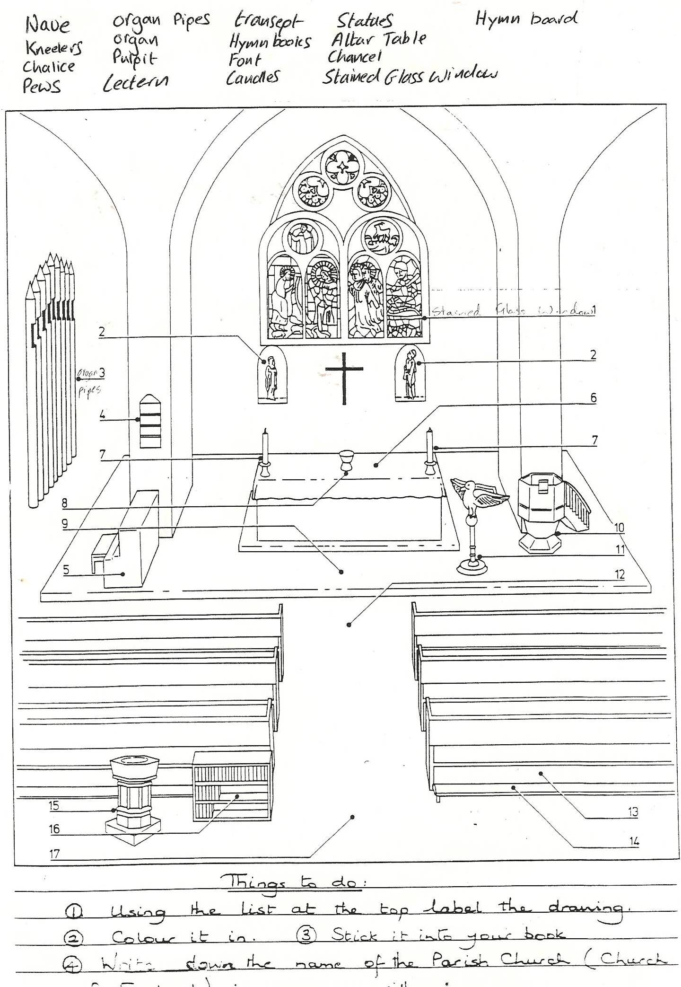Stained glass windows Candles