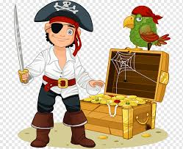
We hope that you have all enjoyed the ‘Mad about Minibeasts’ theme. This week we are learning about ‘Pirates.’ If you have any queries regarding your child’s learning please email us at
Williams@lea-st-marys.lancs.sch.uk
Jennings@lea-st-marys.lancs.sch.uk Mrs Williams and Mrs Jennings

English  ➢Watch the video. Open the link for this week’s story which is ‘The Night Pirates.’ Listen to the story with your child: https://www.youtube.com/watch?v=mdWxBn-xvrQ  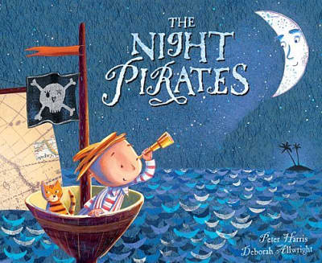  ➢Discuss Talk about the story first. What do you think it’s about? Why? Listen to the story and see if you were right. When you have finished watching, can you re-tell the story to someone in your family? Can you think of words to describe the characters? What would you look like if you were a pirate?  ➢Draw and label a picture of a pirate ship and label the different parts of it. Here are some words to start you off: sails, bow, Jolly Roger. See how many more your adult knows.  ➢Write some sentences about Captain Patch or another pirate character from the story.  ➢Research See what you can find out about pirates: https://central.espresso.co.uk/espresso/modules/news/ey_news/special_days/080917sd_pirate.html?source=search-all-F-all-all&source-keywords=pirates  ➢Create a poster. Include a picture of a pirate and some interesting facts. | Spelling/Phonics  Review phase 3 sounds  - Practise saying, reading and writing words with phase 3 sounds and tricky  words (Examples on class page/printed in pack)  Practise phase 4 consonant clusters in the end of words.  Examples of words are desk, lamp, send, tent.  - Say the sounds  - Blend the sounds  - Read the words with the sounds in  Use the link to help you: Phase 4 consonant clusters  Practise your blending with Buried Treasure (phonicsplay games) Drag the coins with real words to the treasure chest. Drag the coins with fake words to the dustbin. Select Phase 4 or child appropriate activity (phase 2/3)  Read by sounding out, then blend https://new.phonicsplay.co.uk/resources/phase/4  Practise reading your tricky words, from phase 2 to phase 5  https://www.phonicsplay.co.uk/
  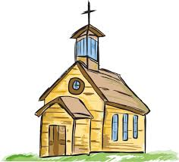RE
  Church is a special place for Christians where we can be
  close to Jesus.
  Draw or colour a picture of a church:
  https://www.saintanneshelper.com/support-files/church2.pdf
  Discuss with someone at home why people go to church.
  Think of your own prayer that you would like to say to Jesus.
Maths  Word problems - addition  Time for the pirates’ treasure hunt! Please download the activity sheet on the class page then answer the questions.  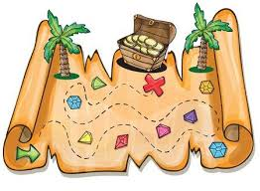  Reception children – you could use objects such as pasta, coins, shells, buttons or pegs, or draw pictures to help work out the answers. (You will need an adult to read the questions and may require some support.)  Year 1 children – solve the pirate word problems and record each as an addition sum.  Challenge: Can you create your own pirate themed addition word problems? Challenge your family to find the answers.  Solid Shapes (cone focus)  - Watch the video about 3D shapes.  https://central.espresso.co.uk/espresso/modules/ey_shape/video_solid1.html  https://central.espresso.co.uk/espresso/modules/ey_shape/video_solid2.html  - This week look for cones inside and outside your home. Practise using mathematical language to describe the shape.  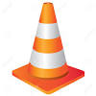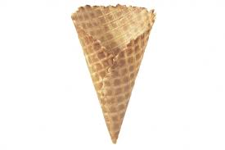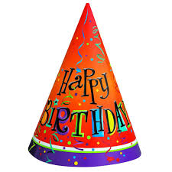 | Topic  Art/ DT ideas  Choose one of these activities:  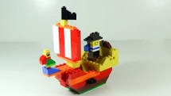  - Can you make a pirate ship out of lego, blocks or cardboard boxes?  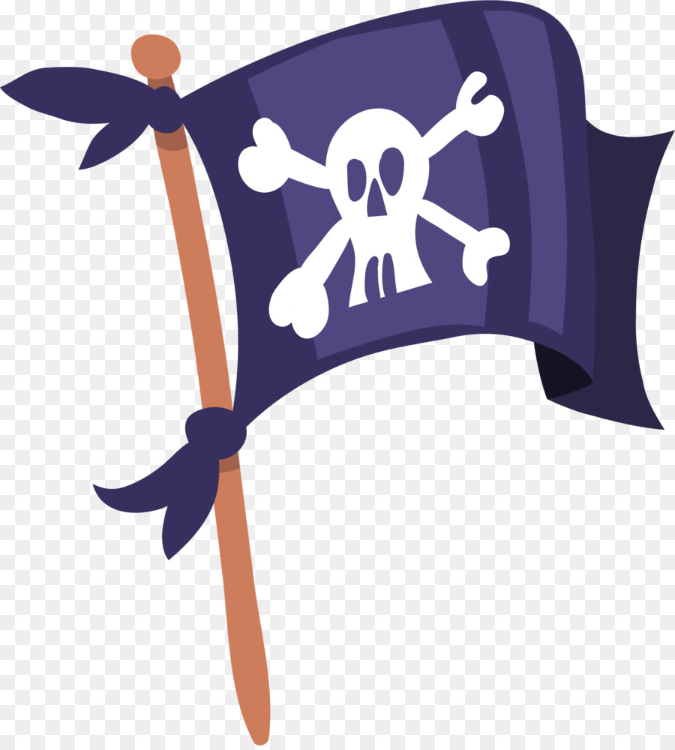  - Design a new flag for your very own pirate ship. https://www.twinkl.co.uk/resource/t-t-5218-design-your-own-ship-flag-worksheet  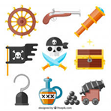  - Use some old boxes, packaging and other materials to make a pirate accessory. It could be a treasure chest, a pirate hat, a telescope, a sword, or maybe even a parrot!  Music  Listen to the Pirate song. Join in with the words and actions.  https://www.youtube.com/watch?v=PxcaR3KG_AQ  Science  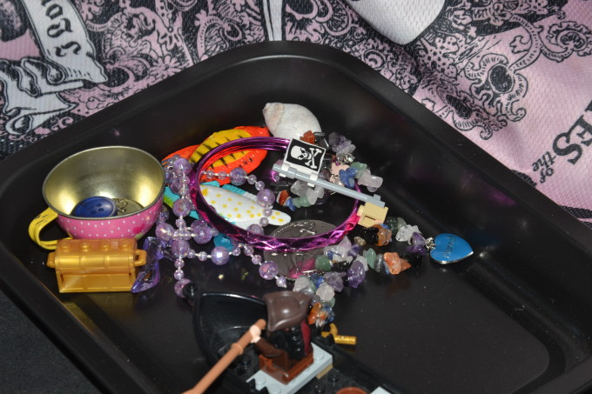  Pirate sink or float activity: Collect your own ‘pirate treasure!’ This may include coins, plastic necklace, bracelet, shells, pebbles and buttons. Ask an adult to help you. Feel each object and predict whether it will sink or float. Test each item by dropping it carefully into the water.
SHAPE \* MERGEFORMAT

