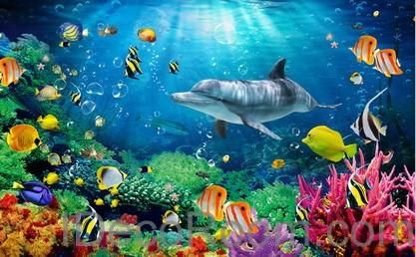
We hope that you have all enjoyed the ‘Pirates’ theme.
This week we are learning about ‘Under the Sea.’
If you have any queries regarding your child’s learning please email us at

Williams@lea-st-marys.lancs.sch.uk
Jennings@lea-st-marys.lancs.sch.uk Mrs Williams and Mrs Jennings

English  ➢Watch the video. Open the link for a factual clip about under the sea:  https://central.espresso.co.uk/espresso/primary_uk/subject/module/video/item1053724/gradef/module1045246/index.html?source=search-all-all-all-all&source-keywords=under%20the%20sea  ➢Discuss the clip. What did you find interesting? Which sea creatures would you like to learn more about? Practise blending and reading sea creature names:  https://central.espresso.co.uk/espresso/primary_uk/subject/module/activity/item1053224/gradef/module1045246/index.html  ➢Imagine you are going on a submarine journey under the sea. Where would you go? What would you see? What did it sound and feel like? Draw some pictures and write a word or sentence in each box to tell your story!  https://central.espresso.co.uk/espresso/primary_uk/servlet/file/store66/item1053669/doc.pdf  ➢Research-Watch the clip and see what you can find out about sea creatures:  https://www.bbc.co.uk/bitesize/clips/zmxqxnb  ➢Draw and label a picture of a sea creature and write some interesting facts.  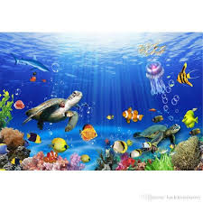  ➢Create a ‘guess the sea creature’ poem. Include clues and a picture of a sea creature. | Spelling/Phonics  Review phase 3 sounds  - Practise saying, reading and writing words with phase 3 sounds and tricky  words (Examples on class page/printed in pack)  Practise phase 4 consonant clusters at the end of words.  - Watch the video and practise reading words with some common consonant blends (The consonant blends included are nk, st, nd, mp and ft).  https://www.youtube.com/watch?v=k-1rmuOxGE8  - Say the sounds  - Blend the sounds  - Read the words with the sounds in  - Watch the episode of alpha blocks, what consonant blends can you spot? Practise sounding out and blending to read the words.  https://www.youtube.com/watch?v=fhY6kYAV-x4  Practise reading your tricky words, from phase 2 to phase 5  https://www.phonicsplay.co.uk/
  RE
  Watch the video about what is inside a Church.
  https://central.espresso.co.uk/espresso/primary_uk/subject/module/video/item339366/grade2/module648491/index.html
  With the support of your adult research the interior of a church and complete the
  activity sheet ‘Church Interior Sheet’
  Talk about what the different parts are and their purpose.
  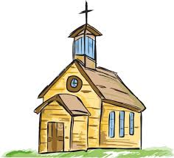
Maths  Word problems – Subtraction  Please download the activity sheet on the class page then answer the questions.  Reception children – Similarly to last week you could use objects such as pasta, coins, shells, buttons or pegs, or draw pictures to help work out the answers. (You will need an adult to read the questions and may require some support.)  Year 1 children – solve the under the sea word problems and record each as a subtraction sum.  Challenge: Can you create your own under the sea themed subtraction word problems? Challenge your family to find the answers.  Solid Shapes (cone focus)  - Watch the video about 3D shapes.  https://central.espresso.co.uk/espresso/modules/ey_shape/video_solid1.html  https://central.espresso.co.uk/espresso/modules/ey_shape/video_solid2.html  - This week look for cylinder inside and outside your home. Practise using mathematical language to describe the shape.  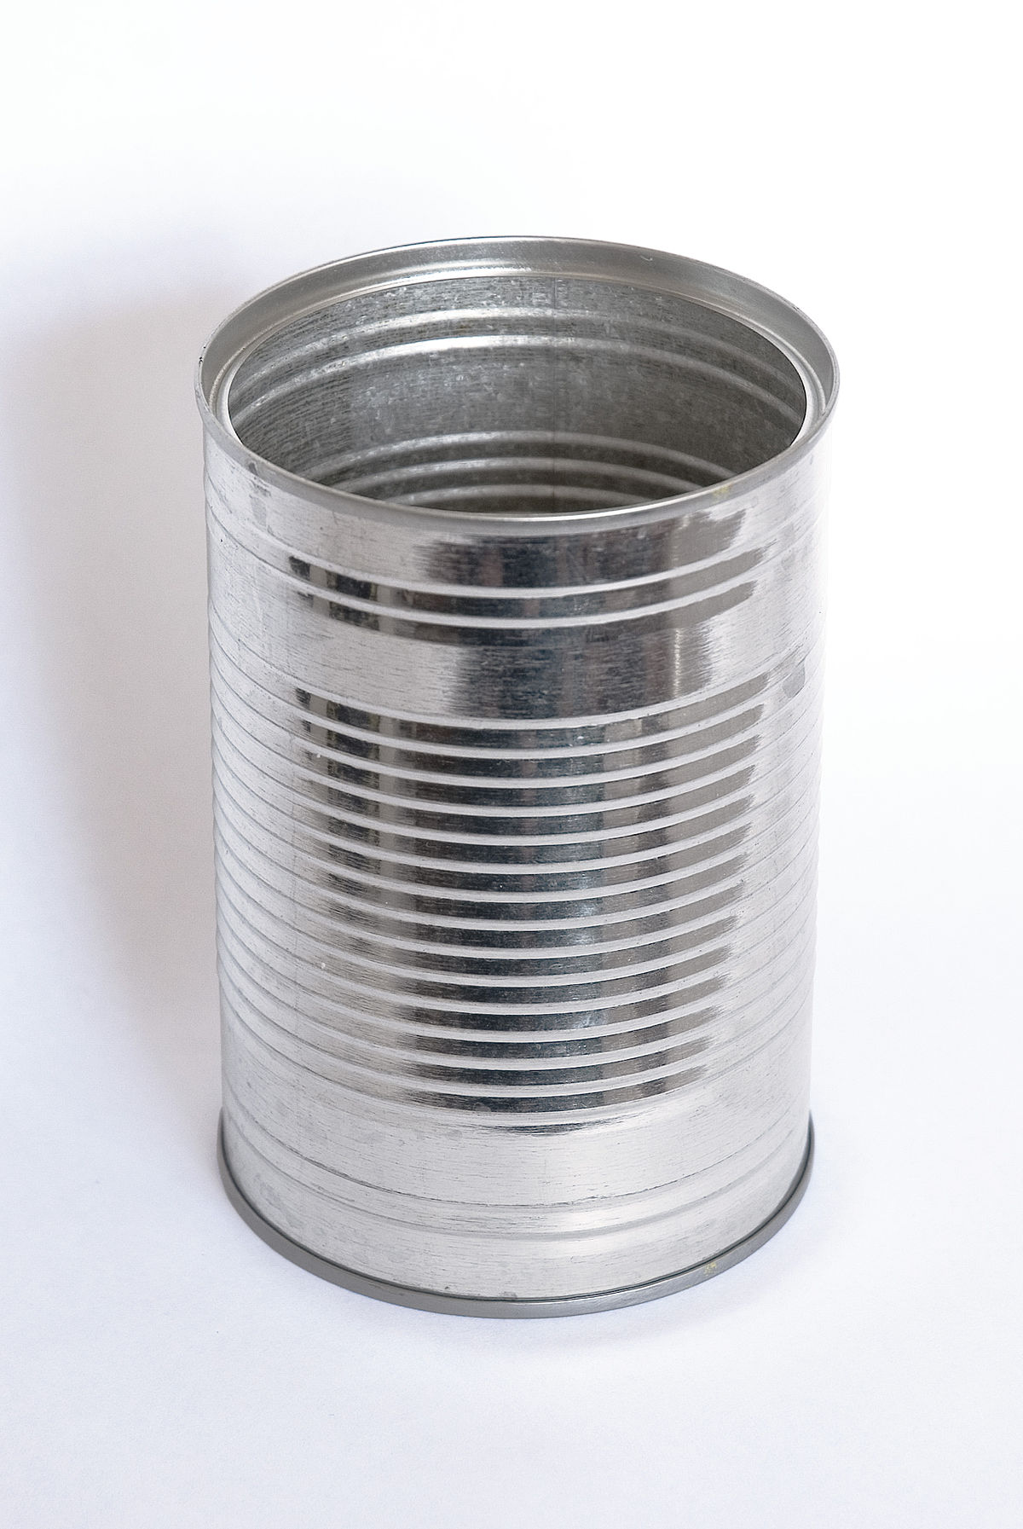  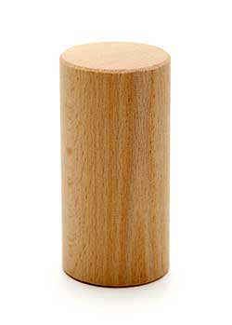  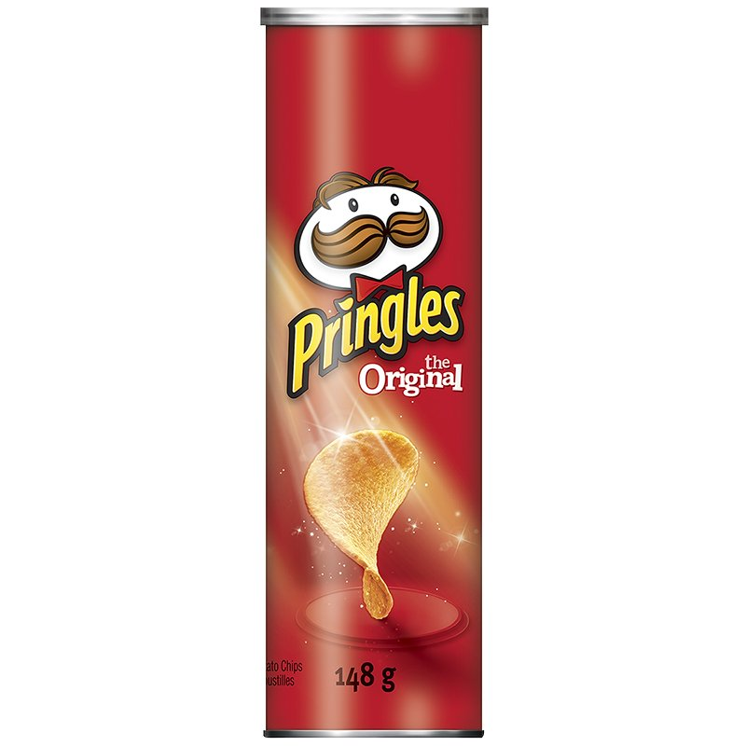 | Topic  Art/ DT ideas  Choose one of these activities:  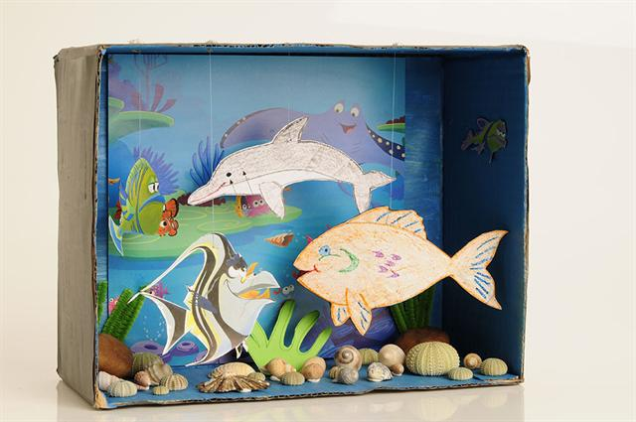  - Can you create a under the sea aquarium? Use an old box and fill it with sea creatures, seaweed, shells and rocks.  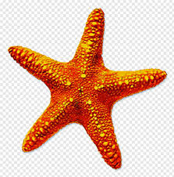  - Draw and paint a picture of your favourite sea creature, find real photos online to refer to for details.  - Create an under the sea silhouette painting. Paint an ocean background, allow time to dry then draw or cut and stick sea creatures in black onto your picture.  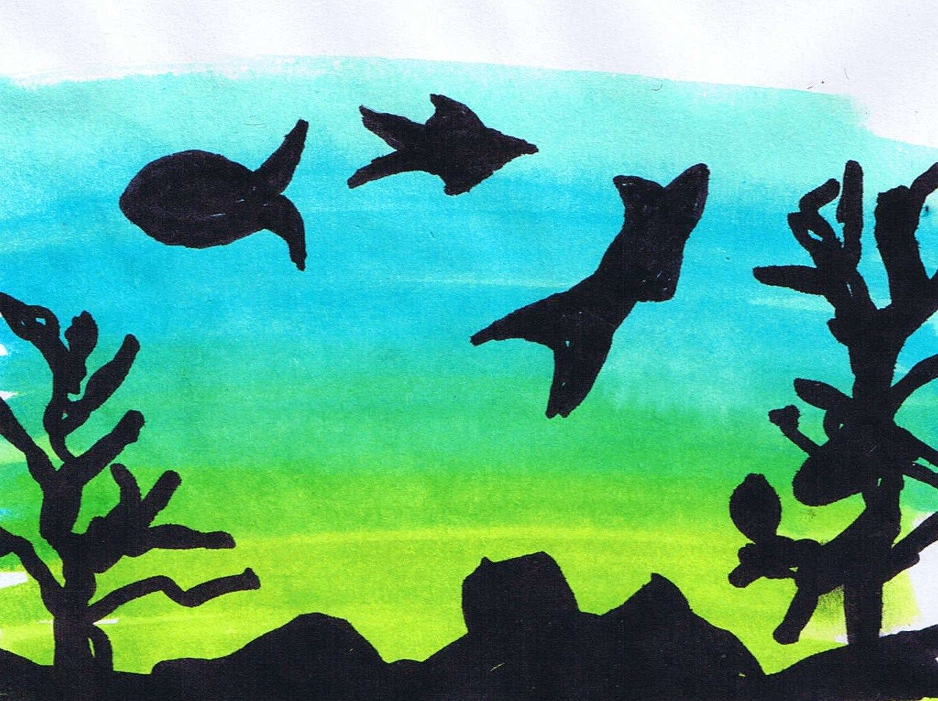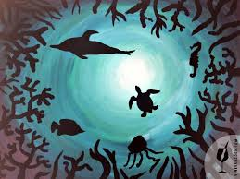  Music  Listen to the song ‘A hole in the bottom of the sea’. Join in with the words, can you create your own actions? How many sea creatures can you see/name?  https://www.youtube.com/watch?v=R1Qn2bcZRTo  Science  Draw a poster to explain some of the ways people can take care of the sea. Write a sentence at the bottom of your poster to explain what you drew.
SHAPE \* MERGEFORMAT

