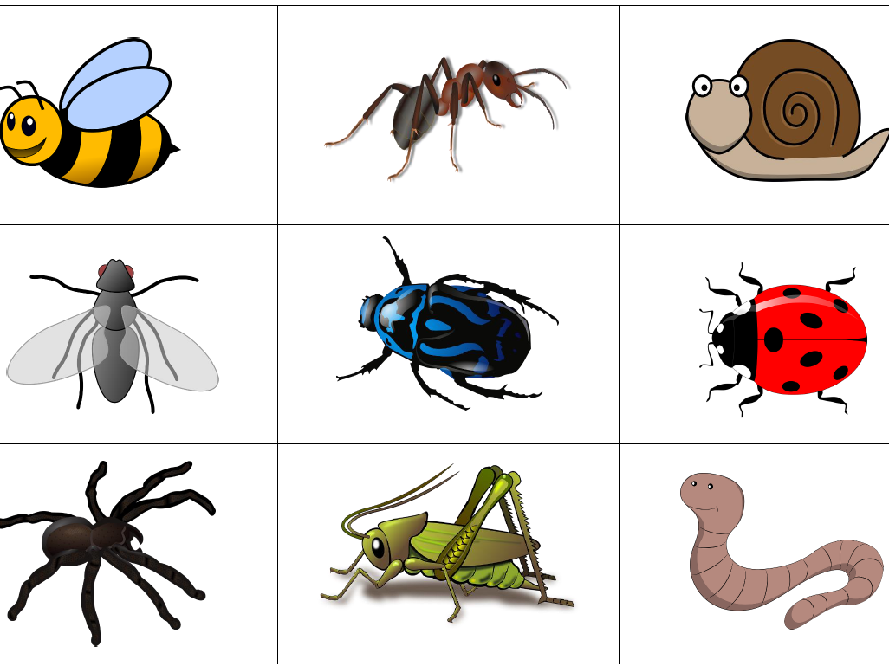
This week our theme continues to be ‘Mad about Minibeasts!’ We hope that you are all keeping safe and well. If you have any queries regarding your child’s learning please email us at:
Williams@lea-st-marys.lancs.sch.uk
Jennings@lea-st-marys.lancs.sch.uk

English  ➢Watch the video ‘What are Minibeasts’ and complete the quiz:  https://www.bbc.co.uk/bitesize/topics/z6882hv/articles/z9fkwmn  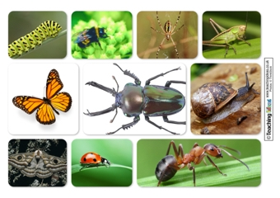  ➢Discuss the information about mini beasts. What did you find interesting?  ➢Draw and label a picture of a mini beast. https://central.espresso.co.uk/espresso/primary_uk/standalone/activity_html/item325383/index.html?referrer=https%3A%2F%2Fcentral.espresso.co.uk%2Fespresso%2Fmodules%2Fnews%2Fey_news%2Fanimals%2F050511a_minibeasts.html%3Fsource%3Dsearch-all-F-all-all%26source-keywords%3Dmini%2520beasts&bgcolor=ffffff  ➢Research mini beasts https://central.espresso.co.uk/espresso/primary_uk/subject/module/factfile/item1154858/grade1/module1142775/index.html?source=search-all-KS1-all-all&source-keywords=mini%20beasts#sub-heading-1  ➢Create an information page about mini beasts including:  - Title  - Subheadings  - Interesting facts  - Picture and description | Spelling/Phonics  Review phase 3 sounds  - Practise saying, reading and writing words with phase 3 sounds and tricky  words (Examples on class page/printed in pack)  Practise phase 4 consonant clusters at the beginning of words. Play the ‘word machine game’ blend the sounds to read the words:  https://central.espresso.co.uk/espresso/modules/e1_word_machine/index.html  - Say the sounds  - Blend the sounds  - Read the words with the sounds in  Refer to link: Phase 4 consonant clusters  Practise your blending on ‘Phonics Play’ games. Select Phase 4 or child appropriate  activity (phase 2/3)  Read by sounding out, then blend https://new.phonicsplay.co.uk/resources/phase/4  Practise reading your tricky words, from phase 2 to phase 5  https://www.phonicsplay.co.uk/
RE
Think about your friends and family who do not live with you. Talk about some of your favourite memories. What do you look forward doing next time you see them?
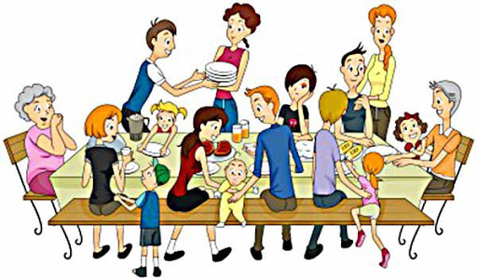

-Write or draw these people around a picture of yourself surrounding yourself with love.
-Think of your own prayer that you would like to say for your friends and
family further afield.
Maths  Number sequences  Find the missing numbers to complete the number lines:  https://central.espresso.co.uk/espresso/primary_uk/standalone/activity_html/item640982/index.html?referrer=https%3A%2F%2Fcentral.espresso.co.uk%2Fespresso%2Fmodules%2Fsearch%2Findex.html%3Fsource%3Dtopnav-search&bgcolor=ffffff  Complete the number sequences counting in multiples of 2, 5, 10 and 3.  (Reception children may require some support)  https://central.espresso.co.uk/espresso/primary_uk/subject/module/activity/item841417/grade1/module784709/index.html?source=search-all-all-all-all&source-keywords=number%20sequences  Can you create your own number sequences counting in 1s and 2s, 5s and 10s? Challenge your family to find the missing number(s).  Number challenge:  -Practise counting forwards and backwards on a number line to 30.  https://www.twinkl.co.uk/resource/T-N-005-Numbers-0-30-on-a-numberline-parents  -Can you count in 2s, 5s and 10s? (Use a hundred square to help you)  https://www.twinkl.co.uk/resource/T-N-016-100-Square  Solid Shapes (cuboid focus)  - Watch the videos about 3D shapes.  https://central.espresso.co.uk/espresso/modules/ey_shape/video_solid1.html  https://central.espresso.co.uk/espresso/modules/ey_shape/video_solid2.html  - This week look for cuboids inside and outside your home. Practise using mathematical language to describe the shape.    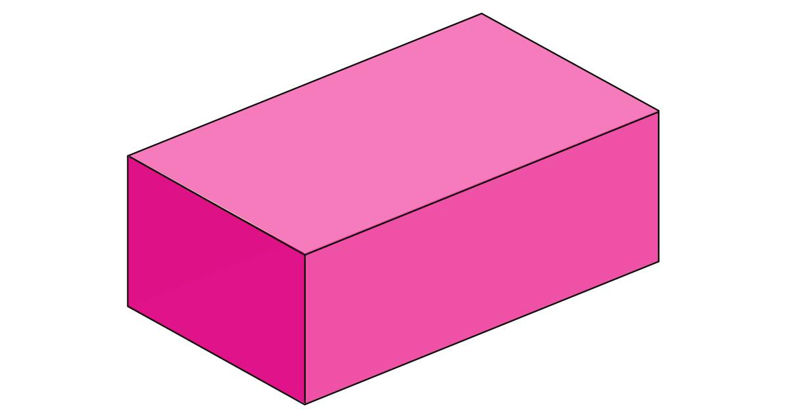 | Topic  Art ideas  - Create a ‘bug house’ for your garden. Use an old tissue box and collect leaves, grass, sticks and seeds and put them inside. Find a cosy spot in your garden and remember to check for visitors!  - Make nature art bugs from leaves and twigs.  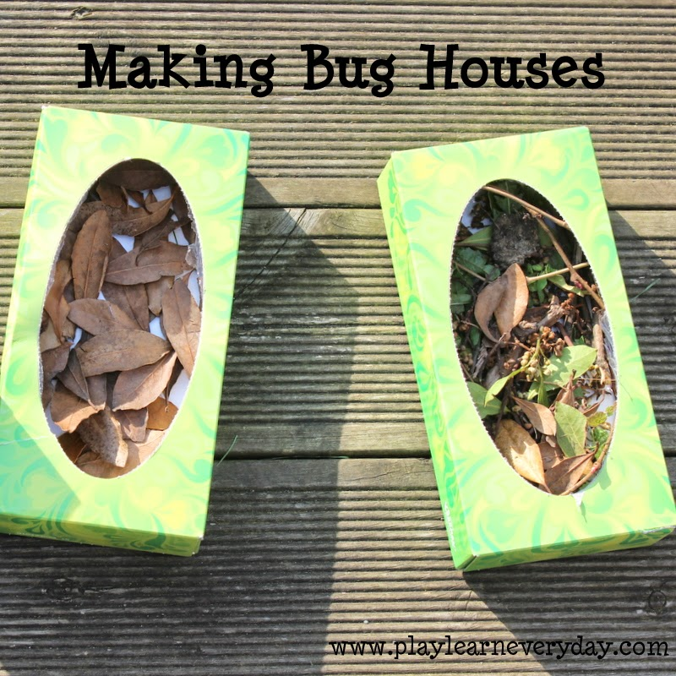  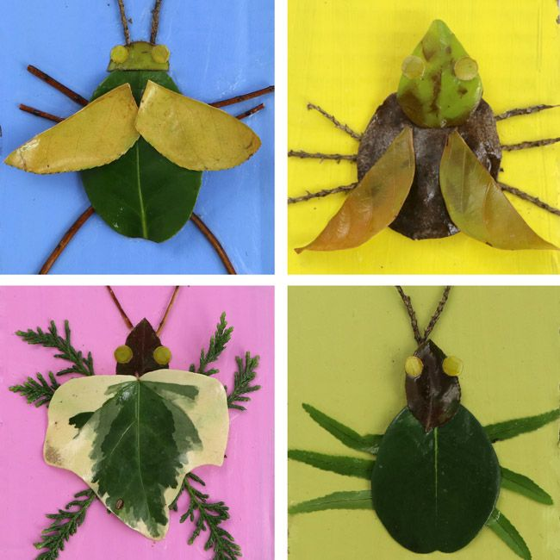  Music  Learn the words and actions to the mini beast song:  https://www.youtube.com/watch?v=LoIeeIEPGJI  Science  -Go on. Minibeast hunt complete the tick list or create your own.  https://www.twinkl.co.uk/resource/T-T-019-Minibeast-hunt-sheet  -Choose two minibeast to compare. Consider the similarities and differences, use the template or create your own.  https://central.espresso.co.uk/espresso/modules/s1_microscope/ttd_minibeast_table.html?source=search-all-KS1-all-all&source-keywords=mini%20beasts  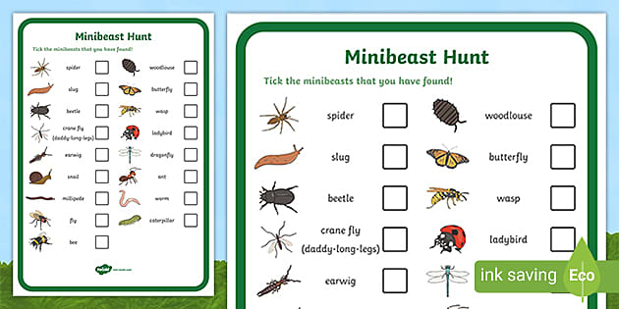
SHAPE \* MERGEFORMAT

