Treasure Hunt
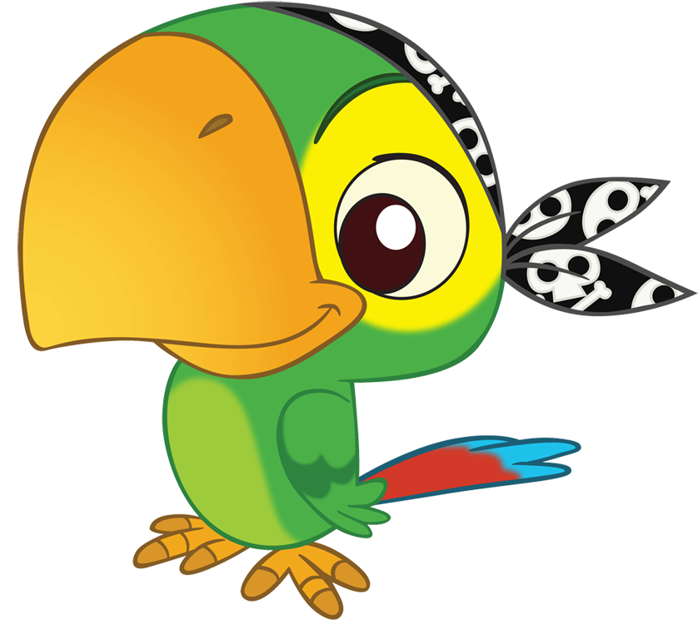
Polly the parrot ate 3 crackers, and then she ate 4 more. How many crackers did Polly eat altogether?


7 pirates were on the deck and 9 more were in the galley. How many pirates were on board the ship?

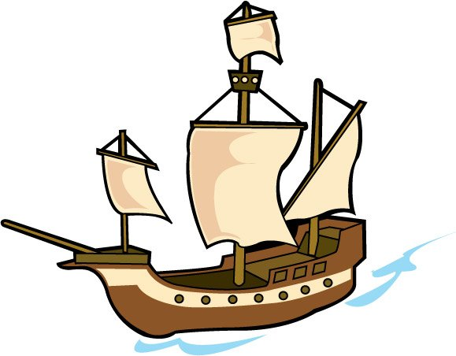
The pirate ship travelled west for 5 days, and then north-west for 8 days until it reached land. How many days did it travel for?
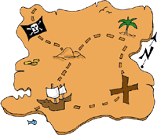
The pirates searched the jungle for 6 days and the desert for 8 days until they finally found the X from the map. How many days did it take?

It was so hot that the pirates took it in turns to dig up the treasure. 7 pirates started then swapped with 6 others. How many pirates did it take?
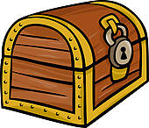
The chest was locked. There were 4 keys hidden underneath it and 8 more under a rock. How many keys were there?
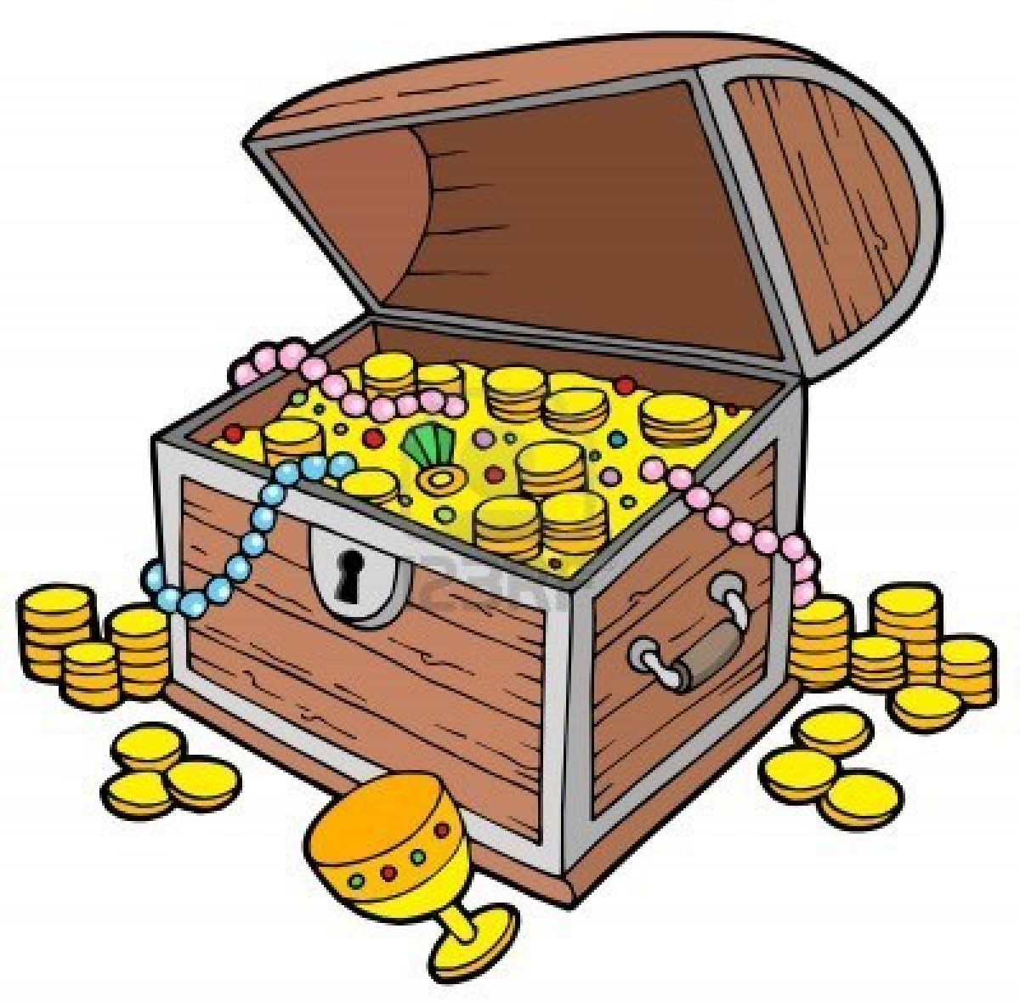
When the chest was finally opened, there were 6 large gold coins, 10 small gold coins and 8 jewels. How many pieces of treasure altogether?

