St. Mary's Catholic School Support Guide

Welcome to the first section of the St. Mary’s Catholic School support guide. My name is Rebecca and I am a therapist at Coastal Child and Adult Therapeutic Services (CCATS) in Poulton-Le-Fylde. I have worked with children and their families for many years who have faced challenging times. The past months have certainly been unusual for everyone and I have been asked by your school to help create a support guide for the pupils.

This is the first part of a booklet which has been created for the children of St Mary’s Catholic School to help support you all through this uncertain time. Each week you will receive a new section to add, so that you can create your own mini booklet.

In the booklet we will be thinking about the ways in which we have spent our time since school has closed, what this has been like for us and tips to help us with any worries we may have. Your teachers will be able to hear your news and they will get a better understanding of what life has been like for you since school has been closed. At the end of each section you will be asked if there is anything you would like to share with your teacher after the week’s reflection. If there is anything you would like to share with them, ask your adult to email this section to your teacher.

For Year 6 children, there will also be an additional section which is aimed at helping you with the different challenges you may have faced.

I hope that you will find this booklet interesting to complete. Try to do as much as you can and remember to ask a grown up to help you if you need to.

Rebecca Serella,

Coastal Child and Adult Therapeutic Services (CCATS)

**PART ONE**

My name is …………………………………………………….

Here is a drawing of me

**PART ONE**

In part one we will be thinking about how life has been for you since school has been closed.

In this box can you draw some of the things that you have been doing?

Great! Now let’s think about the things that have been easy for you and the things which have been a little trickier since you have not been able to go to school.

What has been easy for you since you have been at home. What do you think you have done well? What have you enjoyed?

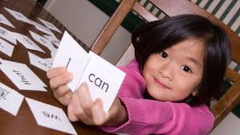

………………………………………………………………..

………………………………………………………………..

………………………………………………………………..

………………………………………………………………..

………………………………………………………………..

………………………………………………………………..

………………………………………………………………..

………………………………………………………………..

………………………………………………………………..

………………………………………………………………..

………………………………………………………………..

Okay, now let’s think about whether there has been anything that has been a little harder for you? If there has been anything, write this here.

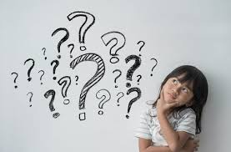

………………………………………………………………..

………………………………………………………………..

………………………………………………………………..

………………………………………………………………..

………………………………………………………………..

………………………………………………………………..

………………………………………………………………..

………………………………………………………………..

………………………………………………………………..

………………………………………………………………..

………………………………………………………………..

………………………………………………………………..

………………………………………………………………..

………………………………………………………………..

All over the world schools have been closed just like yours and this has meant that lots of children have not been able to see their teachers and their friends too.

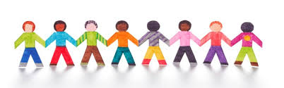

What has it been like for you not to see your teacher or your friends in class?

………………………………………………………………..

………………………………………………………………..

………………………………………………………………..

………………………………………………………………..

………………………………………………………………..

………………………………………………………………..

………………………………………………………………..

………………………………………………………………..

………………………………………………………………..

………………………………………………………………..

………………………………………………………………..

………………………………………………………………..

What would I like to share with my teacher after this week’s reflection? Remember to ask your adult to email this section to your teacher.

………………………………………………………………..

………………………………………………………………..

………………………………………………………………..

………………………………………………………………..

………………………………………………………………..

………………………………………………………………..

………………………………………………………………..

………………………………………………………………..

………………………………………………………………..

………………………………………………………………..

………………………………………………………………..

………………………………………………………………..

………………………………………………………………..

………………………………………………………………..

………………………………………………………………..

………………………………………………………………..

………………………………………………………………..

………………………………………………………………..

Well done on completing the first part of your booklet!



This has helped your teacher find out more about your life. Over the next weeks we will be finding out more about feelings and the ways we can help ourselves to feel happier and healthier.