Sullivan’s Seaside Shop
spade | 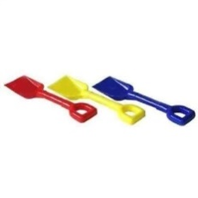 | 15p
bucket | 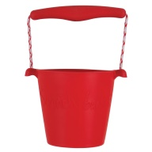 | 5p
fishing net | 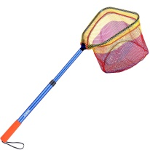 | 17p
kite | 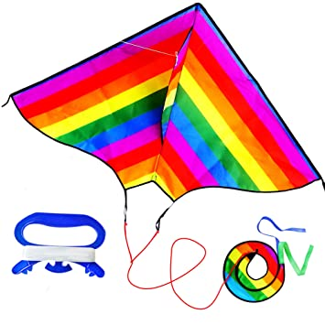 | 6p
ice-cream |  | 8p
ball | 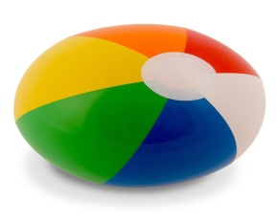 | 18p

- How much does it cost to buy a fishing net and a bucket altogether?
- What is the sum of a spade and a bucket?
- Tom wants to buy a ball plus an ice-cream. How much will this cost?
- Jess buys a ball and a kite? What is the total?
- Harry chooses a spade and a kite, How much does this cost altogether?
- How much will it cost for a ball, a kite and an ice-cream?

