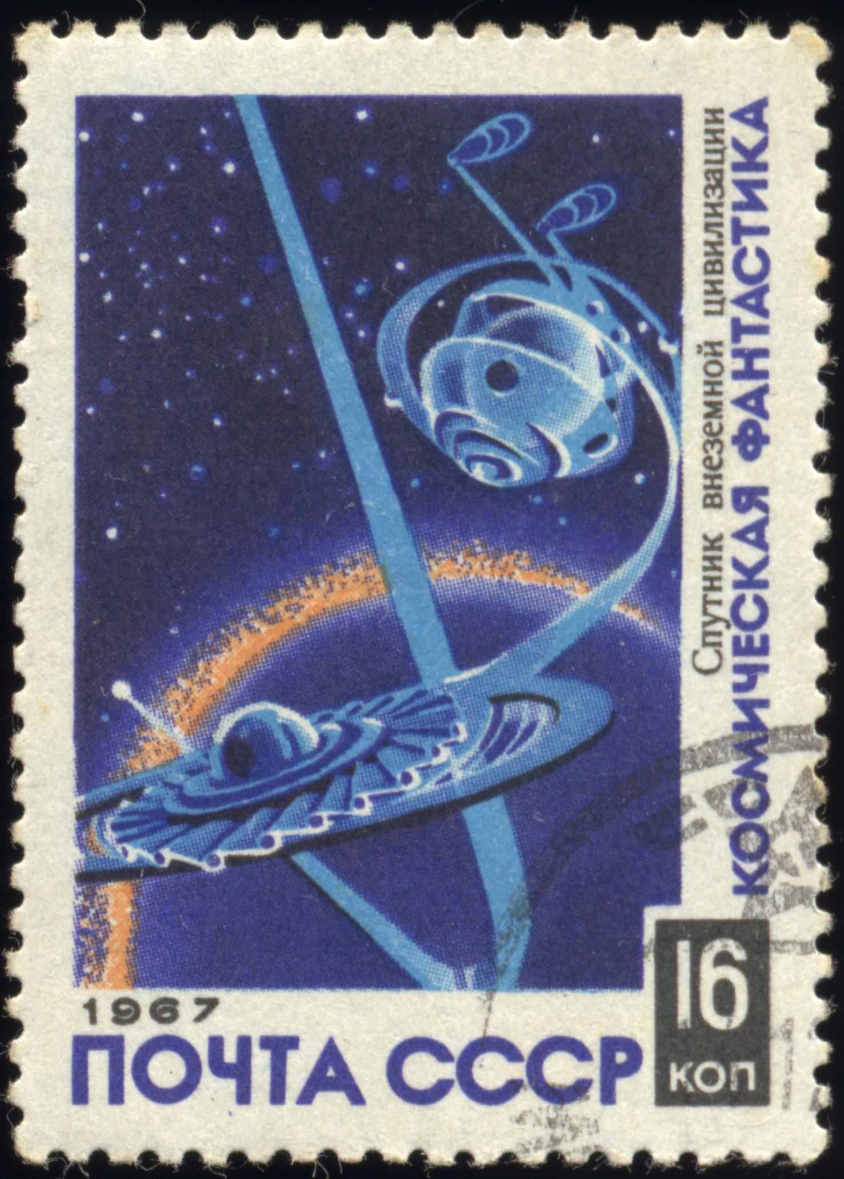
Create a Postcard

____________________________________________________
__________________________________________________________________________________________________________________________________________________________________________________________________________________________________________________________________

