
We hope that you are all enjoying the ‘People who help us’ theme.
This week we are continuing to learn about People who help us ‘’ If you have any queries regarding your child’s learning please email us at
Williams@lea-st-marys.lancs.sch.uk
Jennings@lea-st-marys.lancs.sch.uk
Mrs Williams and Mrs Jennings

English  ➢Watch the video. Open the link to watch the clips about the role of police officers  https://central.espresso.co.uk/espresso/primary_uk/subject/module/video/item1023672/gradef/module1021808/index.html  ➢Discuss What did you find interesting? Talk about what are the different roles of a police officer?  ➢Draw and label a picture the different ways police officers travel (watch the clip again for help).  ➢Write a police report: https://central.espresso.co.uk/espresso/primary_uk/servlet/file/store66/item1024987/doc.pdf  Reception- Imagine you are a police officer draw a picture and write a caption to describe what happened.  Year 1- Include several sentences and a labelled picture in your report.  ➢Research the different roles of a police officer. Watch the power point and create a poster with pictures of the different ways police officers help us.  https://central.espresso.co.uk/espresso/primary_uk/subject/module/book_index/item1021808/gradef/index.html  ➢Create an acrostic poem about a person who helps us:  https://www.twinkl.co.uk/resource/nz-ss-11-heroes-in-our-community-acrostic-poem  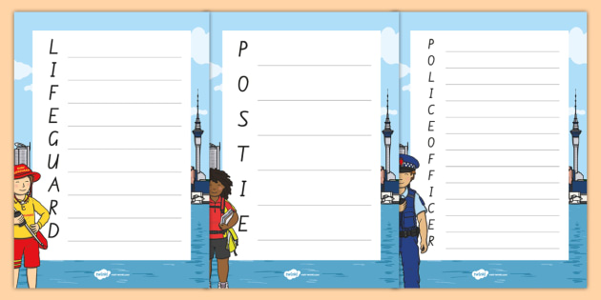 | Spelling/Phonics  Review phase 3 sounds  - Practise saying, reading and writing words with phase 3 sounds and tricky  words (Examples on class page/printed in pack)  Practise This week we are practising words that begin with 3 consonants (ccc)  - Watch the video and discover ccc words: https://central.espresso.co.uk/espresso/primary_uk/subject/module/video/item78778/gradef/module63423/index.html  - Now practise blending, reading and spelling the words:  https://central.espresso.co.uk/espresso/primary_uk/subject/module/activity_index/item63423/gradef/index.html  - Sound out each syllable  - Put them together  - Read the words. What do they say?  Challenge Can you make your own list of ccc words? (e.g. string, scrap, strap) See how many you can find!  Practise reading your tricky words, from phase 2 to phase 5  https://www.phonicsplay.co.uk/
  RE
  Watch the PowerPoint about people who help us. Talk to a grown about the
  different roles and why they are all equally important in their own way.
  https://www.twinkl.co.uk/resource/t-t-5427-people-who-help-us-video-powerpoint
  With your family say a prayer for the key workers asking god to keep them safe.
  
  Select a key worker of your choice to write a thank you letter to, include why you are
  grateful for their hard work.
Maths  Measuring-Weight  Reception – This week you will practice using words to compare the weight of things.  https://central.espresso.co.uk/espresso/primary_uk/servlet/file/store66/item872737/doc.pdf  https://central.espresso.co.uk/espresso/primary_uk/servlet/file/store66/item872712/doc.pdf  Year 1 – This week you will practise measuring weight using standard and non-standard units.  https://central.espresso.co.uk/espresso/primary_uk/subject/module/activity/item852523/grade1/module849225/index.html  https://www.twinkl.co.uk/resource/t-n-5425-how-many-grams-activity-sheet  With an adult use your measuring skills to do some baking! Choose from one of the recipes below or use a family favourite to measure and bake:  https://www.twinkl.co.uk/resource/t-t-2471-biscuit-recipe-cards  https://www.twinkl.co.uk/resource/making-banana-muffins-recipe-cards-t-tp-7611  Number (Money) challenge:  Role play being a shop keeper. Set up a shop with tinned goods or toys and make price tags. Match the coins to the different values to purchase items. Take turns being the shop keeper/customer.  https://www.twinkl.co.uk/resource/cfe-n-026-coin-recognition-activity-sheet  Properties of 2D shapes  Watch the video and play guess the shape:  https://central.espresso.co.uk/espresso/primary_uk/subject/module/video/item883115/grade1/module883106/index.html?source=search-all-all-all-all&source-keywords=2d%20shape%20properties  Now play with your family at home. Describe the features of a 2D shape and see if your family can ‘Guess the Shape’.  https://central.espresso.co.uk/espresso/primary_uk/subject/module/activity/item897066/grade1/module883106/index.html  https://central.espresso.co.uk/espresso/primary_uk/servlet/file/store66/item893663/doc.pdf | Topic  Art/ DT ideas  Choose one of these activities:  - https://central.espresso.co.uk/espresso/primary_uk/servlet/file/store66/item1025020/doc.pdf  - Complete the colour by numbers sheet to create a police officer’s uniform.  - Use a cardboard box to create an emergency vehicle. Research the correct colours and markings.  Music  Listen to the People who help us song. Can you name all the different key workers included in the song?  https://central.espresso.co.uk/espresso/primary_uk/subject/module/video/item1023664/gradef/module1021808/index.html  Join in with the words and actions. Can you think of some more actions of your own?  PSED:  Explore the different activities linked to health workers. Also learn what you can do to help in an emergency:  https://central.espresso.co.uk/espresso/primary_uk/subject/module/frontscreen/item1021914/gradef/index.html?source=subject-PSED-F-PSED-Resource%20types  Now discover the roles of fire fighters and learn some basic fire prevention rules to keep you safe at home:  https://central.espresso.co.uk/espresso/primary_uk/subject/module/frontscreen/item1021830/gradef/index.html?source=subject-PSED-F-PSED-Resource%20types  Geography:  Research people who help us in other countries:  https://central.espresso.co.uk/espresso/modules/ey_people_help/people_other_countries/index.html  Draw a picture and describe their roles.
SHAPE \* MERGEFORMAT

