Activity One - Adjectives

How many words can you think of to describe Sid? Write them all around the picture of him. If you don’t have a printer, draw a picture of Sid and label him with the adjectives that you have thought of.

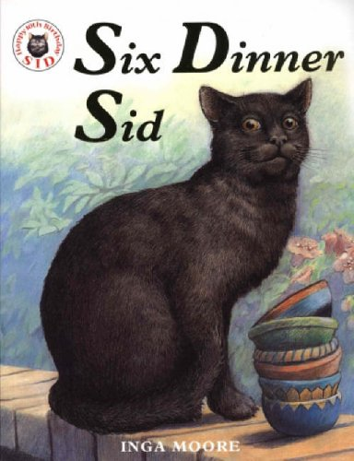

Challenge! Can you write a paragraph about Sid using some of the words you have written? You can do this on the lines below or in your workbook.

___________________________________________________________________________________________________________________________________________________________________________________________________________________________________________________________________

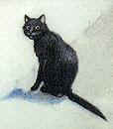Activity Two – Questions about the story

Read the questions and answer on the sheet or in your work book.

1. The people of Aristotle Street did not know about Sid’s six dinners because

________________________________________________________________________________

1. To get six dinners, Sid had to remember...

________________________________________________________________________________________________________________________________________________________________

1. Life was just about perfect in Aristotle Street for Sid because....

________________________________________________________________________________________________________________________

1. Sid’s life was almost perfect until...

________________________________________________________________________________________________________________________

Activity Three – Sid Visits the Vets!

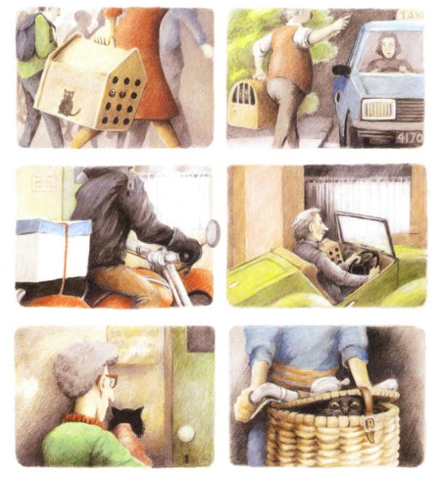

Write a sentence describing how Sid travelled to the vets each time.

__________________________________________________________________________________________________________________________________________________________________________________________________________________________________________________________________________________________________________________________________________________________________________________



Activity Four – Sid’s New Home

Read the questions and answer on the sheet or in your work book.

1. Sid went to live in Pythagoras Place because....

____________________________________________________________________________

1. What was different about the neighbours in Pythagoras Place? What will this mean for Sid?

____________________________________________________________________________

1. How do the neighbours of Aristotle Street feel now that Sid has moved to Pythagoras Place?

____________________________________________________________________________

Activity Five – Book Review

Picture from the story

|  |
| --- |
|  |

Name of Book: _________________________

Author: ______________________________

What is the story about?

_________________________________________________________________________________________________________________________________________________________________________________________

Who would you recommend the story to and why?

_______________________________________________________________________________________________________________

Do you have a pet cat? Would you like one?

_______________________________________________________________________________________________________________

Did you like the story? Why or why not?

_______________________________________________________________________________________________________________

How many stars out of 5 would you give this story? Draw them here.