Pet Shop – Year 1

|  |  |  |
| --- | --- | --- |
| Buy Flexi Standard Dog Lead - Small | Dog collars and leads | Argos  Dog Lead  22p | Ancol Twin Cat Bowl, Grey Stripe - Wadswick Country Store Ltd  Cat Food Bowl  17p | Naturals Carrotys Rabbit Treats - Direct Pets  Rabbit Treats  12p |
| https://www.pond-planet.co.uk/images/goldfish-flake-food-p1823-4398_zoom.jpg  Fish Food  30p | Rainbow Rubber Ball Dog Toy - PearlyPets.com  Dog Toy  25p | Savic Metal Stand for Both Rolly Hamster Wheels: Amazon.co.uk: Pet ...  Hamster Wheel  9p |

Choose some items from the pet shop. How many different ways could you pay for them? Draw the coins that you would use.

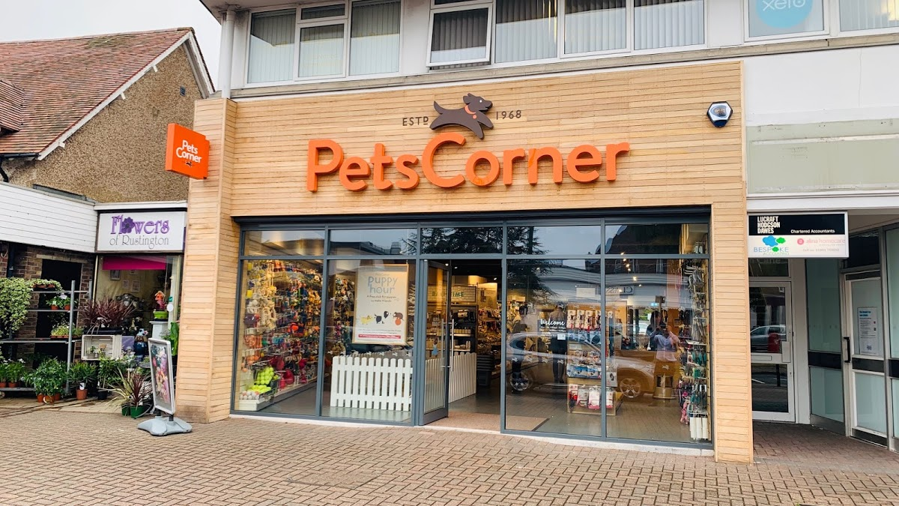

Pet shop – Totalling Amounts

Work out the total amount spent by counting on. Remember to put the biggest number in your head first.

14 p + 7p = _________

21p + 4p = ________

5p + 16 p = _______

10p + 3 p = ________

6p + 11p = ________

3p + 9p = ________

8p +15p = _______

21 p + 7 p = _______

23p + 5 p = _______

4 + 5 + 6 = _______

3 + 11 + 5 = _____

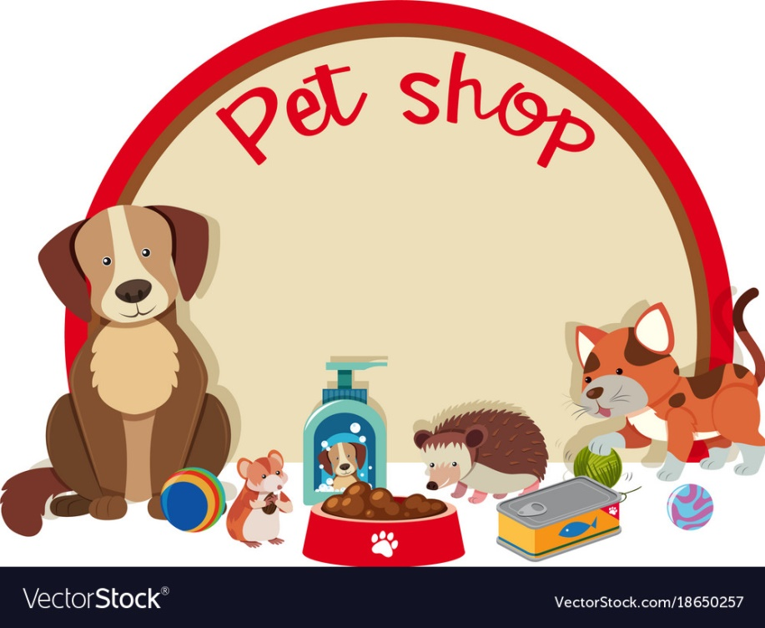

Giving Change

Work out how much change the Pet shop owner needs to give by counting backwards.

15 p – 7p = ________

20p – 5p = ________

12p – 3p = ________

19p – 4p = _______

26p – 7 p = ________

30 p – 5p = _______

21p - 8 p = ________

23p – 6p = _________

Pet Shop Problem

|  |
| --- |
| 1. Tom has a pet cat called Tilly. He buys a cat lead for 13p and a cat bowl for 8p. How much does he spend altogether?   cat - Wiktionary |
| 1. The pet shop has 14 dog bones and sells 7. How many are left in the pet shop?   All Natural Peanut Butter Dog Treats Medium Size Dog Bones | Etsy |
| 1. There are 12 blue fish and 9 yellow fish in the tank at the pet shop. How many fish are there altogether?   The Best Tropical Aquarium Fish for Beginners - Aquatics World |
| 1. The pet shop has 19 bags of rabbit food. He sells 6, how many are left?   Naturals Carrotys Rabbit Treats - Direct Pets |

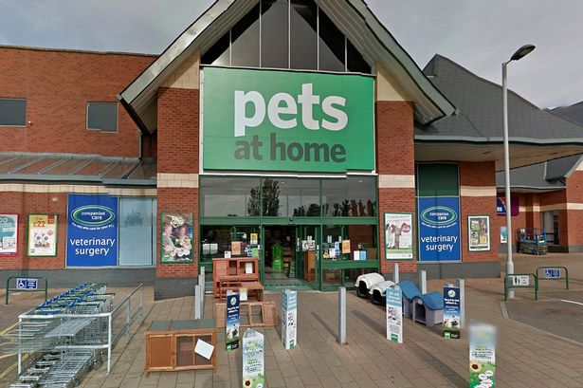

Pet Shop Problems.

Can you make up your own pets shop problems for someone in your family to solve?