Pet Shop – Year 2

|  |  |  |
| --- | --- | --- |
| Buy Flexi Standard Dog Lead - Small | Dog collars and leads | Argos  Dog Lead  26p | Ancol Twin Cat Bowl, Grey Stripe - Wadswick Country Store Ltd  Cat Food Bowl  21p | Naturals Carrotys Rabbit Treats - Direct Pets  Rabbit Treats  48p |
| https://www.pond-planet.co.uk/images/goldfish-flake-food-p1823-4398_zoom.jpg  Fish Food  93p | Rainbow Rubber Ball Dog Toy - PearlyPets.com  Dog Toy  85p | Savic Metal Stand for Both Rolly Hamster Wheels: Amazon.co.uk: Pet ...  Hamster Wheel  19p |

Choose some items from the pet shop. How many different ways could you pay for them? Draw the coins that you would use.

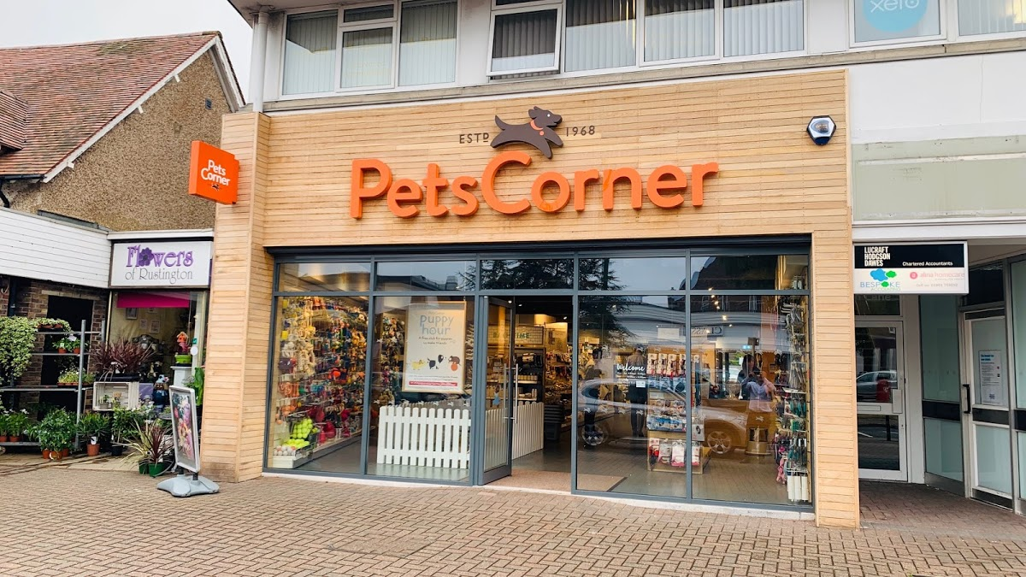

Pet shop

Work out the total amount spent by using base 10 drawings.

14 p + 11p = _________

21p + 34p = ________

15p + 14 p = _______

56p + 33 p = ________

26p + 21p = ________

53p + 37p = ________

68p +21p = _______

51 p + 47 p = _______

23p + 15 p = _______

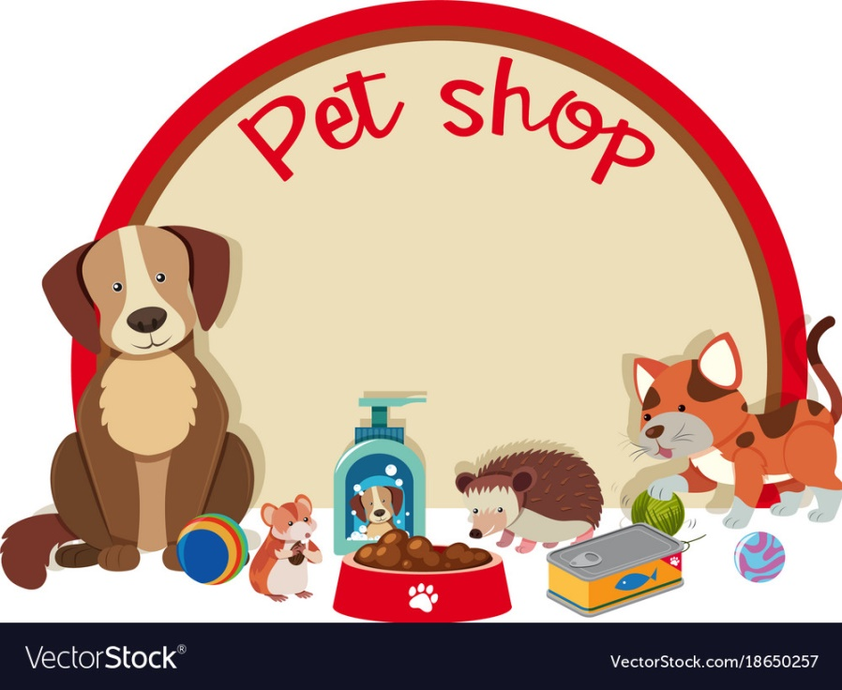

Giving Change

Work out how much change the Pet shop owner needs to give by using base ten drawings.

48 p – 17p = ________

26p – 13p = ________

59p – 23p = ________

47p – 24p = _______

89p –37 p = ________

49p – 25p = _______

87p - 45p = ________

93p – 42p = _________

Pet Shop Problem

|  |
| --- |
| 1. Tom has a pet cat called Tilly. He buys a cat lead for 43p and a cat bowl for 35p. How much does he spend altogether?   cat - Wiktionary |
| 1. The pet shop has 44 dog bones and sells 12. How many are left in the pet shop?   All Natural Peanut Butter Dog Treats Medium Size Dog Bones | Etsy |
| 1. There are 67 blue fish and 21 yellow fish in the tank at the pet shop. How many fish are there altogether?   The Best Tropical Aquarium Fish for Beginners - Aquatics World |
| 1. The pet shop has 29 bags of rabbit food. He sells 16, how many are left?   Naturals Carrotys Rabbit Treats - Direct Pets |



Pet Shop Problems.

Can you make up your own pets shop problems for someone in your family to solve?