**PART THREE**

Now that we have thought a little more about how we can feel. In the next parts of the support guide we will be learning some new skills which can help when we feel scared or upset.

Today we are going to be learning how to use our breathing to help us to feel good and to lift our mood.



You might be thinking ‘I breath all of the time!’ and you are right, we do! Learning how to do lovely deep breathing to help us feel calm and happier is a new skill.

So first of all, we need to learn how to do a really deep breath in through our nose and then let this breath out through our mouth.

1. Try to imagine that you are breathing in a beautiful flower or your favourite smell in the whole world, and breath this in steadily through your nose.
2. Next imagine you are blowing a big leaf away that is in front of you. Blow steadily through your mouth.

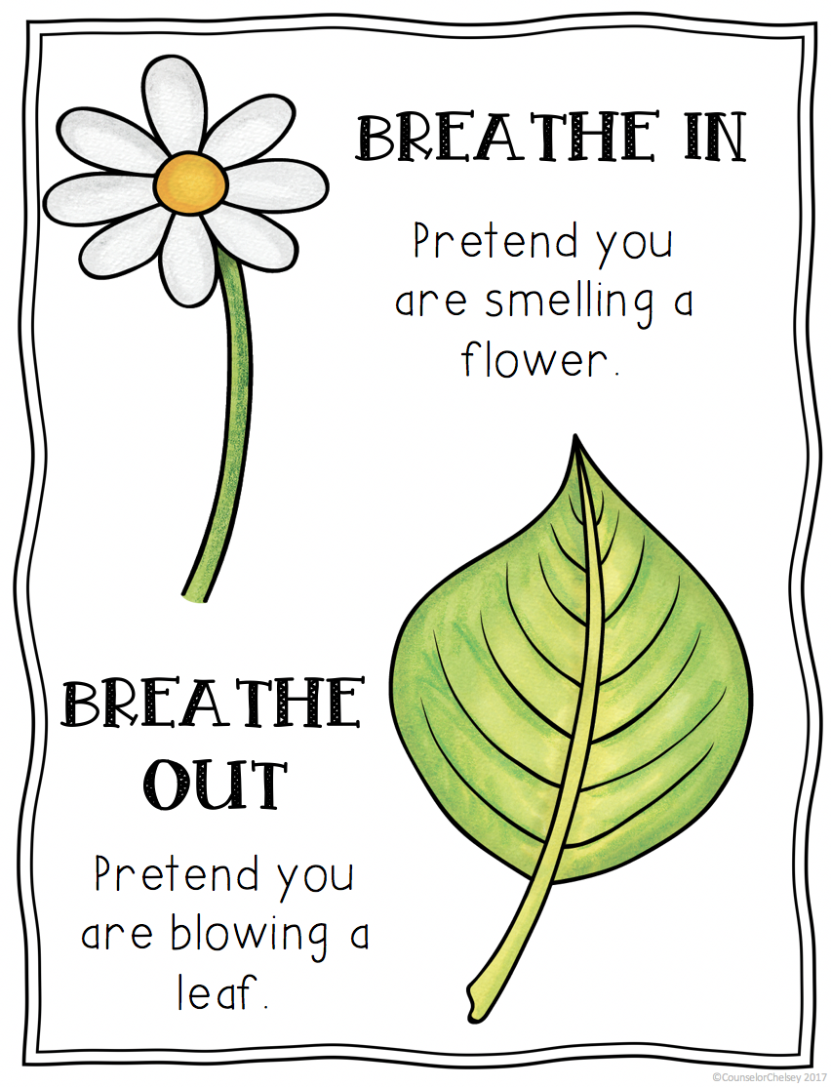

Notice how you were able to fill your lungs with air and then let go of all the air and blow it all away. Well done.

Our next step is to practice using our new deep breathing skill. Like anything we want to get better at, the more we can use our breathing skills the better we will get. A good way to practice a pattern of deep breathing is to use Lazy 8.

Look at the picture of a very lazy number 8 lying fast asleep.

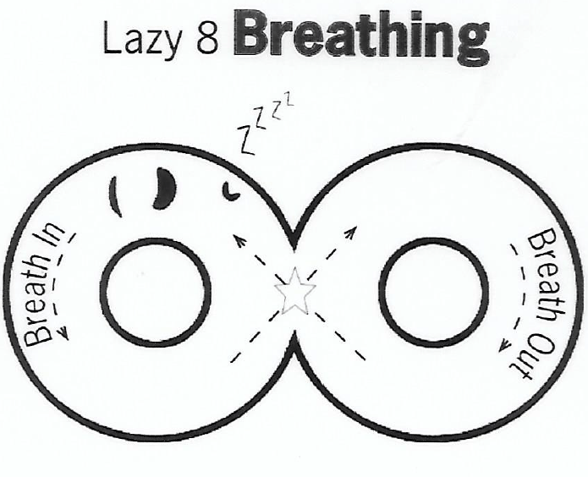

Lazy 8 Breathing

Step 1 Start with your finger on the star in the middle and then move it around the Lazy 8, as though you are drawing the number eight.

Step 2 As you move your finger around the first circle of the Lazy 8 do a lovely deep breath in.

Step 3 Then, as you move past the star and keep drawing the 8 with your finger do a big breath out.

Step 4 Keep drawing the number 8 and keep using your breathing for as many times as you need.

If you can try to think about how using nice big breaths like this feels for you. Do you notice anything happening inside your body when you do lovely calming breaths? If you do, write this below.

………………………………………………………………..

………………………………………………………………..

………………………………………………………………..

………………………………………………………………..

………………………………………………………………..

………………………………………………………………..

………………………………………………………………..

………………………………………………………………..

………………………………………………………………..

………………………………………………………………..

Remember to use your new deep breathing as much as you can. It helps our bodies and our minds to feel calm and even when we are feeling scared, angry or sad, our deep breathing can help us feel much better.

You may want to teach your family too!

Is there anything that you would like to share with your teacher after this week’s reflection? Remember to ask your adult to email this section to your teacher.

………………………………………………………………..

………………………………………………………………..

………………………………………………………………..

………………………………………………………………..

………………………………………………………………..

………………………………………………………………..

………………………………………………………………..

………………………………………………………………..

………………………………………………………………..

………………………………………………………………..

………………………………………………………………..

………………………………………………………………..

………………………………………………………………..

………………………………………………………………..

………………………………………………………………..

………………………………………………………………..

………………………………………………………………..

………………………………………………………………..

Fantastic work! Well done on completing the third part of your booklet.



This has helped you to develop new skills and we will continue with this again next week!