**PART TWO**

In part two of the support guide we will be thinking more about feelings and the many different types of feelings we can all have.

Everybody has feelings! You, your teachers, your family.

Can you read the feelings below and try to match them to the correct picture?

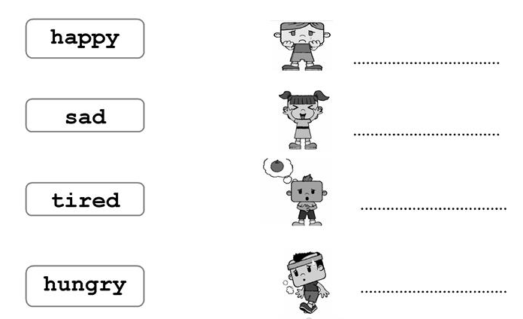

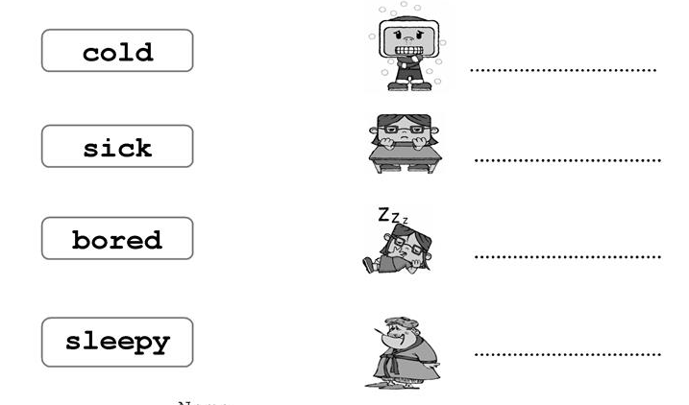

Good work! Now let’s think about some of the main feelings we can all have.

Can you think of a time when you have felt like each of these? Write about what happened and what that was like for you.

1. Happy?

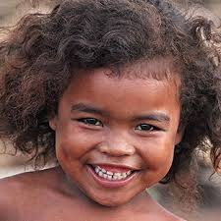

………………………………………………………………..

………………………………………………………………..

………………………………………………………………..

………………………………………………………………..

………………………………………………………………..

………………………………………………………………..

………………………………………………………………..

………………………………………………………………..

………………………………………………………………..

………………………………………………………………..

………………………………………………………………..

1. Sad?



………………………………………………………………..

………………………………………………………………..

………………………………………………………………..

………………………………………………………………..

………………………………………………………………..

………………………………………………………………..

………………………………………………………………..

………………………………………………………………..

………………………………………………………………..

………………………………………………………………..

………………………………………………………………..

1. Scared?



………………………………………………………………..

………………………………………………………………..

………………………………………………………………..

………………………………………………………………..

………………………………………………………………..

………………………………………………………………..

………………………………………………………………..

………………………………………………………………..

………………………………………………………………..

………………………………………………………………..

………………………………………………………………..

1. Angry?



………………………………………………………………..

………………………………………………………………..

………………………………………………………………..

………………………………………………………………..

………………………………………………………………..

………………………………………………………………..

………………………………………………………………..

………………………………………………………………..

………………………………………………………………..

………………………………………………………………..

………………………………………………………………..

You have done very well to think about the times when you have felt happy, sad, scared and angry.

We are now going to think about which of these feelings you may have been having since your school has been closed?

It may have been a confusing time for you because lots of things have been different. All families have had to change how they normally live for a while in some way.

Have you had any of the feelings we have thought about today since school has closed? Can you write them below?

………………………………………………………………..

………………………………………………………………..

………………………………………………………………..

………………………………………………………………..

………………………………………………………………..

………………………………………………………………..

………………………………………………………………..

………………………………………………………………..

Is there anything that you would like to share with your teacher after this week’s reflection? Remember to ask your adult to email this section to your teacher.

………………………………………………………………..

………………………………………………………………..

………………………………………………………………..

………………………………………………………………..

………………………………………………………………..

………………………………………………………………..

………………………………………………………………..

………………………………………………………………..

………………………………………………………………..

………………………………………………………………..

………………………………………………………………..

………………………………………………………………..

………………………………………………………………..

………………………………………………………………..

………………………………………………………………..

………………………………………………………………..

………………………………………………………………..

………………………………………………………………..

Fantastic work! Well done on completing the second part of your booklet.



This has helped your teacher find out even more about how you have been feeling. We will continue next week!