**PART TWO YEAR 6**

Welcome Year 6 children to part two of your supplement.

In part two we will be thinking about some of your memories from your time at St Marys school.

Most of you will have been at the school since you were very small and today we are going to think about the journey you have been on.

On the way you will have met people who have been especially important to you. These may have been special friends you have made or a teacher who helped you. You may also have had bumps in the road, things that were not so easy for you. These experiences are also important parts of becoming the Year 6 children you are today. Ready for the next part of your journey at secondary school.

On the next page, I would like you to think about the times that have stood out for you at St Marys. Try to add each memory on the road from when you began school at the bottom, through to today at the top. You can choose to draw or write about each memory next to your road. If you need more space to add everything you would like to, you could draw your own road on a separate page and add as much detail as you wish.

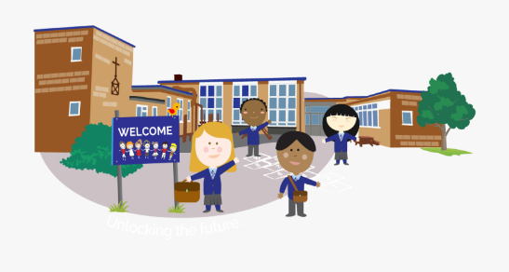

If there is anything you would like to share with your teacher at this stage, please write this below and ask your adult to send this to them.

………………………………………………………………..

………………………………………………………………..

………………………………………………………………..

………………………………………………………………..

………………………………………………………………..

………………………………………………………………..

………………………………………………………………..

………………………………………………………………..

………………………………………………………………..

………………………………………………………………..

………………………………………………………………..

………………………………………………………………..

………………………………………………………………..

………………………………………………………………..

………………………………………………………………..