Homework Tasks- Fire! Fire!

Our challenges are all linked to our Topic this term- The Great Fire of London.

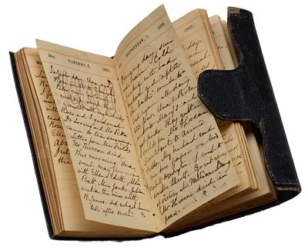Research – Research the Plague and the Great Fire of London using the internet and books. Write or type up the facts that you have found. Or perhaps you could produce a PowerPoint presentation and add pictures in that you have downloaded.

Diary – Samuel Pepys was famous for keeping a diary during the fire. Can you keep a diary of your weekend? You could even draw some lovely pictures to go with your writing.

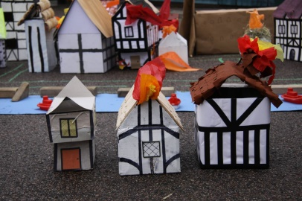

Buildings – Make a model of a house in London in 1066.

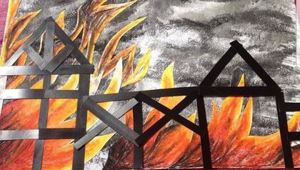

FIRE! – Create a picture depicting a scene from London during the great fire. You could draw, paint, collage, use chalk or a paint package.

Maths – Year 1’s – Practise counting to 50 and recognising numbers to 50. - Maybe an adult could make some flashcards of numbers to 50. Then hide them around the house/garden and when you find them you have to tell your adult what the number is.

Year 2’s - Partition numbers into tens and ones e.g. 34 = 30 + 4. Maybe even try some hundreds numbers 154 = 100 + 50 + 4