**Homework Tasks- All about Me/Traditional Tales**

**R.E**

Draw or paint a picture to show how big God’s love is.

E.g. God’s love for me is bigger than a house!



**Maths**

Measure all the people who live in your house. Can you put them in order of the shortest to the tallest?



**Time**

Draw a picture of the different seasons.

Think about how the weather changes.



**Literacy**

Draw a picture of your favourite fairy tale character.

Can you write some describing words?

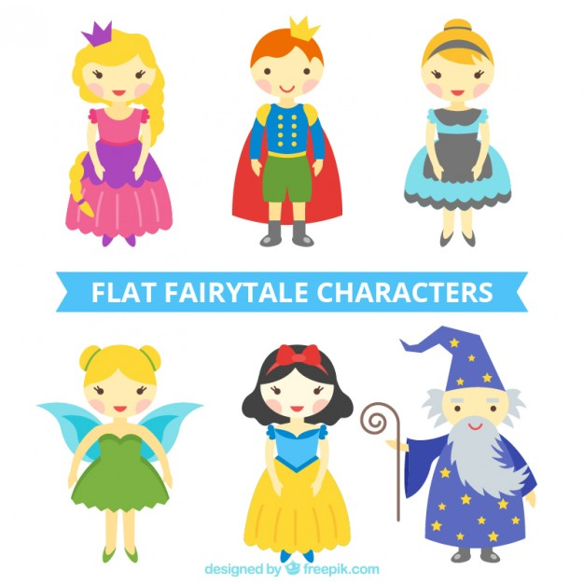

**Science**

Think about how to keep healthy.

Draw and describe an exercise or activity you do to keep fit.

