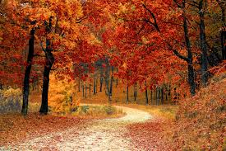

**Isolation Activities -** **Autumn Theme**

**Maths**

Option 1 - See attached Autumn themed maths packs on the class page. There is a pack for each year group.

Option 2 –

Year 1 - How many different ways can you make 10 using addition and subtraction calculations? Maybe you could use little objects from around the house to help you e.g. pasta shells, buttons and 1p’s.

Year 2 – Write down all the number bonds that make 20. E.g. 1 +19 = 20, 2+18 = 20 .

**Literacy**

Find some autumn pictures on the internet. Write some key words to describe what you can see, what might you hear on an autumn day? How might you feel? What might you be able to smell and taste?

Then use all your ideas to write an autumn senses poem. I have attached a writing frame to give you an idea of how you could set them poem out.

**Topic – Research about harvest festival and write the interesting facts that you have found.**

**Art -** Collect some leaves from the garden, can you make a hedgehog picture?

