
Class 1 self-isolation work:
If you have any queries regarding your child’s learning please email us at
Williams@lea-st-marys.lancs.sch.uk
Jennings@lea-st-marys.lancs.sch.uk
Mrs Williams and Mrs Jennings

English  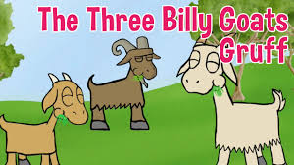  ➢Discuss with an adult the story of The 3 Billy Goats Gruff.’ Tell them what happens at the beginning of the story, in the middle and at the end.  ➢Listen to the story again and share the story with an adult: The 3 Billy Goats Gruff  ➢Answer these questions about the story: Which billy goat tried to cross the bridge first? What stopped the billy goats from crossing the bridge? What did the biggest billy goat do to the troll?  ➢This isolation unit has several activities linked to the story. You will need to click on this link below and follow the lesson order carefully:  The 3 Billy Goats Gruff units  ➢Research: See what information you can find out about goats. See if you can make a poster about them. | Spelling/Phonics  Review phase 2 sounds:  s,a,t,p,i,n,m,d,g,o,c,k,ck,e,u,r,h,b  You can use the following links to focus on and practise each sound:  Phonics: How to pronounce pure sounds  Jolly Phonics sounds in correct order (Letters and Sounds)  Please continue to share a book with your child each day, talk about the pictures with your child and ask them some questions about what is happening in the story.  Try these tasks at home too:  - Look at things around the room and say the sound they begin with. Can you hear the sound they end with too? Try writing some of them down.  - Practise reading your wizard words:  the to I go no into  Can you look in a book and find any of these words? Which words did you spot the most?  - Can you say the following letters and think of a word that begins with each one?  s a t p i n m d g
Maths  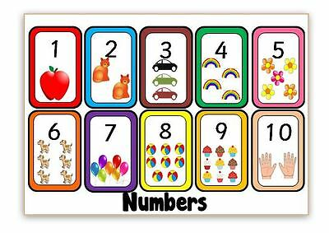  - Ask an adult to hide the numbers to 10 around your room, house or garden. See if you can find all 10 and place them in order. You could ask someone to tell you a number to find. Can you remember what the number looks like and find it?  - Collect 10 leaves from your garden. Write the numbers 1-10, one on each leaf, using a thick marker pen. Use a hole punch to make a hole in either end of the leaves and then thread them onto a piece of string. Don’t forgot to put them in the correct order! You could then put up your homemade number line in your bedroom to help you remember the order of the numbers.  - The following unit is all about Measures. You will need to click on the link below and follow the lesson order carefully:  Measures unit  PE  Animal Antics  Use your body to pretend to be different animals:  Snake: slither across the floor  Butterfly: flutter around the room  Elephant: stomp with both feet  Kangaroo: bounce around  Frog: hop like a frog  Flamingo: stand still on one leg | Science  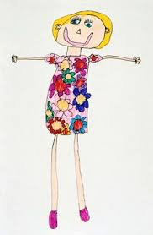  Draw a self-portrait of yourself and label the different parts of the body. Reception children see if you can write the initial sound for each body part, e.g. ‘n’ for nose, ‘m’ for mouth.
RE
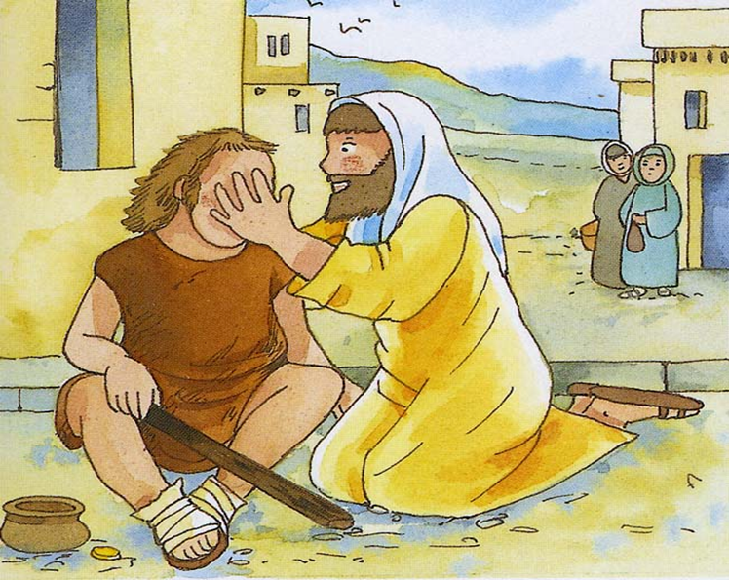
Jesus often helped people who were sick. Draw a picture of a person who you know needs help, maybe they are sick or live by themselves. Write the name of the person at the top of the drawing.

