Weekly Spellings for Year 3

Week 7

Mon 19th October

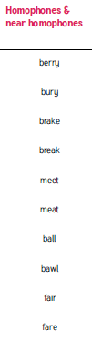

Can you think of any others that follow this rule?

Weekly Spellings for Year 4

Week 7

Mon 19th October

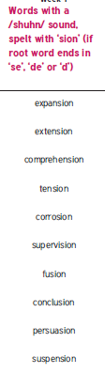

Can you think of any others that follow the rule?