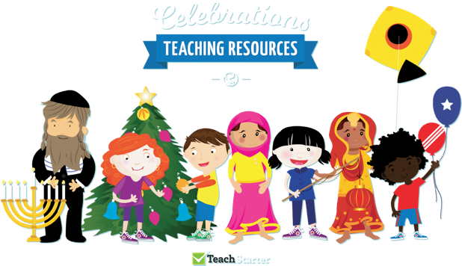
This half term our topic is ‘Celebrations’. We have planned 2 weeks of activities that you can complete while you are learning at home.
We hope that you are keeping safe and well.
If you have any queries regarding your child’s learning please email us at:
Williams@lea-st- marys.lancs.sch.uk
Jennings@lea-st- marys.lancs.sch.uk
English  Literacy/History week 1  The first celebration we would like you to research is bonfire night.  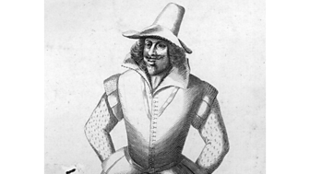https://www.bbc.co.uk/bitesize/topics/zjkj382/articles/zjsqbdm  ➢Watch the video. Open the link for this week’s story ‘the gunpowder plot.’  ➢Discuss the video of Guy Fawkes and the information underneath. Can you record 5 interesting facts about him?  ➢Draw and label a timeline of events of the gun powder plot. (Y1 write short sentences under each picture)  ➢Research pictures of Guy Fawkes. Look at the images of Guy Fawkes is he a modern man, or a man from the past? Draw a picture of him.  ➢Think of some questions that you might like to ask Guy Fawkes. How might he respond? Use question words how, why, when, where and who.  Literacy week 2    Now we know the history of Bonfire Night, lets learn about how we celebrate it!  ➢Watch the video. ‘Celebrating bonfire night’  ➢Discuss the video, what is your favourite part of the celebrations? Draw and label a picture  ➢Research how to be safe on bonfire night. Make a safety poster with 5 rules to remember.  ➢Describe Imagine it is bonfire night, use your senses to describe what you might see, feel, smell, taste and hear.  ➢Write a poem uses all your ideas  I can smell…  I can hear…  I can taste…  I can feel…  I can see… | Spelling/Phonics  Phonics week 1  Remember to access an online reading book (using your epic reading account)  and engage in a 20-minute phonics session daily.  This week’s focus sounds are j, v, w, x  https://www.phonicsplay.co.uk/assets/resources/public/pdfs/printables-flashcards-6-7.pdf  - Say the sounds  - Practise reading and writing words with these sounds in.  - Read by sounding out and blending the sounds:  ➢ https://new.phonicsplay.co.uk/resources/phase/2/buried-treasure  ➢ https://new.phonicsplay.co.uk/resources/phase/2/dragons-den  ➢ https://new.phonicsplay.co.uk/resources/phase/2/picnic-on-pluto  • Practise reading tricky words, from phase 3  ➢ http://www.letters-and-sounds.com/resources/p3tricky.pdf
  Phonics week 2
  Remember to access an online reading book (using your epic reading account)
  and engage in a 20-minute phonics session daily.
  This week’s focus sounds are y, z, zz, qu
  https://www.phonicsplay.co.uk/assets/resources/public/pdfs/printables-flashcards-6-7.pdf
  - Review the set 6 sounds (j, v, w, x)
  - Say the sounds
  - Practise reading and writing words with these sounds in.
  - Read by sounding out and blending the sounds:
  https://www.phonicsplay.co.uk/resources/phase/2/pick-a-picture
  https://www.phonicsplay.co.uk/resources/phase/2/buried-treasure
  • Practise reading tricky words, from phase 3
  ➢ http://www.letters-and-sounds.com/resources/p3tricky.pdf
  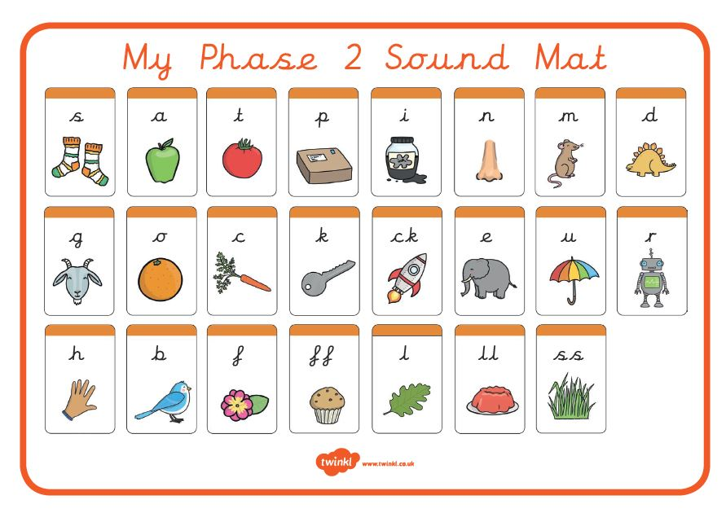
Maths  Numeracy Week 1  In numeracy we are learning to continue and create patterns and number sequences.  ➢Patterns around us  Find real objects inside and outside to create repeating patterns, you will need several of the same item e.g. leaves and sticks  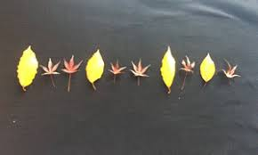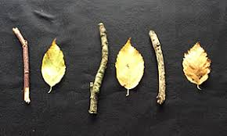  ➢Colour patterns  https://www.coolmath4kids.com/manipulatives/pattern-blocks  Use the pattern blocks to create a repeating pattern. Choose the same shape and put them in a row and change the colours to create a pattern start with 2 colours:  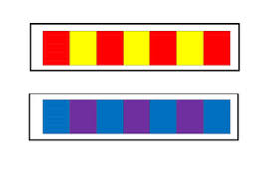  Can you challenge yourself to use 3 colours?  ➢Shape patterns  https://www.coolmath4kids.com/manipulatives/pattern-blocks  Now use different shapes to create a repeating pattern. (make sure you keep the colour of the shape the same)  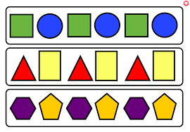  ➢Number challenge: Practise counting and writing numbers to 20, make sure you have formed them all the correct way.  ➢Watch the number bonds song, how many ways can you make 10? Write the number sentences e.g. 5 + 5 = 10  Numeracy Week 2  This week we are going to be focusing on number sequences.  ➢Watch (Reception & Year 1)  https://www.youtube.com/watch?v=dBKyiYq5k98&list=PLwSyqOHzLg-XNqzeCyIeCjyr8esgeGn-t  (Year 1 Only)  https://www.youtube.com/watch?v=GddAGHgH1IM&list=PLwSyqOHzLg-XNqzeCyIeCjyr8esgeGn-t&index=4  ➢Follow the link below to complete the different ordering and sequencing numbers  https://www.topmarks.co.uk/ordering-and-sequencing/caterpillar-ordering  ➢Create your own number sequences, counting forwards/back, different starting points etc (year 1 try counting in 5s & 10s)  ➢ Challenge your family to complete your number sequences, now mark their work! Check their answers, did they get it right?  Shapes  ➢ Practise naming the 2D and 3D shapes:  https://www.youtube.com/watch?v=DmfCdqxTjEw  ➢Use and name 2D shapes to create a firework picture  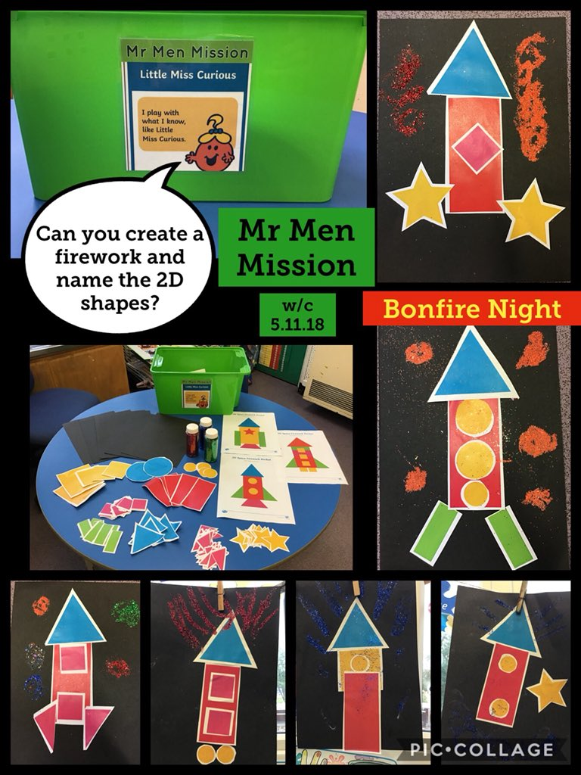 | Topic  RE  This half term we are learning about how we celebrate as Catholics. Such as weddings, baptisms, Christmas and how we celebrate Jesus.  ➢Adult led discussion about a celebration that children can name. Ask your child to share their individual experiences, reflect on the different elements that make a celebration e.g. cards, decorations, presents, visitors and food.  ➢Draw a picture of the celebration you remember.  ➢Look at photos of you, your family and friends at celebration events, including baby photos.  ➢Talk about the different ways you celebrate, e.g. wearing special clothes, prayer etc.  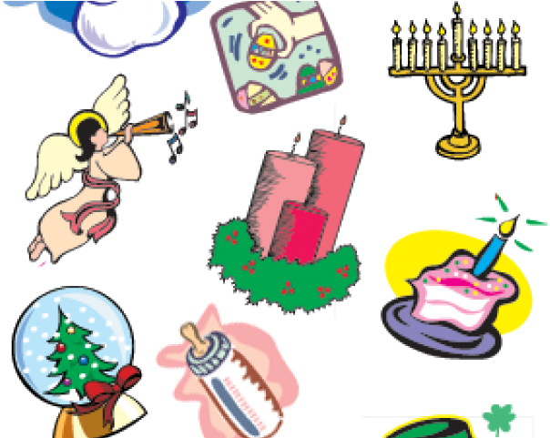  Art ideas  - Make your own junk model firework, you could use a toilet roll tube to make a rocket.  - Create a bonfire night sky, draw a variety of brightly coloured fireworks using wax-crayons then use black water paint to cover the page to create the effect of the night sky.  - Make large chalk firework pictures on black paper or the ground outside.  - Use your handprint to create a bonfire picture. Cover your hand in paint and print it in red, yellow and orange to create the flames of the fire.  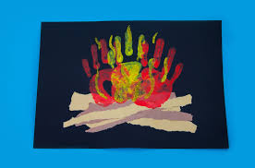  Music  ➢Learn the words and make up your own actions for the bonfire night song:  https://www.youtube.com/watch?v=YydmLDvGIp4  ➢Make your own instrument that makes a firework sound. Play along to the bonfire night song.  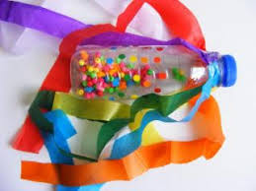  Science ‘Our bodies’  ➢How can we keep our bodies healthy? Plan an exercise routine including 5 different exercises. Feel your pulse before and after, how has it changed? Research why.  ➢Find out about the different food groups. Help to plan a healthy balanced meal for you and your family.  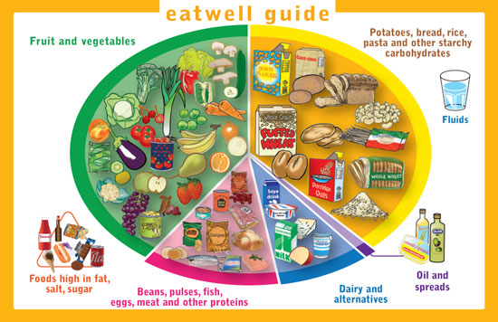
SHAPE \* MERGEFORMAT

