
Class 2 self-isolation work Week 1 of 2

This term in Class Two we are going to be explorers. We will be learning about famous explorers and significant individuals such as Neil Armstrong, Amy Johnson and Christopher Columbus. Then in geography and art we will be exploring the physical and human features of Africa and African art. If you are having to work at home I have provided some further opportunities along the same theme.

If you have any queries regarding your child’s learning please email me at sullivan@lea-st-marys.lancs.sch.uk.

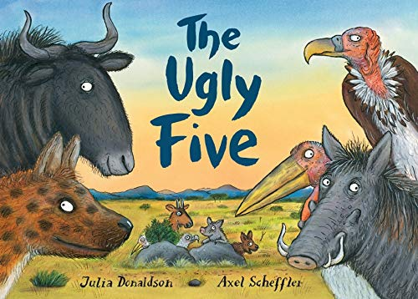  English  The ‘Ugly Five’ is a story set in Africa. Watch the story on the following link:  https://www.youtube.com/watch?v=_Q-b1m_RcBo  Day 1 - Find all of the rhyming words in the book. Can you make your own list of rhyming words?  Day 2 - Find collective nouns to describe different groups of animals. E.g. a group e.g. a pride of lions, a pack of wolves. Write these up in a list.  Day 3 - Choose one of the animals in the story, draw a picture of the animals and then label it with adjectives. Now use these ideas to write a detailed description of the animal.  Day 4 - Think of some speech / thought bubbles to add to the illustrations. What are the animals saying / thinking?  Day 5 - Imagine that the title of the book was 'The Ugly Six'. Make another page based on a sixth member of the group. | Spelling/Phonics  Year 1 Learn the triagraph ‘air.’ Practise spelling and reading the words: hair, chair, fair, stairs, pair, repair, aircraft, hairy, dairy, fairy.  Learn the diagraph ‘ow.’ Practise spelling and reading the words: cow, now, brown, crown, town, gown, howl, flower, towel, clown, wow.  Children could play games to learn these words. You could write the words on pieces of paper, hide the words and they have to find the words. Children could play quick spell by seeing how many words they can write in 2 minutes.  Year 2  We have already learnt the ‘ch’ sound in words like chop, chip and munch. But if there is a vowel before the ‘ch’ sound then it is ‘tch’ e.g. ditch, fetch, match, hatch, watch, patch, kitchen, stitch and switch. Can you practise these words in your neatest handwriting? Now put all the words into a sentence?  Year 1 and 2  https://www.phonicsplay.co.uk/resources - Have a go at the free games on phonics play. Year 1 should go on phase 3 and 4. Year 2 should go on phase 5.
Maths  For a maths starter visit the following website and choose from the appropriate age group.  https://www.topmarks.co.uk/Search.aspx?Subject=16  Oak Academy There are enough lessons here to do one a day for 2 weeks.  Year 1  https://classroom.thenational.academy/units/addition-and-subtraction-within-20-79fd  Year 2  https://classroom.thenational.academy/units/addition-and-subtraction-of-2-digit-numbers-f192 | Topic - Lot’s of ideas to keep you busy!  - Find out about habitats. What other animals might live on the African plain?  - Make a food chain that includes some of the animals mentioned in the story.  - Choose one of the animals in the story and write a report about it.  - Think about how the animals are adapted to living in this particular habitat.  - Why would you be lucky to see the Shy Five? What does it mean to be nocturnal and why do animals behave in this way?
PSHE  - Look through the story and sort some of the words that the author uses to describe the animals (e.g. ugly, spindly, graceful, divine). Which ones are positive and which are negative?  - The Ugly Five become a group of friends at the end of the story. What are the qualities of a good friend? Could you draw a picture of you and your friends and label with your ideas. | Art /DT  - Choose one of the animals from the story and create a collage, drawing or painting of it.  - Using playdoh Could you make a model of one of the animals in the story?

