**Class Two Homework**

This term in Class Two we are going to be ‘explorers.’ We will be learning about famous explorers and significant individuals such as Neil Armstrong, Amy Johnson and Christopher Columbus. Then in geography and art we will be exploring the physical and human features of Africa and African art.

However for homework I would like you to focus on exploring and learning about the South Pole.

Below are a selection of activities that you could have a go at to extend your learning:

**Research** – Research an animal that would live in the South Pole. Can you produce a simple fact sheet about the animal?

**Read –** With an adult, look at the powerpoint about explorers on the class page. Discuss with your adult interesting facts that you have learnt. Then write down some of your interesting facts. How do you think it would be different for a modern day explorer visiting the South Pole?

**Think!** Imagine you are an explorer going to the South Pole. What would you take with you? Draw and label pictures of items that you would put in your backpack

**Time** – Time is an area of maths/an everyday life skill that many children struggle with. Therefore if your child has a watch please could they wear it for school, as regularly throughout the day I will be doing ‘time checks’ to encourage them to read the time and apply their understanding of time in their everyday life. Don’t worry if they don’t have a watch as we have a big clock in class.

I will also be sending home with your child a clock worksheet and a split pin so that they can make a clock for homework and then practise reading o’clock, half past, quarter to and quarter past. Some year 2’s could challenge themselves to learn time to the nearest 5 minutes.

**Art** – Have a go at these lovely igloo collages or cute penguins!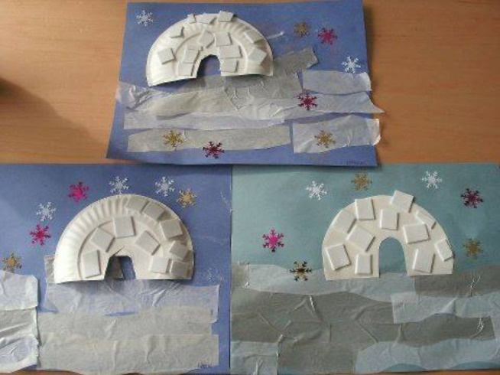 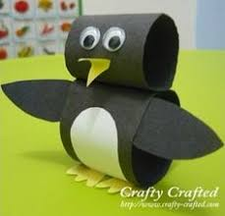

**RE**- As Christmas is approaching, read the Christmas story in a children’s Bible. Can you design a Christmas card with a scene from the story?