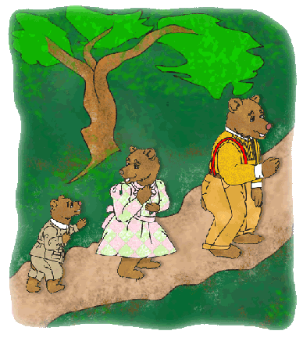
Class 1 self-isolation work:
If you have any queries regarding your child’s learning please email us at
Williams@lea-st-marys.lancs.sch.uk
Jennings@lea-st-marys.lancs.sch.uk
Mrs Williams and Mrs Jennings

English  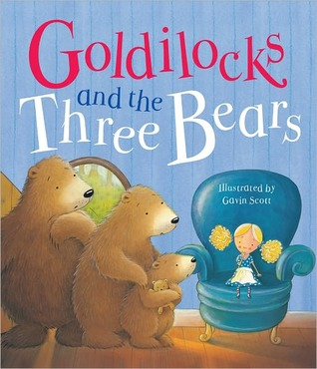  ➢Share the book. You can access this version of ‘Goldilocks and the 3 Bears’ on Getepic. Read and share the story with your child:  ➢Talk about the story together. What did Goldilocks do in the Bears’ house? What happened when the Bears came home? Try using different voices for the different characters.  ➢ Talk about how the characters may have felt. How did baby bear feel when he found his chair broken? How may Goldilocks have felt when she woke up and saw the three bears?  ➢ Retell the story with home-made puppets, pictures or props! (See art planning opposite.)  ➢Draw and label a picture of The Three Bears.  ➢Write a letter to the Three Bears from Goldilocks to say she is sorry for the mess she has made. (Y1 pupils)  ➢Research: See what information you can find out about bears. Use the link below:  Bears | Spelling/Phonics  Review phase 2 sounds:  Practise saying the different sounds with actions.  s,a,t,p,i,n,m,d,g,o,c,k,ck,e,u,r,h,b,f,ffl,ll,ss  You can use the following links to focus on and practise each sound:  Phonics: How to pronounce pure sounds  Jolly Phonics sounds in correct order (Letters and Sounds)  Practise your blending on ‘Phonics Play’ games. (Use link below.) Select Phase 2:  - Say the sounds  - Blend the sounds  - Read the words with the sounds in  Phonicsplay  Getepic/ Oxford Owl online reading: Please continue to share a book with your child each day, talk about the pictures with your child and ask them some questions about what is happening in the story.  Try these tasks at home too:  - Look at things around the room and say the sound they begin with. Can you hear the sound they end with too? Try writing some of them down.  - Practise reading your wizard words:  Red wizard words: the to I go no into  Blue wizard words: you they all are my her he she we me be was  Can you look in a book and find any of these words? Which words did you spot the most?
Maths  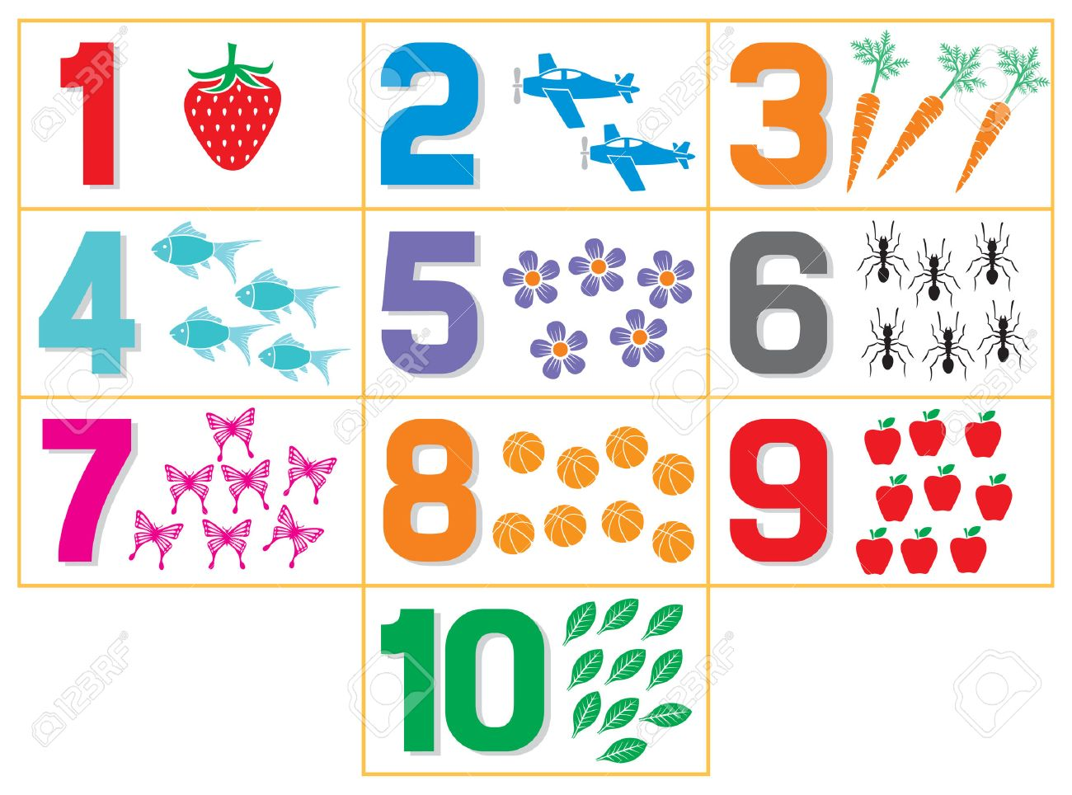  - Put out the numbers 1 to 10. Place the correct number of objects next to each number (e.g. you could use pasta, buttons, leaves, etc.) Make sure you count the objects carefully! (Year 1s to use numbers to 20.)  - Help your child to learn the numerals by exploring their shapes. You could have fun forming numbers in porridge oats with a stick, or making numbers out of play doh. Write numbers for your child to copy, and hold your hand over their hand to help direct them. Try holding their finger and forming the number in the air. Once they can trace out the shape of numerals, see if they can write numbers on their own. (Y1s to practice writing numerals to 20.)  - Make a big dice out of an empty box. Stick or write the numbers on. Throw the dice and do that many hops, jumps or claps.  Using measures-  - Look at different objects and talk about their size. What other words can we use to describe something small? Medium? Large?  - Goldilocks and the 3 Bears love eating porridge. Try making some porridge with a grown-up: First add 100g porridge oats to a bowl. Then add 200ml water. Next add 1 tablespoon of sugar. Put it in the microwave for 2 minutes and stir well. Do you like porridge? (This lesson links with the science lesson - see science planning opposite) | 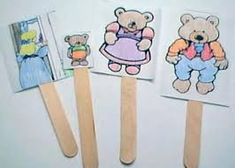  Art  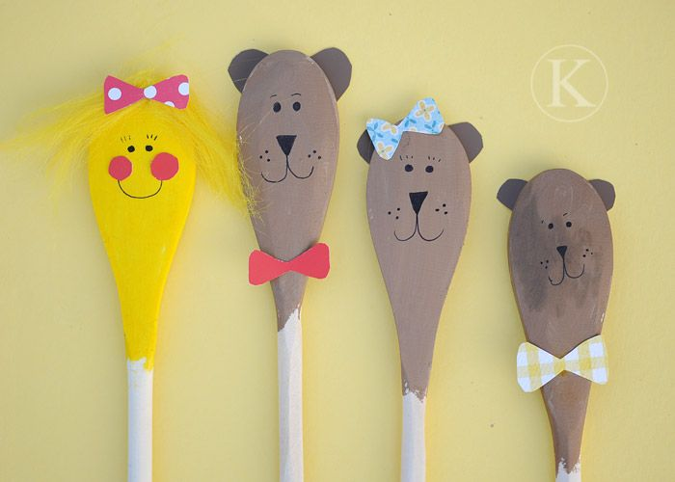  You could decorate wooden spoons to make the characters of Goldilocks and the 3 Bears.  You could make stick puppets of Goldilocks and the 3 Bears  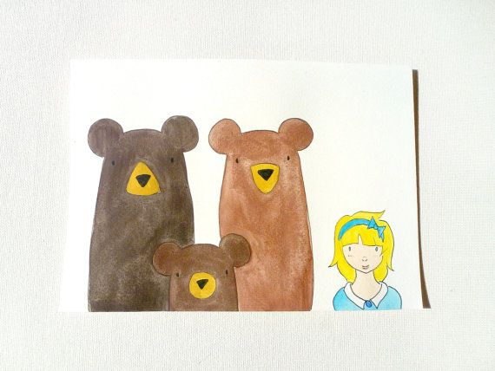  Draw or paint a picture of Goldilocks and the 3 Bears.  Science  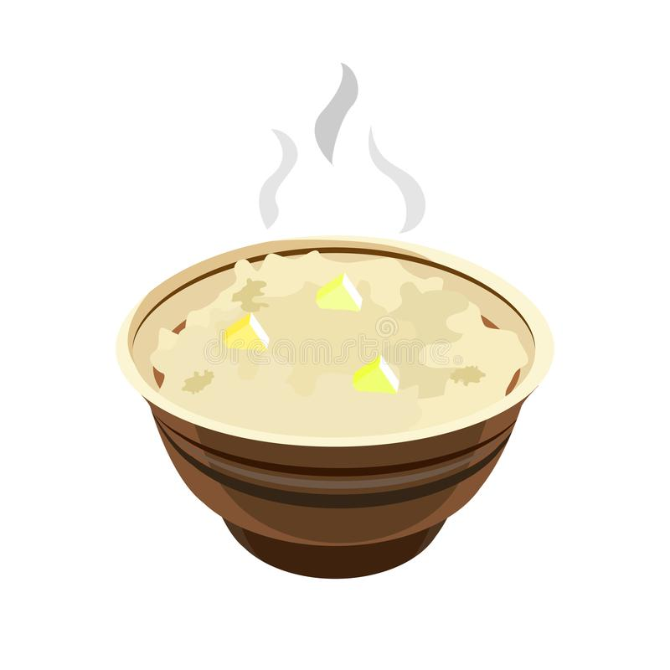  What makes porridge yummy? Why did Goldilocks like Baby Bear’s porridge? What was wrong with the other porridges? Can you use the ingredients listed opposite (see maths planning) to make some yummy porridge?  Now find out which ingredients are good for porridge and which are not so good? Try putting some different ingredients in your porridge to see if it tastes nice, such as jam, marmite, syrup, fruit or ketchup. Which ingredients make the best porridge? Which are not so nice? Are there any other ingredients you would like to try out?
Music  Learn to sing the song ‘When Goldilocks went to the house of the Bears’ by clicking on the link below:  Goldilocks song  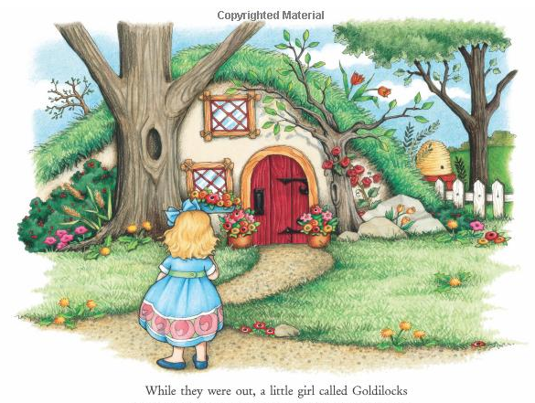 | RE    Celebrate the beauty of creation!  Go on a walk and take the time to look at the beautiful colours, shapes and patterns.  Thank God for all the beauty in nature.  Y1s write a thankyou prayer and decorate it with a seasonal border.

