Friday 29th January

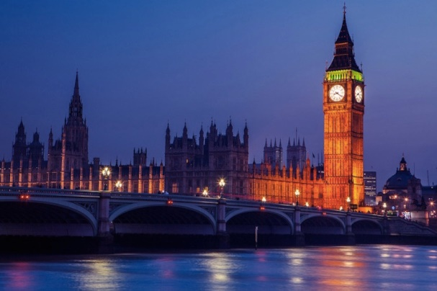 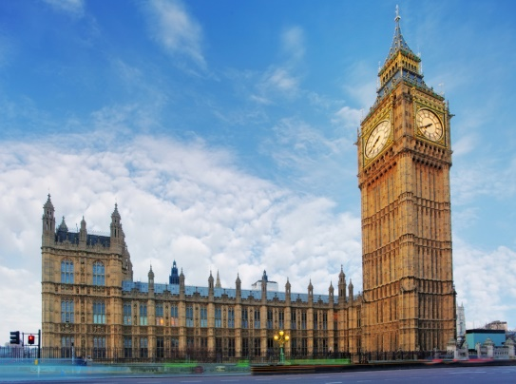

Big Ben

_______________________________________________________________________________________________________________________________________________________________________________________________________________________________________________________________________________________________________________________________________________________________________________________________________________________________________________________________________________________________________________________________________________________