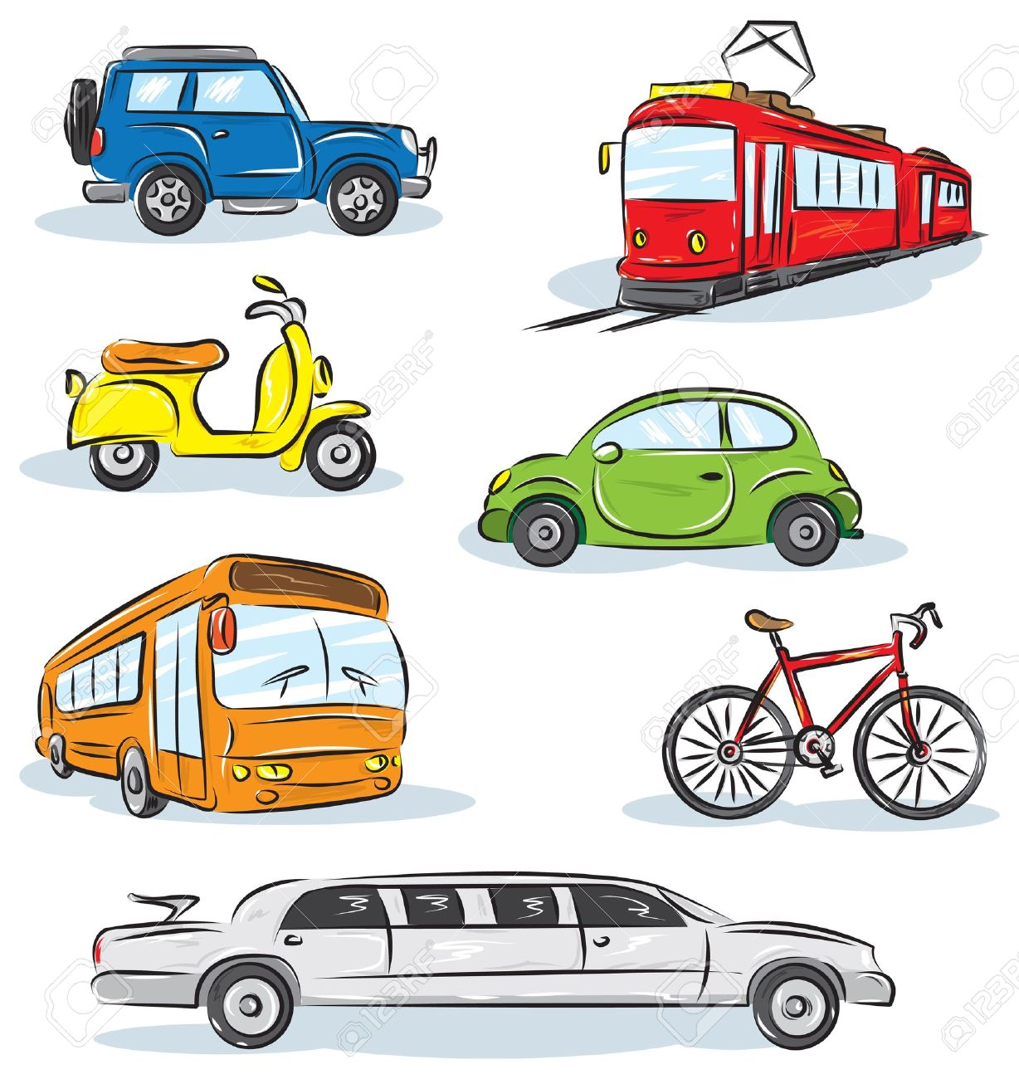
This half term our topic is ‘Transport’. We have planned lots of exciting activities that you can complete while you are learning at home.

We hope that you are keeping safe and well.
If you have any queries regarding your child’s learning please email us at:
Williams@lea-st- marys.lancs.sch.uk
Jennings@lea-st- marys.lancs.sch.uk
Harrison@lea-st-marys.lancs.sch.uk
English  Literacy  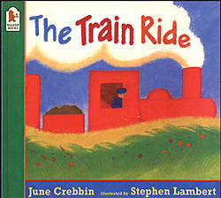  Monday:  ➢Watch the video. Open the link for this week’s story ‘The Train Ride.’  https://www.youtube.com/watch?v=RoEvHK_mP4Y  ➢Talk about the story. Why do you think the person telling the story slows down towards the end of the story? Listen to the story again and see if you can join in with some of the words.  Tuesday:  ➢Discuss the story. Can you remember 5 things that the little girl and her mum saw from the train? Make a list of them.  Wednesday:  ➢Draw and label a picture of some of the things they saw from the train. (Y1 write short sentences under each picture. Remember to use capital letters and full-stops.)  Thursday:  ➢Make up a story with an adult about an adventure you could have on a train. Where would you go to? What would you see? Who would go with you? See if you can act out your story.  Y1 children to write some sentences about their adventure.  Friday:  ➢Draw and label a picture of a train.  Handwriting  Practise forming letters cursively.  This week we would like you to practise writing c,a and d  Refer to the class page for the ‘Letter families’ link, showing how to form the letters correctly. | Spelling/Phonics
  Phonics
  Remember to access an online reading book and engage in a 20-minute phonics
  session daily.
  Monday and Tuesday:
  Review the phase 3 sounds we have learnt so far: j, v, w, x, y, z, zz, qu, ch, sh, th
  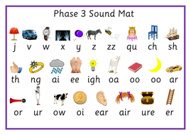
  - Say the sounds
  - Practise reading and writing words with these sounds in.
  - Read by sounding out and blending the sounds
  - Practise tricky words (wizard words on class page) ++
  Wednesday:
  Please practise the ‘ng’ sound. Read, write and say the sound.
  https://www.phonicsplay.co.uk/resources/phase/3/pick-a-picture
  Thursday:
  Please practise the ‘ai’ sound. Read, write and say the sound.
  https://www.phonicsplay.co.uk/resources/phase/3/buried-treasure
  Friday:
  Please practise the ‘ee’ sound. Read, write and say the sound.
  https://new.phonicsplay.co.uk/resources/phase/2/picnic-on-pluto
  • Practise reading tricky words, from phase 3 (Daily)
  ➢ http://www.letters-and-sounds.com/resources/p3tricky.pdf
Maths  Numeracy Week 1:  This week we are going to be focusing on numbers and addition:  Monday:  ➢Numbers  Go for a walk with a grown-up. What numbers can you see on houses and parked cars? Can you spot numbers 1 to 20 anywhere?  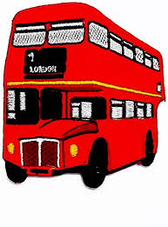  Tuesday:  ➢Number challenge  Practise counting and writing numbers to 20, making sure you have formed them all the correct way.  Y1 can you practise the words alongside the digits  (1 one, 2 two etc)  Wednesday:  ➢Draw a picture of a bus with 5 windows. Add 4 wheels to your bus, 3 people in the bus, 2 windscreen wipers and 1 numberplate. Now tell a grown-up where you would like to go on your bus.  Y1 challenge yourself to write some number sentences (5 + 4 =_)  Thursday:  ➢Addition  Watch the video to learn about addition and then practise your addition skills with the activities provided:  https://www.bbc.co.uk/bitesize/topics/zhsspg8/articles/z8hyfrd  Friday:  ➢Watch the number bonds song:  https://www.youtube.com/watch?v=OvbWuiYn-Uk  How many ways can you make 10? Write the number sentences e.g. 5 + 5 = 10  Use objects to help you. | RE  This half term in RE we are learning about Our World and how it is our job to look after it.  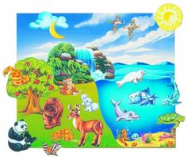  ➢Adult led discussion: Ask your child to share their individual experiences of what they think is wonderful in our world, e.g. animals, flowers, family, friends, etc.  ➢Draw a picture of something that is wonderful in our world e.g. animals, flowers, friends, family.  ➢Say a simple prayer thanking God for these wonderful things.  DT  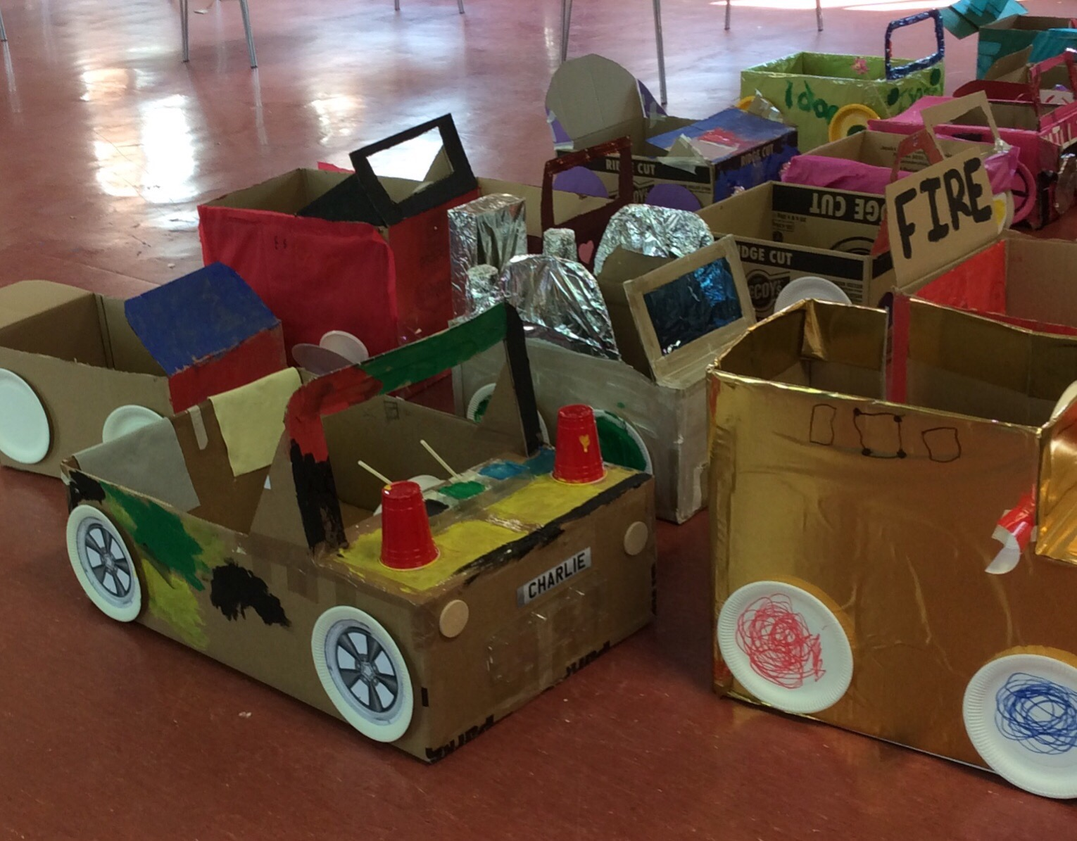  - Can you make a model of your favourite type of transport? You could use empty cardboard boxes or building bricks. What model will you make? You could make a car, boat, train or hot-air balloon! We would love to see your creations.  Music  ➢Join in with the words and make up your own actions for the song ‘We All Go Travelling By.’  https://www.youtube.com/watch?v=cSw50Jw0H34  Geography  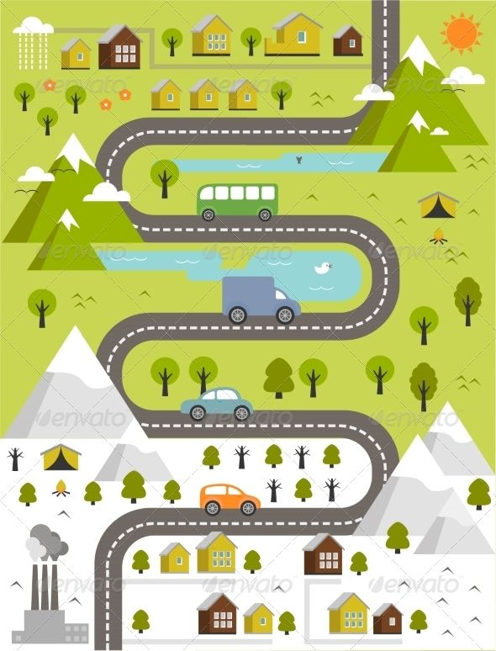  Think about a journey you often make. Can you draw a simple map showing some of the things you see on the journey?  PE  Join in a daily exercise on go noodle https://www.gonoodle.com

