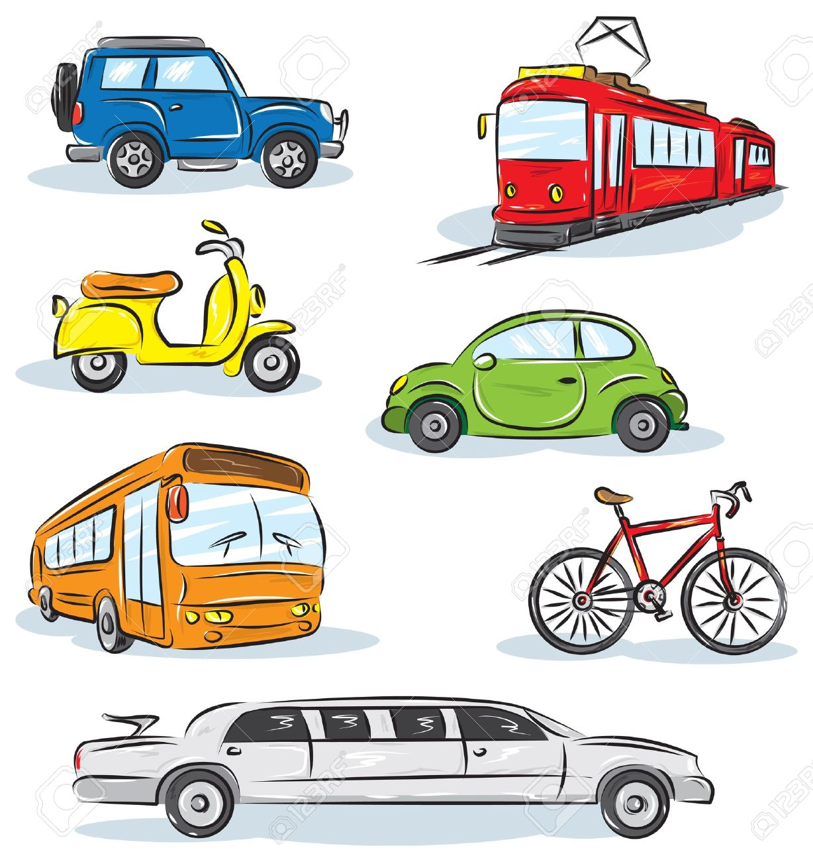
This half term our topic is ‘Transport’. We have planned lots of exciting activities that you can complete while you are learning at home.

We hope that you are keeping safe and well.
If you have any queries regarding your child’s learning please email us at:
Williams@lea-st- marys.lancs.sch.uk
Jennings@lea-st- marys.lancs.sch.uk
Harrison@lea-st-marys.lancs.sch.uk
(Mrs Williams Monday to Wednesday, Mrs Jennings Thursday and Friday)
English  Literacy  Monday:  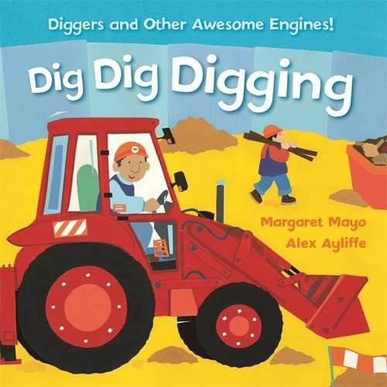  ➢Share the book ‘Dig Dig Digging by clicking on the link below:  https://www.youtube.com/watch?v=YpTyKSswicU  ➢Talk about the story. What are the different vehicles used for? Talk about their functions. Look at the final page together; can children spot all the different vehicles in this night-time scene?  ➢Listen to the book again and try to join in. Can you invent actions for digging, tipping, pulling and swooshing?  Tuesday:  ➢Draw and label a picture of your favourite vehicle from the book.  Wednesday:  ➢ Think of some questions that you might like to ask about your favourite vehicle. Use question words how, why, when, where and who. Year 1 children write down your questions and remember to use a question mark for each one.  Thursday:  ➢ Research – Choose your favourite vehicle from the book. See what information you can find out about it. Write down some facts about it.  Friday:  ➢Talk to an adult about how to stay safe near a road. Make a road safety poster.  Handwriting  Practise forming letters cursively.  This week we would like you to practise writing g,q and o  Refer to the class page for the video, showing how to form the letters correctly.  Spellings  Y1 children please practise reading and spelling these words every day:  the a do to today of said says | Spelling/Phonics
  Phonics
  Remember to access an online reading book (using your epic reading account)
  and engage in a 20-minute phonics session daily.
  Phonicsplay is now free again and there are lots of good games for you to play.
  Choose games from phases 2 and 3.
  Login: jan21
  Password: home
  Monday and Tuesday:
  Review the phase 3 sounds we have learnt so far: j, v, w, x, y, z, zz, qu, ch, sh, th, ng,
  ai, ee
  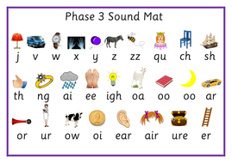
  - Say the sounds
  - Practise reading and writing words with these sounds in.
  - Read by sounding out and blending the sounds
  - Practise tricky words (wizard words on class page) from phases 2 and 3 ++
  ➢ http://www.letters-and-sounds.com/resources/p3tricky.pdf
  Wednesday:
  Please practise the ‘igh’ sound. Refer to the class page for the video.
  Read, write and say the sound.
  Watch this clip:
  https://www.youtube.com/watch?v=8Qy0VtMS_FM
  Practise writing words with ‘igh’ in your neatest handwriting.
  Y1 children – Choose 2 of these words and write them in sentences of your own.
  Thursday:
  Please practise the ‘oa’ sound. Refer to the class page for the video.
  Read, write and say the sound.
  Watch this clip:
  https://www.youtube.com/watch?v=M8nGaspuWAQ
  ‘oa’ word examples: goat, boat, coat, road, soap, toast, float
  Practise writing these words using a different colour for each word.
  Friday:
  Please practise the ‘oo’ sound. Refer to the class page for the video.
  Read, write and say the sound.
  Make a list of ‘oo’ words
  Y1 – Put some of your ‘oo’ words in simple sentences.
  ➢Choose games from phases 2 and 3 Phonicsplay to practise your sounds.
  https://new.phonicsplay.co.uk/resources/phase/2/picnic-on-pluto
Maths  Numeracy  Reception:  This week we are going to be focusing on addition and subtraction within 10. There are five lessons you can follow, each with a video clip and follow-on tasks.  Follow the link below:  https://classroom.thenational.academy/units/addition-and-subtraction-within-10-d631  Y1:  This week we are going to be focusing on addition and subtraction within 20. We would like you to follow lessons 1 to 5, each has a video clip and follow-on tasks.  Follow the link below:  https://classroom.thenational.academy/units/addition-and-subtraction-within-20-79fd | RE  This half term in RE we are learning about Our World and how it is our job to look after it.  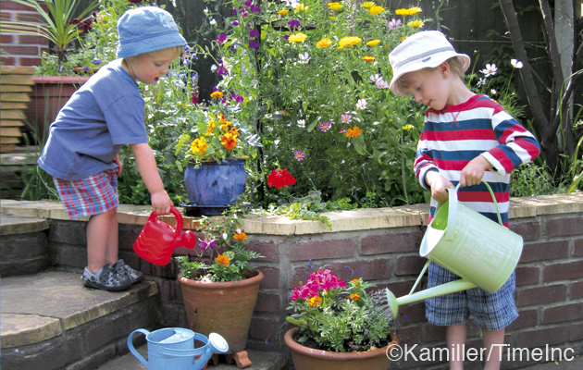  ➢Talk about the different ways you can help to take care of God’s wonderful world (e.g. watering plants, putting litter in the bin)  ➢Y1 children make a list of 5 different ways you can help to look after God’s world.  ➢Reception children draw 3 different ways of looking after God’s world.  Science  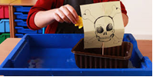  ➢Make some toy boats out of different materials (e.g. paper, card, tin foil, etc.) Ask an adult to help you. Do you think they will sink or float? Test each ‘boat’ by dropping it carefully into the water.  Music  ➢Join in with the words and make up your own actions for the song ‘Driving My Tractor.’  https://www.youtube.com/watch?v=Lj_odhwo81s  Art  Draw or paint a picture of your favourite type of vehicle.  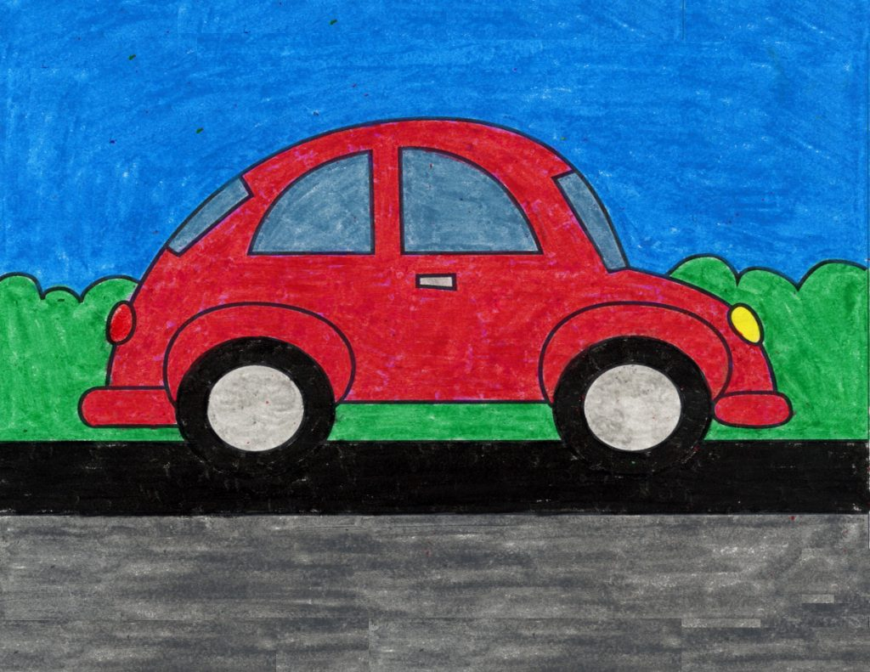  PE  Try some Cosmic Yoga this week with Diggory the Dump Truck:  https://www.youtube.com/watch?v=lppLh0FI3iw

