
Class 1 home learning (Bubble closure):

This week the theme is Winter

If you have any queries regarding your child’s learning please email us at
Williams@lea-st-marys.lancs.sch.uk
Jennings@lea-st-marys.lancs.sch.uk
Mrs Williams and Mrs Jennings

English  Monday:  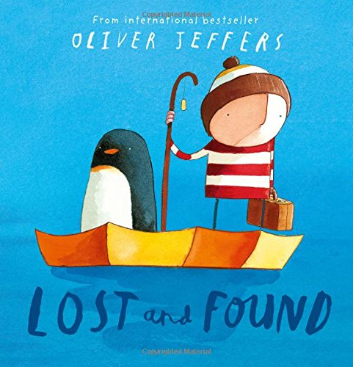  ➢ Read and share the story with your child by clicking on the link below:  Lost and Found  ➢Talk about the story together. How does the penguin feel at the beginning and the end of the story? Where do penguins come from? Can you think of some other ways the boy and the penguin could have travelled there? ➢Draw and write a list of items needed for a trip to the south pole.  Tuesday: ➢Draw and label the missing penguin.  Wednesday: ➢The boy and the penguin love to go on adventures.  Reception children – Can you make up your own adventure and act it out? Y1 – Write some sentences to say what you think happens when the boy and the penguin get home.  Thursday: Draw and label a person dressed for winter: hat, coat, scarf, socks, boots, gloves.  Friday: Look at the winter picture at the top of this plan. Reception children: write five words to describe it. Y1 - write three descriptive sentences using adjectives. | Spelling/Phonics  Thursday:  As above. Also:  Choose games from phases 2 and 3 Phonicsplay to practise your sounds:  https://www.phonicsplay.co.uk/resources/phase/3/buried-treasure  Friday:  As above. Also:  Choose games from phases 2 and 3 Phonicsplay to practise your sounds:https://www.phonicsplay.co.uk/resources/phase/3/pick-a-picture
  Phonics
  Remember to access an online reading book (using your epic reading account or
  Oxford Owl) and engage in a 20-minute phonics session daily.
  Phonicsplay is now free again and there are lots of good games for you to play.
  Choose games from phases 2 and 3.
  Login: jan21
  Password: home
  Monday and Tuesday:
  Review the phase 2 and 3 sounds we have learnt so far:
  - 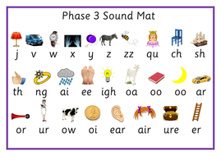Say the sounds
  - Practise reading and writing words with
  - these sounds in.
  - Read by sounding out and blending the
  - sounds.
  - Practise tricky words (wizard words on class page) from phases 2 and 3 ++
  Wednesday:
  As above. Also:
  Choose games from phases 2 and 3 Phonicsplay to practise your sounds:
  https://new.phonicsplay.co.uk/resources/phase/2/picnic-on-pluto
Maths  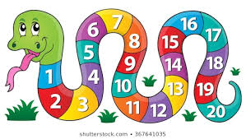  Monday: Revise practising recognising and ordering numbers to 10. Put out the numbers 1 to 10. Place the correct number of objects next to each number (e.g. you could use pasta, buttons, crayons, etc.) Mix up the numbers and see if you can put them in the correct order. (Year 1s to use numbers to 20.)  Tuesday: Practise finding one more and one less than a given number of objects. Select a number of objects (e.g. crayons, toys, lego) and count the objects carefully. Can you say what 1 more and 1 less would be?  Wednesday: Make a big dice out of an empty box. Stick or write the numbers on. Throw the dice and do that many hops, jumps or claps.  Thursday: Look at different objects and talk about their weight. (You could use items such as a tin of soup, a bag of sugar, pasta, fruit, etc.) Put 3 items in order of weight. Which is the heaviest? Which is the lightest? Now repeat using 4 different items. Answer questions such as: Which items are heavier than the pasta? Which items are lighter than the soup?  Friday: Look at different objects and talk about their length/ height. Put 3 objects in order of length. Which is the longest? Which is the shortest? Now repeat using 4 different objects. Use vocabulary such as longer/taller/ shorter than, longest, tallest, shortest. | Art  Choose one of the following craft ideas:  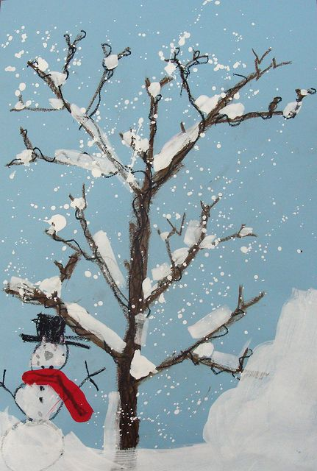  ➢Make your own winter scene picture using paint, twigs, cotton wool, etc. Be as creative as you like!  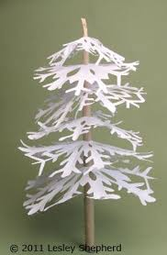  ➢Make your own magical snowflake tree by using a twig and paper snowflakes to practise your cutting skills!  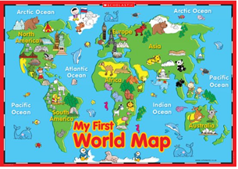  Geography  Use a world map to find out where the south pole is. Research some of the animals that live in the south pole as well as penguins. What can you find out about them?
Music    Join in with the words and actions for the ‘Snowflakes Song’ by clicking on the link below:  Snowflakes Song  PE  Try some Cosmic Yoga this week with Joybob the Polar Bear by clicking on the following link:  https://www.youtube.com/watch?v=DP9jd1Ug2y4 | RE    Celebrate the beauty of creation!  Go on a walk and take the time to look at the beautiful colours, shapes and patterns.  Thank God for all the beauty in nature.  Y1s write a thankyou prayer and decorate it with a seasonal border.  Well-being Wednesday  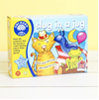  Choose your favourite board game and play it with your family. Enjoy!

