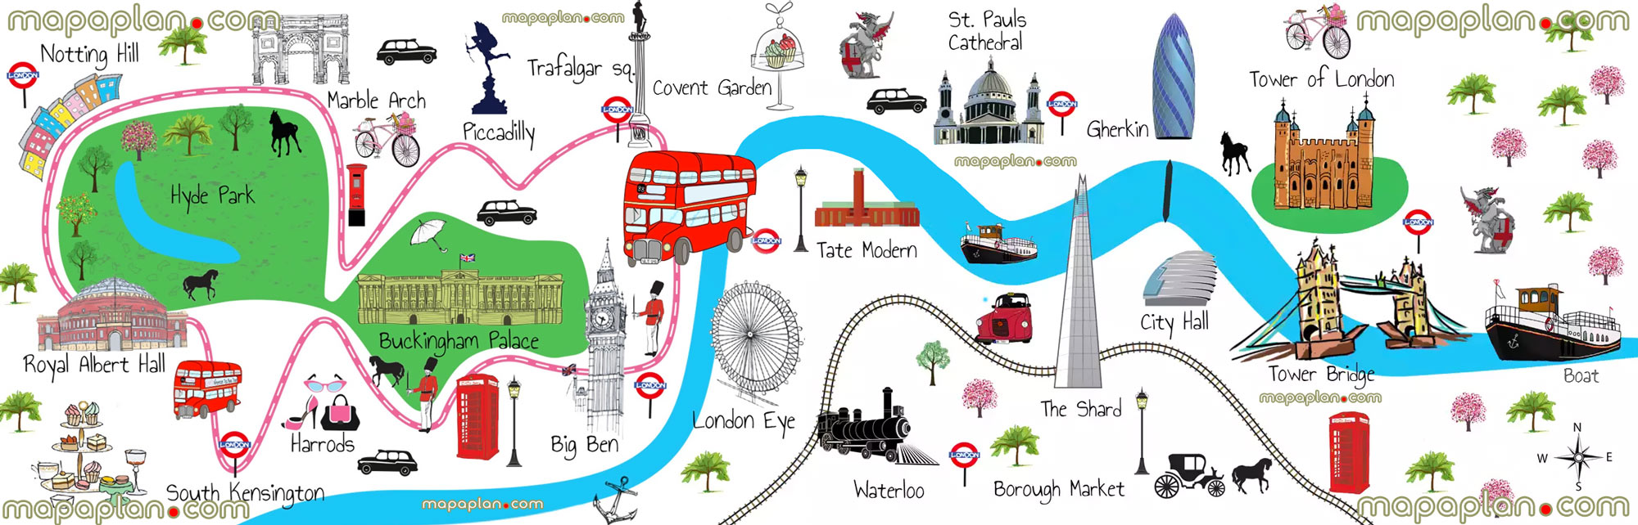

Mrs Sullivan’s Example of an Itinerary of Paddington Bears Day Out in London

1. First, jump on the underground train and go to Buckingham Palace. The Queen lives here and the palace has over 800 rooms. Look to see if the flag is up as it means the Queen is at home! You can also watch the changing of the royal guards, they look great in their smart red uniform and big black hats.
2. Next, take a stroll around Hyde Park and visit the beautiful rose gardens. You could also have a play on the amazing playground.
3. Then, get on the red bus to go on The London Eye. It is a big Ferris wheel and from the top you can see for 35 miles. It will take you thirty minutes to go all the way around the wheel in a little capsule.
4. After that, take a black cab to visit the Natural history museum where you can see a diplodocus skeleton and a blue whale skeleton, Wow!
5. Finally, hop onto a river tour boat down The River Thames to watch the big Tower Bridge open up to let the boats go through it is quite an amazing sight.

Sentence Opener Ideas

First, jump on the underground train

Next, take a stroll

Then, get on a red bus,

After that, take a black cab,

Finally, hop onto a river tour boat,

Remember you have two days to do this writing so do point one and two on Thursday . Then three and four on Friday.