

Week Beginning: Monday 1st February

Spellings

1. saw
2. lawn
3. straw
4. draw
5. 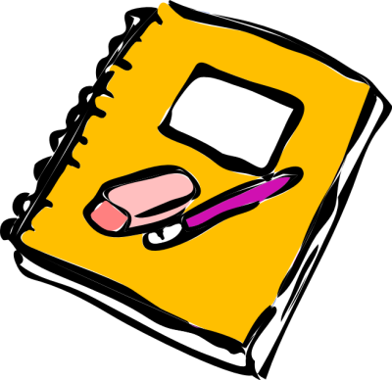crawl
6. what
7. whirl
8. wheel
9. why
10. when

Challenge words

awful

where

|  |  |
| --- | --- |
| **aw** | **wh** |