This half term our topic is ‘Transport’. We have planned lots of exciting activities that you can complete while you are learning at home.
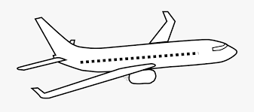
We hope that you are keeping safe and well.
If you have any queries regarding your child’s learning please email us at:
Williams@lea-st- marys.lancs.sch.uk
Jennings@lea-st- marys.lancs.sch.uk

Following on from your project to research vehicles this week we are going to focus on planes.

Literacy  Wednesday  https://www.youtube.com/watch?v=FDw0pAf7QXw  ➢Watch the first 5 mins of the clip, what have you learnt about the role a pilot?  Draw a picture and write a list.  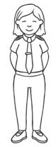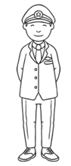  Thursday  ➢ https://www.youtube.com/watch?v=rD602zNMzI4  Let’s build a plane! Watch the clip and draw your own plane. Now watch again and listen for the names of the different parts of the plane. Can you include some labels?  Friday  ➢ Today you are going to use your imagination to go on a flight. Watch the airport clip.  https://m.youtube.com/watch?v=jy88ejZrPWw  Now draw/write recount of your trip  First I packed my bag   Next the taxis picked us up   Remember to use time connectives (First, Next, After that, Then Finally)  Handwriting  Practise forming letters cursively.  This week we would like you to practise writing i, l and t  Refer to the class page for a video of how to form the letters correctly. | Phonics  Remember to access an online reading book (using your epic reading account) and engage in a 20-minute phonics session daily.  Wednesday-Friday  Revise all of phase 2 sounds:  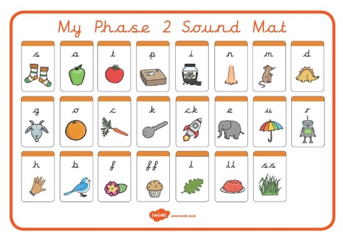  - Say the sounds  - Practise reading and writing words with these sounds in.  - Read by sounding out and blending the sounds:  - Practise tricky words (wizard words on class page) ++  Wednesday  ➢ https://new.phonicsplay.co.uk/resources/phase/2/buried-treasure  Thursday  ➢ https://new.phonicsplay.co.uk/resources/phase/2/dragons-den  Friday  ➢ https://new.phonicsplay.co.uk/resources/phase/2/picnic-on-pluto  • Practise reading tricky words, from phase 3 (Daily)  ➢ http://www.letters-and-sounds.com/resources/p3tricky.pdf
Numeracy  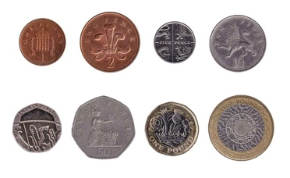  This week we are going to be focusing on money. There are five lessons you can follow. Please complete the first three lessons this week. Watch each video clip and follow-on tasks.  Follow the link below:  https://classroom.thenational.academy/units/money-a713  Additional tasks  ➢Role play, create a shop with your toys. Make price tags and take turns being the shop keeper and customer.  ➢Money box, do you have a money box? If so empty it and have a look at the different coins and values OR ask an adult if you can look at the different coins in their purse/wallet.  ➢Coin sorting, can you sort coins into groups of the same value? Count to find the total of the pennies etc | Topic  Art  Create a junk model plane. Research plane markings and decorate your plane. You could use a toilet roll or kitchen roll tube.  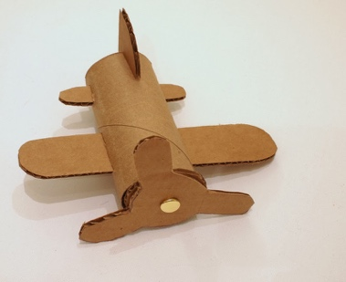  DT  Follow the steps below to make your own paper plane…  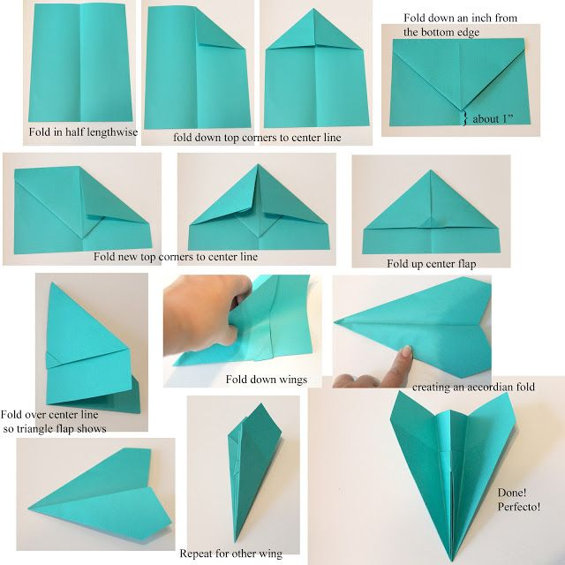  Now test it out!  Evaluate your design:  How far did it go?  Can you improve it?  Does it go further inside or outside? Why?  History  Find out about the very first plane and flight  https://www.youtube.com/watch?v=YDlk4Ky_ahs  Watch the clip and refer to the Wright brothers power point on the class page.  ➢Draw a picture of the first plane and record some interesting facts.

