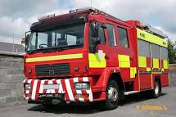
In Class 1 this half-term we are going to be learning about ‘Transport.’ We want you to complete a topic project today by researching different types of vehicles and what they are used for. The following link should help with your research:
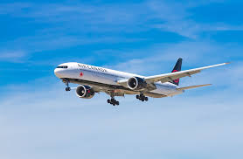
Types of Transport
We want you to create an information piece about some of the vehicles. You should include:
• Names of the vehicles
• Pictures of the vehicles with a caption underneath.
• Some simple facts about your vehicles or words to describe them.
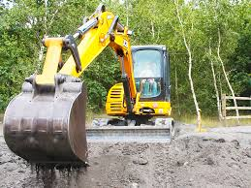
Email us your completed project with all the above and you will win team points. The best ones will go on our class page too!

