**MINDFULNESS FOR KIDS AND TEENS – CALMING GLITTER JAR AKA MIND JAR**

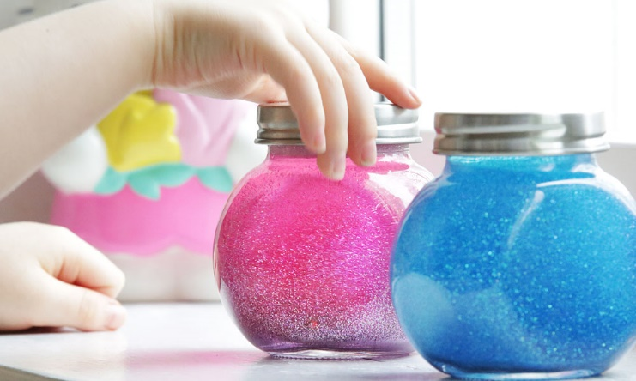

**The Calming Glitter Jar** is a great tool for calming down and a fun craft project to do with your child. The Calming Glitter Jar is a proven mindfulness tool and it can help to relax both kids and adults of all ages.

Also, the Calming Jar offers a practical way to “meditate” with a kid who doesn’t want to sit still. The idea is that your child can learn to use the jar on his own when he’s experiencing difficult emotions.

**The Calming Jar helps children to:**

Learn focusing skills,   
calm down,   
and figure out that paying attention to their senses helps them regulate emotions.

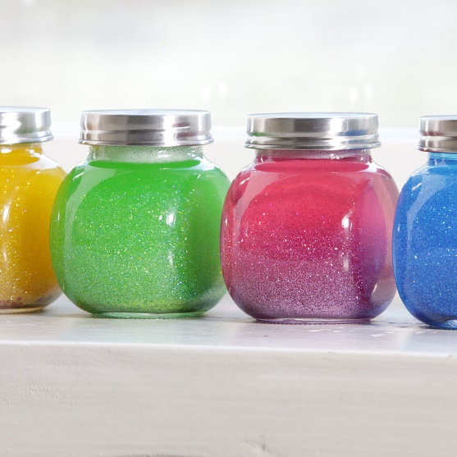

**SENSORY AWARENESS**

It is amazing at how the simple act of paying attention to our senses has such a strong calming effect.

We can pay attention to what we smell, touch, hear or see. Whenever we bring awareness to what we are experiencing with our senses, we are being mindful. When we do this simple act, our minds calm down.

**Why does this happen?**

The short answer: when you pay attention to your senses, you shift your focus away from your emotions and thoughts. Instead of worrying about the future or the past, you focus your mind and reduce the brain chatter. It’s simple and very powerful.

When you understand this, you can help your child calm down in various playful ways.

**MINDFULNESS FOR KIDS AND TEENS – CALMING GLITTER JAR**

**Purpose:** Emotional Regulation, Calm, Focus  
**Best for ages:** 3+  
**Materials:**

* Small jar (make sure it will hold liquid tightly)
* Clear glue
* Glitter (any colours you like)
* A few drops of food colouring
* Hot water
* Whisk or a stick

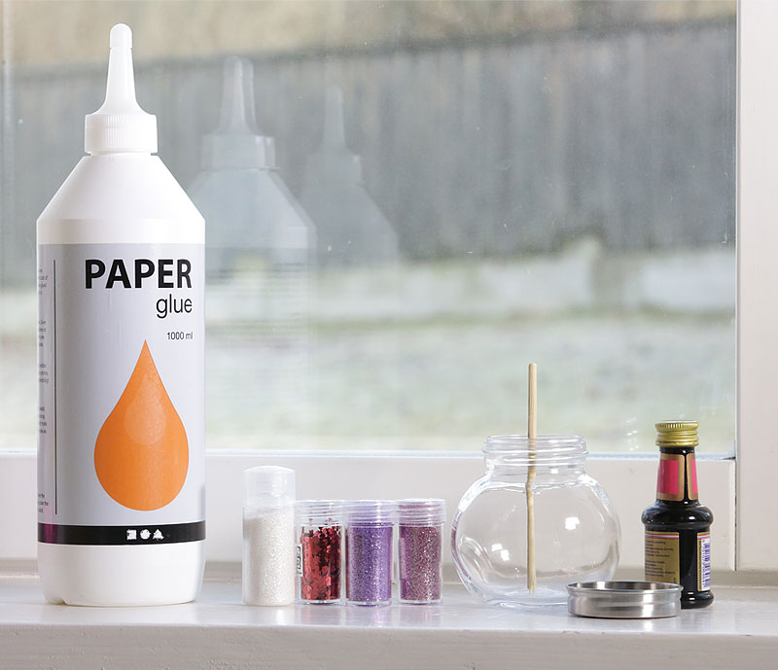

**DIRECTIONS**

* Warning: you may need to use your mindfulness skills to stay calm when your kid disperses glitter all over the place ;-)
* This is a great tool for calming down and it’s simple to build. Depending on the sort of glue you use, you may have to experiment to get the consistency just right for you. That’s part of the fun. You can experiment with about 20% glue, 80% water, and add as much glitter as you feel comfortable with. The more glue you use the longer it will take for the glitter to settle after shaking the jar. You can use clear school glue and glitter, or glitter glue and add some more glitter to get the effect you want.
* **1. Pour glue and hot water (tap water is okay) into the jar and mix with a whisk.** The glue gives the liquid a different thickness and makes impressive swirls of glitter.
* **2. Add some glitter.** You can start with 1-2 tablespoons of glitter. I prefer to combine both chunky and finer glitter. For a pink jar I used red hearts, purple, pink and iridescent glitter. Iridescent glitter will give a nice lighter look, so be sure to try it out.
* **3. Add a drop or two of food colouring to give it more excitement.**
* **4. When everything is blended, put the lid on and give it a good shake so the glitter is dispersed throughout.**
* **5. Then let it cool without the lid.**
* **6. You can secure the lid with super glue.**

**TRY IT OUT TOGETHER**

* When you’ve built the jar with the glitter, you can explain the purpose of the jar.
* Shake it and tell your child that sometimes our minds are full of thoughts, swirling around like the glitter in the jar.
* Sometimes we experience angry thoughts. Sometimes sad thoughts.
* Tell them that it’s okay to have strong feelings but that we can calm those thoughts and our bodies as well.
* One way to do this is to let your thoughts settle like the glitter in the jar. When our minds are calm it’s easier to work out problems and to talk about whatever it is that is causing us to be upset.
* Shake the jar up until the glitter is spinning wildly. Then set it on a table or the floor and calmly watch it with your child until the glitter, and your minds, are all settled down.

