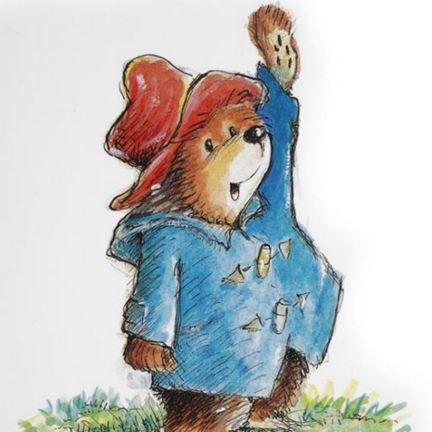

Monday 18th January

Questions to answer from the opening part of the story of Paddington Bear

**Slide 2**

1. How did Paddington get his name?

________________________________________________________________________________________

1. Who were The Browns waiting for?

________________________________________________________________________________________

1. What does the word ‘repeated’ mean?

________________________________________________________________________________________

1. What was Paddington near at the station?

________________________________________________________________________________________

**Slide 3**

1. How is the suitcase described?

________________________________________________________________________________________

6. Where was Paddington Bear from?

**________________________________________________________________________________________**

7. What kind of bear do you think Paddington is and how do you know that? Give an example from the text.

**________________________________________________________________________________________**

**Slide 4**

8. What did Paddington eat on his journey to London?

**___________________________________________________________**

**Slide 6**

9. Do you think Mr Brown wanted Paddington to stay with them? Explain your answer.

**______________________________________________**

**Slide 7**

10. Use a dictionary to find out what the word hastily means, if you don’t have one, you could always use an online dictionary.

**____________________________________________________________________________________________**