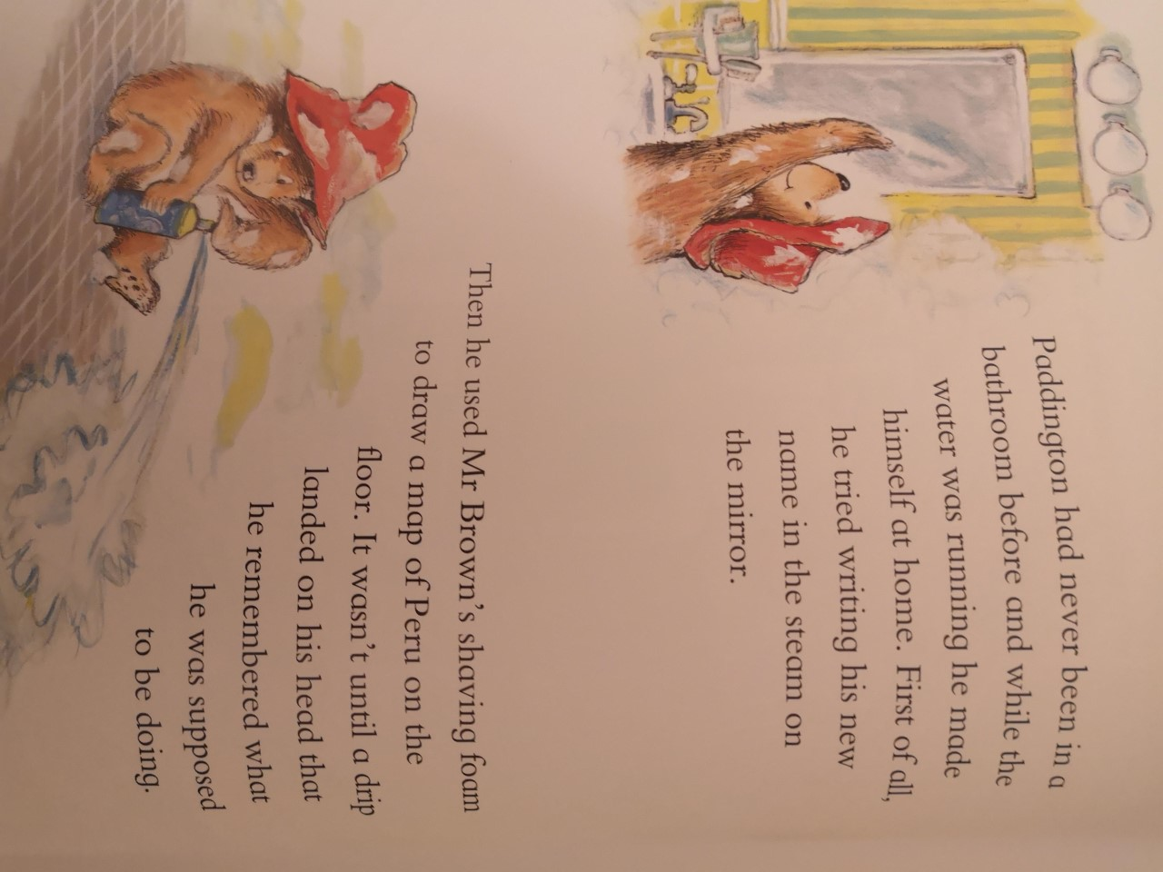

Tuesday 19th January

To recount an event.

_______________________________________________________________________________________________________________________________________________________________________________________________________________________________________________________________________________________________________________________________________________________________________________________________________________________________________________________________________