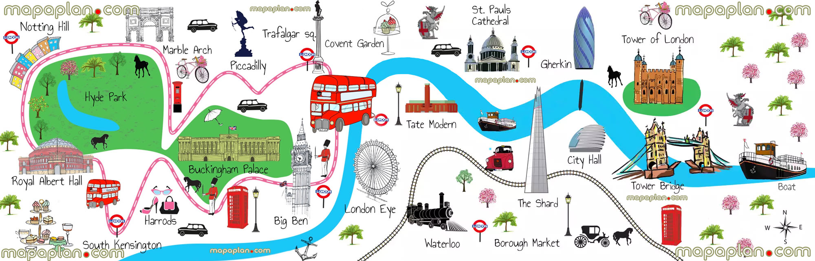

Paddington’s Day Out in London Itinerary

______________________________________________________________________________________________________________________________________________________________________________________________________________________________________________________________________________________________________________________________________________________________________________________________________________________________________________________________________________________________________________________________________________________________________________________________________________________________________________________________________________________________________________________________________________________________________________________________________________________________________________________________________________________________________________________________________________________________________________________________________________________________________________________________________________________________________________________________________________________________________________________________________________________________________________________________________