
St Mary’s Catholic Primary school remote learning planner for week beginning 11th January
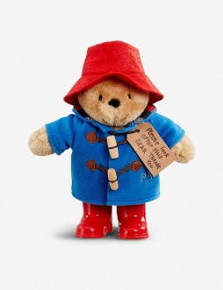
We were amazed by last week’s home learning that you sent us, please keep up the hard work. This week we are starting our work on Paddington Bear.
If you have any queries regarding your child’s learning please message me on the seesaw app all these messages appear to me privately or email me at sullivan@lea-st-marys.lancs.sch.uk.
Thank you for your support. Mrs Sullivan and Mrs Coulter 😊

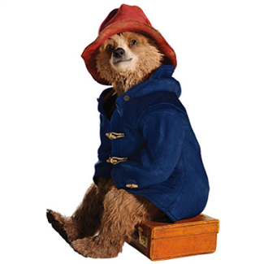
Literacy – Our literacy is based around the story of Paddington Bear. Before you start, watch these video clips from the film. They show how an explorer discovered and became friends with Paddington bear’s family and how much the bear family love marmalade! Then Aunt Lucy became too old to look after Paddington Bear so she stowed him away in a boat to send him to London in hope that someone would look after him.
Clip 1 https://www.youtube.com/watch?v=CYp7-4xy4_w
Clip 2 - https://www.youtube.com/watch?v=NyAAqAeyfCE

Monday - https://www.youtube.com/watch?v=t95Zwch09wQ

Watch this video clip of Paddington Bear. He filled his suitcase full of marmalade. What do you think he should have packed? There is a template on the class page to use in your task.
Year 1 – Draw and label items some items that Paddington should have packed in his suitcase.
Year 2 - Write a list of the items that Paddington Bear should have packed in his suitcase.

Tuesday - https://www.youtube.com/watch?v=t95Zwch09wQ
Watch this video clip again and in particular the part where Aunt Lucy puts a label around Paddington’s neck. She was hoping that someone would find Paddington Bear, read his label and look after him. Today I would like you to write a label for Paddington Bear’s. Watch my video clip on the class page showing you my label for Paddington. A label base is on the class page.

Wednesday - https://www.youtube.com/watch?v=sCgnuhb45ik Watch this video clip. This is the story of how Paddington got his new home. Whilst watching the video clips can you think of some adjectives to describe Paddington Bear? E.g. lost, brown, furry, red, soft hat. Gather these ideas in a word bank.

Thursday – Watch my video clip for today’s lesson. We are going to step through the magic mirror and pretend we are Paddington, We will then write a speech bubble for Paddington. Speech bubble template will be on the class page.

Friday - Paddington met his new family at Paddington Station in London, that is why he is called Paddington. Do you know much about London, what would you like to learn about London? Write some questions. Remember to use a capital letter to start you sentences and a question mark at the end. I have put some question opening words to help you. For example, How long does it take to get to London from Preston? Does the queen live in London?

Handwriting – Please practise the letter g. Then apply in the words: got, get, go, grab, gate, grow, goat, glass. Now think of your own g words. Watch my handwriting video clip on the class page. https://www.youtube.com/watch?v=Kh3tJ79ZJ2o&feature=youtu.be
Reading - Please use your epic reading accounts or the oxford reading tree. I have also attached some reading comprehensions that your child could have a go at reading and answering the questions of they wish. I am happy for you to use this just as another source of reading material.

Phonics - ou and ie diagraph.
Gummy Bears -
Monday- Watch this clip - https://www.youtube.com/watch?v=I6_Twpffldk ou word examples – out, loud, about, mouth, sound, ground, proud, shout, cloud. ouch, count. Practise writing these words, could you use a different colour pencil crayon or felt tip for each word? Remember to use your neatest handwriting. I have attached some flashcards for you.
Tuesday – Put some of your ‘ou’ words in simple sentences and underline the ‘ou’ word. E.g I can count to ten.
Wednesday Watch this clip - https://www.youtube.com/watch?v=esc6yoAU5yU Then read ‘ie’ postcard on class page. Can you find the ie words?
Thursday – https://www.youtube.com/watch?v=5HNpJFVEjFU Watch this video clip on different ways of making ‘ie’ or igh. Can you make a list of words with ‘igh’ and ‘ie’ words. We haven’t learnt magic ‘e’ just yet but won’t do any harm to watch about it.
Friday – Spelling test
High Frequency Words. Please practise reading and spelling these words: he, she, we, me, be.

Jelly Beans- Adding ‘ed’
Monday- Look at powerpoint on adding ‘ed’ and Mrs Coulter’s video clip on the class page. Recap last week’s rules for adding ‘ed’ to verbs. Introduce new rule, if a word already ends in an ‘e’ than you just add ‘ed’ e.g bake to baked. Have a go at changing these words: dance, smile, close, wave, wipe, phone, scare, stroke and use.
Tuesday – Can you apply yesterday words in a sentence?
Wednesday – Introduce todays rule, if the word ends in a ‘y’ change a ‘y to an i, then add ed’ E.g. marry goes to married. Have a go at changing these words: hurry, worry, carry, study, bully, empty, fry and try.
Thursday – Have a go at the adding ‘ed’ worksheet on the class page. If you have not got a printer you could copy the words out and the change the words
Friday –Spelling test

Phonics Play
Once again phonics play is free again, there are some good games for the children to play. Gummy Bears have just started phase 5 this week. So could play games from phase 3 and 4.
Jelly Bean have started phase 6 however would benefit from playing games in phase 5.
Login: jan21
Password: home

Maths
Year 1
https://classroom.thenational.academy/units/money-88ba Following on from last week complete lessons 5 – 9 .

Monday - Compare different amount of money https://classroom.thenational.academy/lessons/to-compare-different-amounts-of-money-6gwk8c

Tuesday – Addition and Subtraction with money.

https://classroom.thenational.academy/lessons/to-use-addition-and-subtraction-in-the-context-of-money-cmv32c

Wednesday – To exchange money for items.

- https://classroom.thenational.academy/lessons/to-exchange-money-for-items-crv3je
Thursday – Find the cost of two items.
https://classroom.thenational.academy/lessons/to-find-the-total-cost-of-two-items-c8vkgr

Friday – To work out change.
https://classroom.thenational.academy/lessons/to-calculate-the-amount-of-change-needed-part-1-69j3ee

Year 2
https://classroom.thenational.academy/units/money-4a71 Following on from last week complete lessons 5 - 10

Monday – Change from a pound

https://classroom.thenational.academy/lessons/change-from-a-pound-6wwkac
Tuesday – Adding money in different ways

https://classroom.thenational.academy/lessons/adding-money-in-different-ways-60w3jt

Wednesday – Use the fewest amount of coins

https://classroom.thenational.academy/lessons/using-the-fewest-amount-of-coins-and-notes-71k64c

Thursday – Giving change
https://classroom.thenational.academy/lessons/giving-change-cct3ge

Friday – Complete both lessons on Problem solving
Part 1 -https://classroom.thenational.academy/lessons/problem-solving-part-1-6ctk8t
Part 2 - https://classroom.thenational.academy/lessons/problem-solving-part-2-6dh68r
Topic
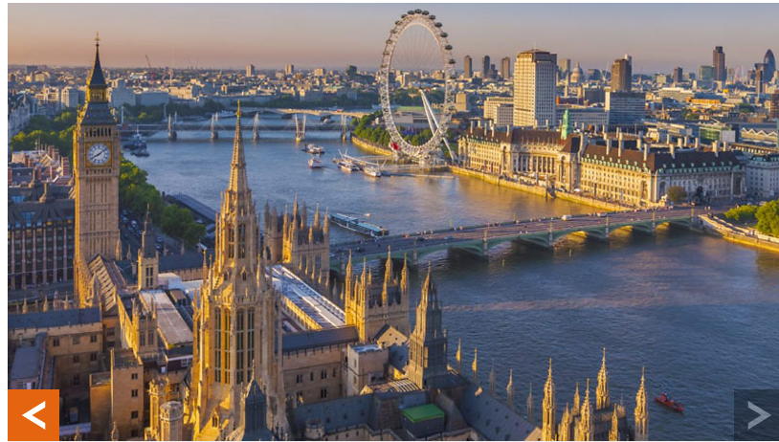
Geography - https://www.bbc.co.uk/bitesize/topics/zyhp34j/articles/z4v3jhv

Listen to Freya explaining about her Uncle Bob’s adventures in the United Kingdom. Then scroll down and play the game moving the labels to name the countries and the cities.
Then use the sheet on the website to colour each country a different colour and label your map with the name of the country and the capital city.

Science - https://classroom.thenational.academy/units/seasons-and-change-3c8a
What do we know about weather? Listen to the lesson and complete the activities during the lesson.

Activity – Can you make a seasons wheel? Draw around a plate and split it into quarters. In each quarter draw some key pictures that represent each season and label each quarter with the name of the season. Alternatively use the season’s wheel base that is on our class page.
Creative – Draw and create your own Paddington picture. You can choose what media you would like. Do you want to draw, colour, paint, collage? I can’t wait to see your fabulous work!
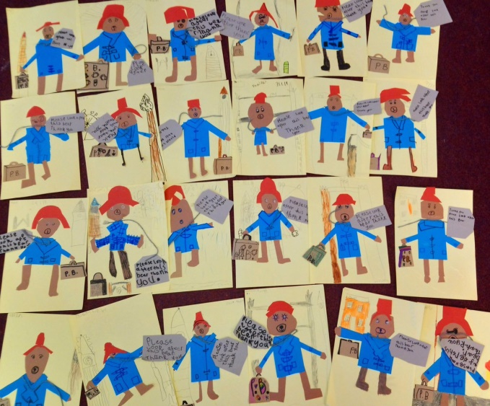

R.E - Our new topic this term is called ‘Treasures.’
Encourage the children to say what they treasure and why. Discuss your own ‘treasures’ e.g. photo of special people, memorable artefacts. Walk around your home and local area, take photos/video clips/make lists of treasures around us. Discuss what the things we treasure are and why.
Some key questions to ask: How did you feel when you received the treasure? What did you say to the person that gave you the gift? What did you do with the gift? What treasures do we share?
Activity – Children to decorate an old shoe box to make a treasure chest or draw a treasure chest and draw some items inside that they treasure. There is also a template attached on the class page of a treasure chest.

P.E – Cosmic yoga on you tube is a great resource that your children can complete independently. It encourages mindfulness, relaxation and exercise.
There are different themed work outs. Here is a Harry Potter one!
https://www.youtube.com/watch?v=R-BS87NTV5I
