Week Beginning: 1st February

**Spellings – Adding ‘ing’**

1. 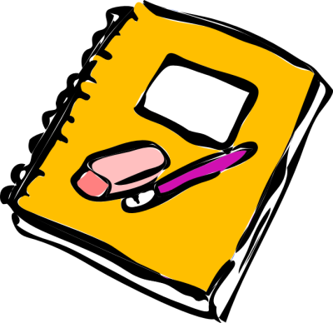jumping
2. hunting
3. standing
4. turning
5. smiling
6. taking
7. hiding
8. begging
9. putting
10. nodding

Challenge words

writing

deciding