**The Worry Jar**

A **Worry Jar** is a place for your child to put their worries so that they do not need to keep thinking about them. It is like storing them or putting them away for safe keeping. Just knowing that their worries are contained in the jar can free your child from having to replay them in their minds.

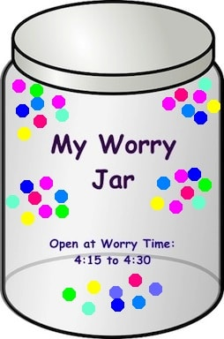

       Create a worry jar with your child. Find a real glass or plastic jar. Have your child decorate it (which is the really fun part) and then label it with a name (e.g., ‘Johnny’s Worry Jar’ or ‘My Worry Jar’). Once the jar is finished, help your child write down all his or her worries in a list on paper. You and your child can then cut each worry into its own strip of paper. Fold each worry and put it in the jar. Once all the worries are inside, have your child close the jar.

**Schedule Worry Time**

The next step is to schedule **“Worry Time”**. Worry time is a set time of day when your child has permission and is encouraged to worry as much as he or she wants. This specific time serves as another way to contain the worries. The key is to remember that when worry time is over, you and your child know that the worrying must end for the day.

       Choose 10-15 minutes a day after school or after supper (but not right before bed) and write down when worry time is on the worry jar (e.g., 4 PM to 4:15 PM). You may want to set a timer or alarm to notify your child that worry time has begun. Once worry time starts, your child can open the worry jar, look inside, and proceed to worry all he or she wants. Your child can choose to review all the worries or focus on one or two each day. Depending on the child and your child’s developmental age, worry time can be spent alone or with you. To end worry time, have a timer or alarm sound to indicate that worry time is over for the day. Your child should close the jar to put his or her worries away.

Of course, it is normal for worries to come up at other times during the day. After all, your child may be an expert worrier (like so many of us). If a worry appears at another time, you or your child can write it down and “save the worry” for worry time. That is, remind your child that it is not the right time to worry and he or she can think about the worry at the next worry time.

By using the **worry jar**, at some point your child will likely tell you that he or she is no longer worrying about something he or she had previously put in the jar. This is the exciting part for your child as this discovery represents success at overcoming a worry! Celebrate these moments together and make a big deal out of it. Have your child remove the worry and rip it up.

Similarly, you may also notice that your child decides to skip **worry time** some days as he or she feels they don’t need it. This is another sign of success to be reinforced and recognized!

