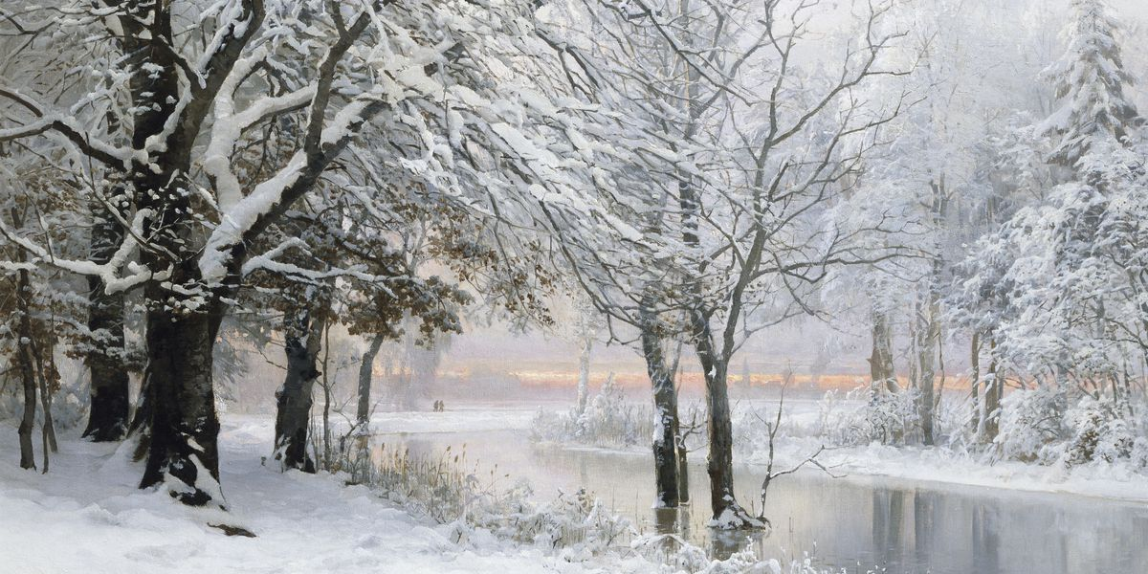
Wonderful Winter Class Project!

This term in science our focus will be seasons and weather. I would like you to start a little project today all about Winter. We will carry on with this in our home learning this week. You can send me pictures of all your work on our seesaw app using the ‘messages’ section.

There are four seasons in the year. Can you name the seasons? Winter falls in the months of December, January and February. Tell your grown up what you already know about winter.

First practise spelling the word ‘Winter.’ Can you write it in the air? Can you write it on your hand with your finger? Now write it in your neatest writing on a piece of paper.

Activities
- Read the ‘All about Winter’ powerpoint with your grown up. Now, use the ideas to create a poster all about what happens in Winter. It could have pictures, key words and sentences on. Maybe you could even present your poster and information like you are a You tube Vlogger!

- Think carefully about the weather over the past few days and look at the pictures I have included. Now, design yourself clothing to wear on a cold, winter’s day that would be suitable for sledging in! It must be cosy, warm and waterproof. You can design it in your favourite colours.

