These learning links and project work are in case we are unable to post learning. As soon as possible, we will return to posting our normal weekly planners.
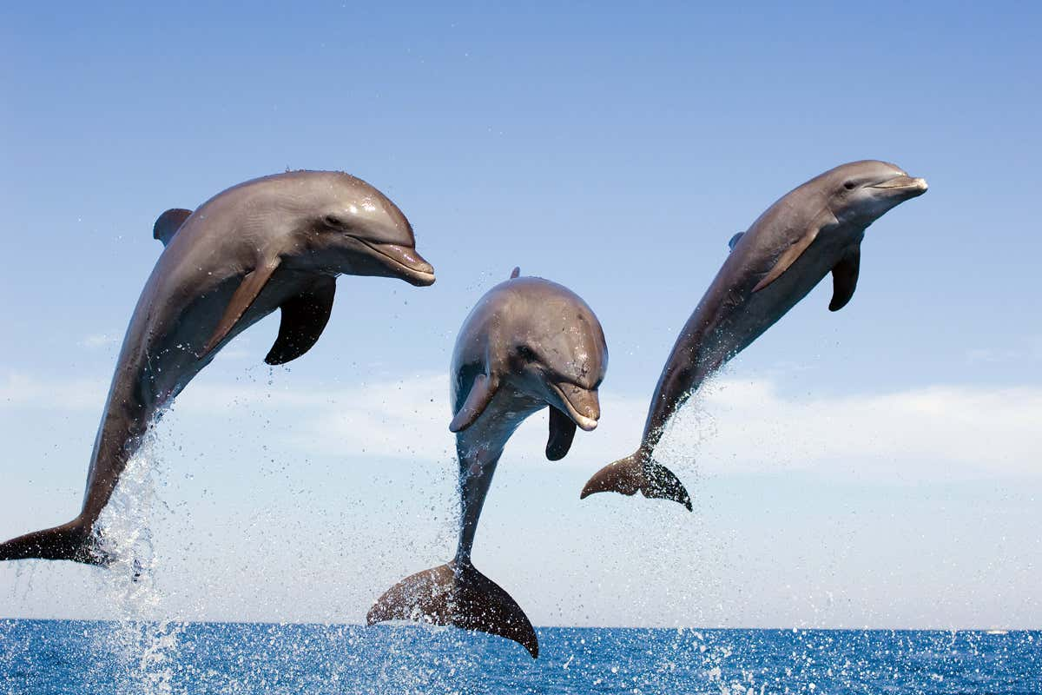
Suggested links for home learning and under the water themed topic work.
Numeracy – A week of numeracy lessons based on shape and space.
https://classroom.thenational.academy/units/shape-and-patterns-8ccf
Useful maths games to play can be found on this website:
https://www.topmarks.co.uk/Search.aspx?Subject=16&AgeGroup=2

Literacy – A week of literacy lessons based on Monkeys and Hats story. https://classroom.thenational.academy/units/monkeys-and-hats-problems-19ec

Phonics Play –
https://www.phonicsplay.co.uk/
Login: jan21
Password: home
Once again phonics play is free , there are some good games for the children to play. Gummy Bears have just started phase 5. So could play games from phase 3 and 4.
Jelly Bean have started phase 6 however would benefit from playing games in phase 5.
Under the Sea themed activity ideas
- Research a sea creature and create an information poster on the sea creature.

- Learn about divers and what they experience under water and the equipment they use (flippers, goggles, air tanks etc) and discuss the purpose of each. Ask the children what they think a diver would see underwater. Children to imagine they are a diver and write a diary entry explaining their day’s exploring.

- Make a junk model sea creature with items from around the home.

- Design a board game with ‘under the sea’ theme.

- Research sea pollution and how we can help protect our oceans and seas.

- Conduct a survey to find out information about your family’s favourite sea creatures, then complete a tally chart and pictogram to show the results.

