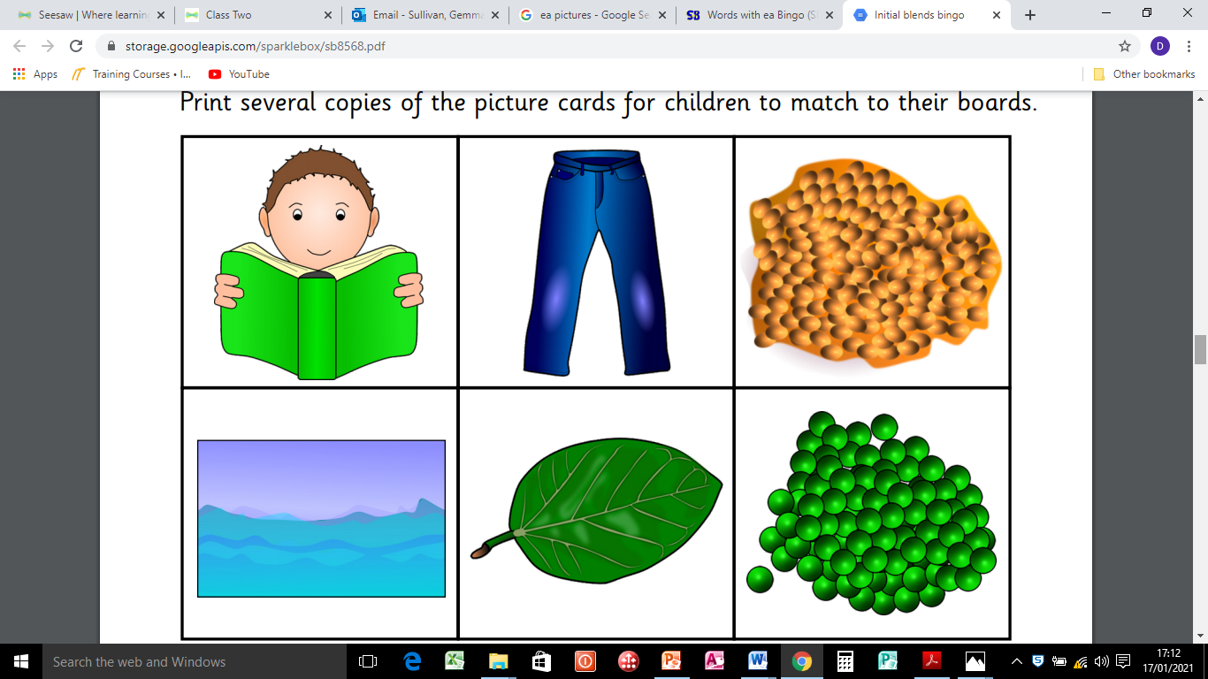

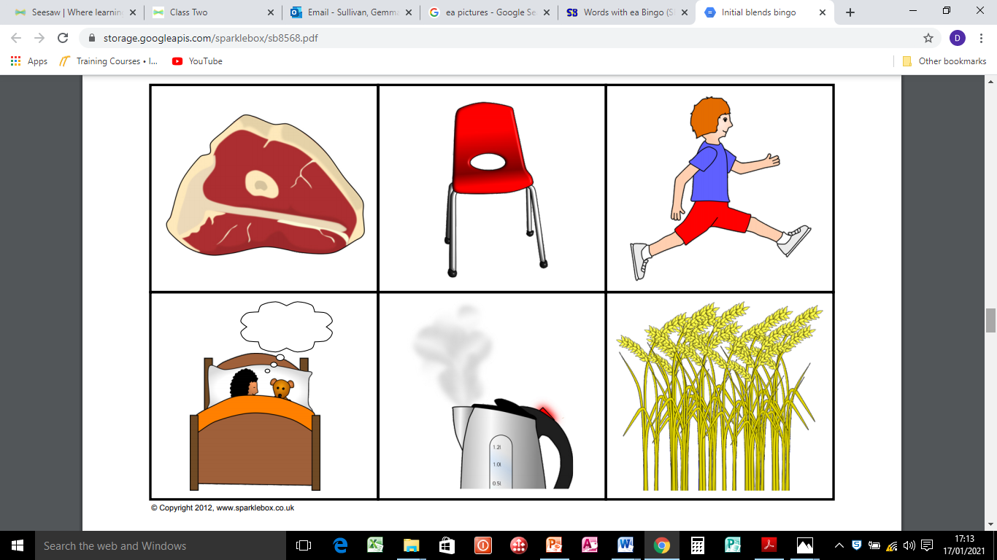

‘ea’ words – Check you have spelt them correctly!

Page 1

1. read
2. jeans
3. beans
4. sea
5. leaf
6. peas
7. meat
8. seat
9. leap
10. dream
11. steam
12. wheat