Can you predict what the book will be about?

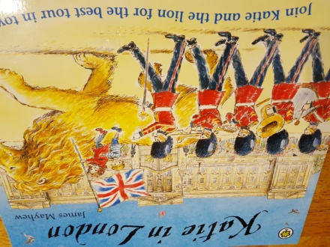

The title of this book is Katie in London.

The author of the book is James Mayhew.

On the cover I can see ……

The setting is .........

The main characters in this story are .....

This story reminds me of .........

I predict that in this story …..

I think ….. because .....

I wonder why ……

Challenge:

My questions about this book: