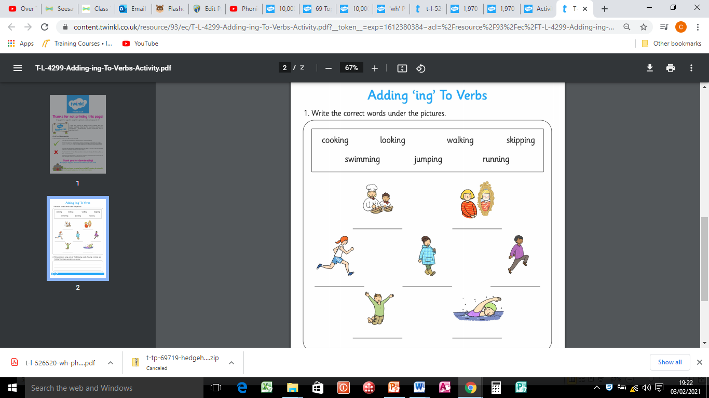

Apply three of these words in a sentence.

__________________________________________________________________________________________________________________________________________