My character is a wizard.
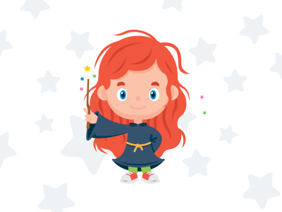
(Draw your character in this box, you might want to give them a name too.)

Lesson Ideas:
- Broom flying lessons
- Potion mixing class
- Spell reading class
- Spell casting masterclass
- History of wizards
- The keeping of magical pets class

Year Two’s might add a sentence to explain some of the classes. E.g A history of wizards class to learn about great wizards of the past and their amazing achievements.

