WATCH OUT!
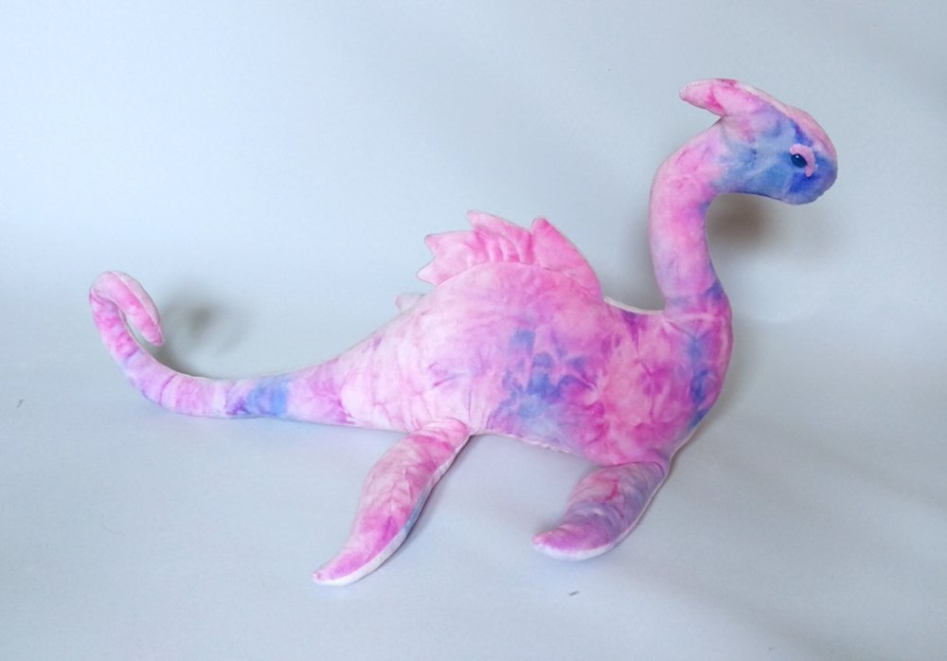

Look out for this pink and purple monster with smooth scales. She has a long, slim body with a curly tail and spiky plates on her back. This mysterious creature is hard to spot because she swims gracefully using her four powerful flippers and she hides secretly in the water.
£1000 reward for anyone who can take a picture of this amazing creature!!

